11
Transportation Planners’ Reference Guide

MACOG Transportation Planners’ Committee

Contents
I. Introduction 3
A. Purpose 3
B. What is an RPC? 3
C. The RPC-MoDOT Relationship 5
II. What Does a Transportation Planner Do? 7
A. MoDOT Expectations 7
B. RPC Expectations 7
C. Skill Set/Competencies 8
D. How Transportation Planning Integrates With Other Planning Tools 10
i. Comprehensive Economic Development Strategy (CEDS) 10
ii. Comprehensive Planning 11
III. Need to Know Information 11
A. MoDOT Work Plan 11
B. TAC 12
C. RTP 14
D. Local Financing Options for Transportation 14
E. Grant Writing 16
i. Funding Types – CDBG, SRTS, TE, DNR, etc. 16
ii. Tips for good grant writing 17
F. MACOG Transportation Planners’ Committee 18
IV. Quick Reference sections and Resources 19
A. MoDOT Documents 19
i. RPC Guidance Document 19
ii. RTP Guidelines (Original) 39
B. Timelines and Deadlines 62
a. MoDOT 62
C. TAC Handbook/Information 63
i. TAC Agenda Guidance 63
ii. Bylaws 67

iii Formation and Responsibilities 68
D. Contact Lists 72
i. MoDOT Contacts 72
ii. RPC Transportation Planners 72
E. Engineering Terms 75
F. Acronyms 103
G. Organizations/Websites 105
a. State and National Organizations 105
b. Transportation 105
c. GIS 105

Introduction
Transportation planning is the process of identifying transportation problems and looking for solutions to those problems. The Regional Planning Commission’s (RPC) of Missouri work with federal and local governments, state departments of transportation, transit agencies, area stakeholders and the public to ensure that the plans and projects developed help move the region toward the goal of achieving a rising quality of life for everyone. Transportation planners look at different transportation alternatives and work with the public to select those that make the most sense based on the long-term goals for the region.
Without the public's input and ideas, state and local planners cannot have a true understanding of a community’s needs. The goal of the RPC is to have significant and ongoing public involvement in the transportation planning process. A period for public comment is provided for the updates and major amendments to all of the primary transportation planning projects for which the RPC’s are responsible.

Purpose
This document is to be used as a training manual for newly staffed regional planners at the RPC level. Since the vast majority of transportation planners contribute to other projects at their respective RPC’s (environmental projects, grant writing, economic development, etc.), this document aims to ease the transition for new staff members who may not be familiar with the “in’s and out’s” of transportation planning in the State of Missouri.

What is an RPC?
In 1965, the Missouri Legislature enacted the State and Regional Planning and Community Development Act. This Act, which appears as Chapter 251 of the Revised Statutes of Missouri (1969), created the Missouri Department of Community Affairs. The Act also authorized the governor to create regional planning commissions upon the petition of local governmental units. If the Governor finds that there is a need for a regional planning commission, and if the governing bodies of local units within the proposed region include over 50 percent of the population of the proposed region, then the governor may create the regional planning commission.
Today, the State of Missouri’s 114 counties and the City of St. Louis have been divided into 19 regional planning commissions. The map below provides a summary of the regional planning commissions and the counties they serve. According to the Revised Statutes of the State of Missouri, 1969, Section 251.300, regional planning commissions “…may conduct all types of research studies, collect and analyze data, prepare maps, charts, and tables and conduct all necessary studies for the accomplishment of its other duties…”
In matters relating to comprehensive planning, a regional planning commission “…may enter into a contract and cooperate with any federal, state, or local unit of government including other planning commissions or organizations within this or other states under the laws of Missouri….The comprehensive plan shall be made with the general purpose of guiding and accomplishing a coordinated, adjusted and harmonious development of the region which will, in accordance with existing and future needs, best promote public health, safety, morals, order, convenience, prosperity or the general welfare, as well as efficient and economy in the process of development.”
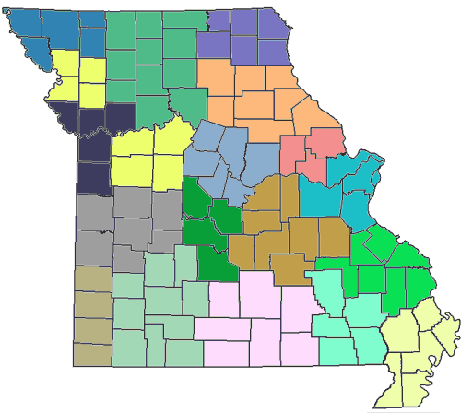
16
7
6
5
19
17
15
2
18
9
3
1
11
10
12
8
13
4
14
Number | Regional Planning Commission
1 | Boonslick Regional Planning Commission
2 | Bootheel Regional Planning and Economic Development Commission
3 | East-West Gateway Coordinating Council
4 | Green Hills Regional Planning Commission
5 | Harry S Truman Coordinating Council
6 | Kaysinger Basin Regional Planning Commission
7 | Lake of the Ozarks Council of Local Governments
8 | Mark Twain Regional Council of Governments
9 | Meramec Regional Planning Commission
10 | Mid-America Regional Council
11 | Mid-Missouri Regional Planning Commission
12 | Mo-Kan Regional Council
13 | Northeast Missouri Regional Planning Commission
14 | Northwest Missouri Regional Council of Governments
15 | Ozark Foothills Regional Planning Commission
16 | Pioneer Trails Regional Planning Commission
17 | South Central Ozark Council of Governments
18 | Southeast Missouri Regional Planning and Economic Development Commission
19 | Southwest Missouri Council of Governments

The RPC-MoDOT Relationship
MoDOT has outlined a framework that will bring about improvements in the state’s transportation planning and decision-making process. Working with the state’s metropolitan planning organizations (MPOs), RPCs, public officials, special interest groups and citizens, MoDOT is able to determine and refine a statewide transportation vision in the long-range transportation plan which includes policies and goals and a fiscally constrained strategy to achieve the highest-priority components of the plan.
One of the main goals of the planning framework is to ensure that the general public and local officials actively participate in the process. MoDOT has been able to achieve this with its MPO and RPC planning partners.
MoDOT works closely with the regional commissions to develop regional transportation plans that include long-term goals, needs identification and public outreach. These plans must be approved by the regional commission’s board of directors, which consists of local officials. The regional plans are then forwarded to the state for consideration in the development of the state’s transportation plan.
The element of local input is important in statewide transportation planning. The Missouri Department of Transportation (MoDOT) developed a process to use the RPC’s to determine which transportation needs and values are most important to the region and the state. MoDOT chose the RPC’s because they geographically covered the state, were knowledgeable about planning activities, had experience in working with federal programs, and had the desire to be involved in the transportation planning process.
The initial activities began in 1993. Each RPC was required to appoint a transportation advisory committee that was composed of local officials and citizens, gather general transportation comments, and work actively with MoDOT. The success of the activities in the initial phase led to expanded RPC planning activities in 1995. The expanded process directed each RPC to develop an annual transportation work program that identified specific transportation planning activities they would conduct for MoDOT. The additional items included an evaluation process of transportation needs, a public involvement process, development of regional data, and professional staff development.
The program has been successful in providing transportation information that can be used in the MoDOT decision-making process. The program will be continued in the upcoming years to assist the department with updates to the long-range transportation plan and the selection of projects to meet those transportation needs.

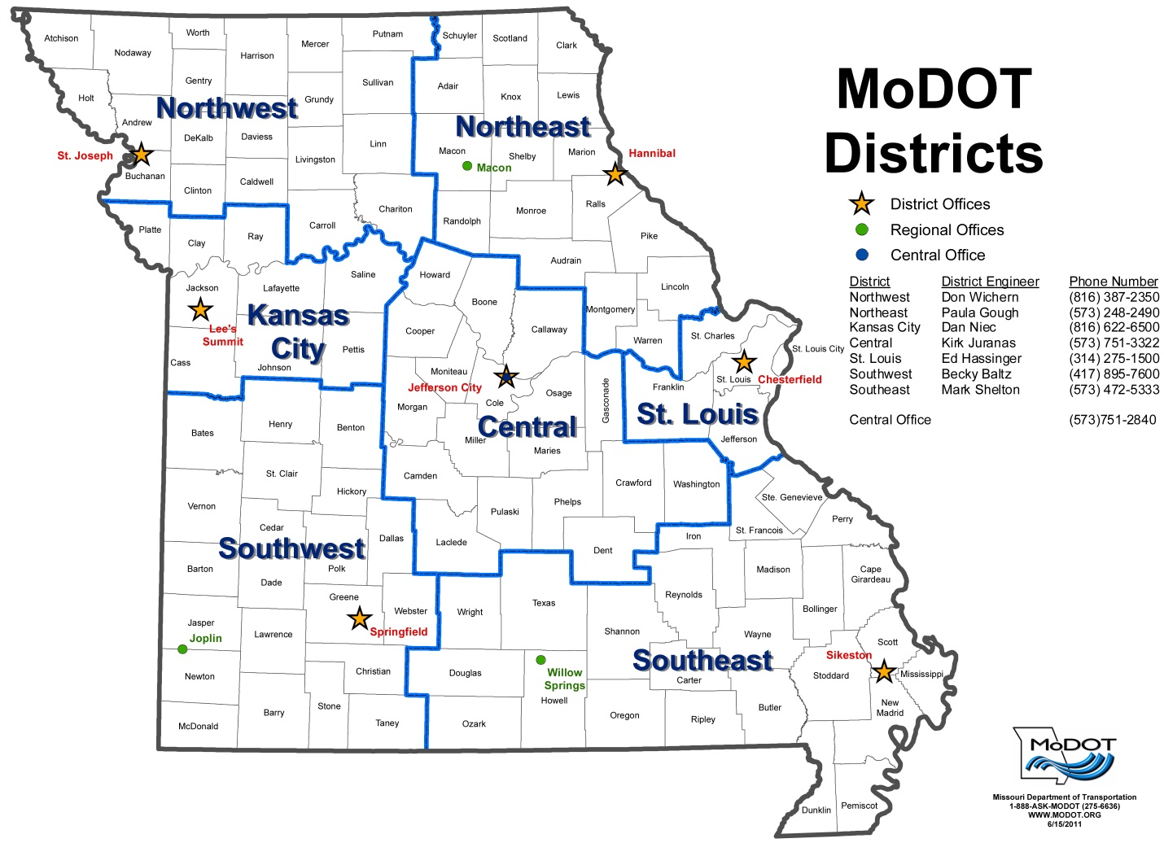

What Does a Transportation Planner Do?

MoDot Expectations
1. Develops and administers Regional Planning Commission (RPC) work program. (Numbers 2-5 below are included in the work program.)
2. Develops and maintains a Regional Transportation Plan (RTP) that is updated annually to include the region's road needs, bridge needs and sidewalk assessments.
3. Provides a mechanism for non-metropolitan local consultation, e.g., facilitating Transportation Advisory Committee (TAC) meetings to allow MoDOT staff to meet with local officials.
4. Supports MoDOT district activities, e.g., participating in Transportation Enhancement (TE) prioritization and selection.
5. Supports MoDOT Central Office activities, e.g., participating in the annual planning meeting, providing assistance and input to statewide activities and participating in updating the Planning Framework update.

RPC Expectations
1. Assures that the MoDOT expectations (listed above) are met
2. Assures that the following documents (current) are on file (digital or hard copy format) at the RPC:
a. Signed contract with MoDOT
b. Fiscal year MoDOT transportation work plan
c. Completed MoDOT “Transportation Self Evaluation” form
d. Financial and narrative MoDOT billing documentation
e. RPC Regional Transportation Plan
f. RPC Public Transit – Human Services Transportation Plan
g. MoDOT audit results, any recommendations and any responses to recommendations
h. RPC Transportation Advisory Committee (TAC) bylaws
i. RPC TAC roster including contact information
j. RPC TAC meeting summaries (minutes)
k. RPC TAC sign-in sheets

3. Assures that the following resource documents are available at the RPC in digital or hard copy format:
a. MoDOT Statewide Transportation Improvement Program (STIP)
b. Missouri’s Blueprint to Arrive Alive
c. Missouri Advance Planning – Missouri’s Long-Range Transportation Plan
d. Practitioner’s Guide – Missouri’s Framework for Transportation Planning and Decision-Making (March 2004)
e. Missouri Sunshine Law – State’s open meetings and records law

Skill Set/Competencies
Tools used in this occupation:
• Personal computers
• Laptop computers
• Photocopiers – photocopying equipment
• Facsimile machines – fax machines

Technology used in this occupation
• Office suite software – Microsoft Office software
• Word processing software – Microsoft Word
• Spreadsheet software – Microsoft Excel
• Presentation software – Microsoft PowerPoint

Tools and technology skills
• Understands and efficiently uses basic computer hardware (e.g., personal computers, printers) to perform tasks
• Uses word processing software to enter data into computer files quickly, with an acceptable degree of accuracy
• Creates documents such as letters, directions, manuals, reports, graphs, and flow charts
• Uses spreadsheet software to enter, manipulate, edit and format text and numerical data
• Effectively creates and saves worksheets, charts, and graphs that are well organized, attractive, and useful
• Uses the internet and web-based tools to conduct information searches
• Understands the company e-mail system and its basic functions (e.g., replying to/forwarding messages, using electronic address books, attaching files)
• Effectively uses both internal resources (e.g., internal computer networks, company filing systems) and external resources (e.g., internet search engines) to locate and gather information relevant to the problem
• Is comfortable and proficient with a computer
• Adds, subtracts, multiplies and divides with whole numbers, fractions, decimals and percents
• Calculates averages, ratios, proportions and rates

Knowledge used in this occupation:
• Exhibits knowledge of principles and methods for moving people or goods by air, rail, water or road including the relative benefits
• Exhibits knowledge of principles and processes for providing customer and personal services including customer needs assessment, meeting quality standards for services and evaluation of customer satisfaction
• Locates, understands, and interprets written information in manuals, reports, memos, letters, forms, graphs, charts, tables, calendars, schedules, signs, notices, applications and directions
• Identifies alternatives to traditional federal funding of transportation projects
• Identifies basic modes of transportation including air, rail, water, truck, public and intermodal
o Air Transportation – transportation of passengers and/or cargo using aircraft, such as airplanes and helicopters
o Rail Transportation – transportation of passengers and/or cargo using railroad rolling stock
o Water Transportation–transportation of passengers and cargo using watercraft, such as ships, barges, and boats
o Truck Transportation–over-the-road transportation of cargo using motor vehicles, such as trucks and tractor trailers
o Public transportation infrastructure (e.g., highways, airports, train terminals, ports, commercial space launching facilities and inter-modal facilities)
o Intermodal Transportation – transportation of passengers or freight using multiple modes of transportation
• Relates the multidimensional impact of transportation on the economy, public systems, national and local infrastructure, and the environment
• Applies the Sunshine Law
• Identifies basic information about Geographic Information Systems (GIS)
• Identifies basic information about transportation planning
• Identifies basic information about civil engineering
• Identifies basic information about accounting
• Identifies basic information about project management

Skills/Abilities
• Developing Objectives and Strategies — Establishes long-range objectives and specifies the strategies and actions to achieve them.
• Establishing and Maintaining Interpersonal Relationships — Develops constructive and cooperative working relationships with others and maintains them over time.
o Communicates with people outside the organization including representing the organization to customers, the public, government and other external sources by exchanging information in person, in writing, by telephone or e-mail.
o Communicates with supervisors, peers or subordinates by providing information to supervisors, co-workers and subordinates by telephone, in written form, e-mail, or in person.
o Keeps customers up to date about decisions that affect them.
o Seeks the comments, criticisms, and involvement of customers.
• Facilitating Public Meetings -- Holds public meetings with government officials, the public and special interest groups to formulate, develop or address issues regarding transportation planning. Participates in public meetings or hearings to gather feedback from those affected by projects.
• Gathering Data — Performs data gathering, research and analysis duties regarding a variety of data including routine information and specific data. Gets information by observing, receiving and otherwise obtaining information from all relevant sources.
• Identifying Objects, Actions, and Events — Identifies information by categorizing, estimating, recognizing differences or similarities, and detecting changes in circumstances or events.
• Analyzing Data or Information — Identifies the underlying principles, reasons, or facts of information by breaking down information or data into separate parts. Analyzes and assembles a variety of data for agency use for incorporation into various reports. Prepares regular and customized reports on a routine and special request basis to present information in an easy to read format.
• Evaluating Information to Determine Compliance with Standards — Uses relevant information and individual judgment to determine whether events or processes comply with laws, regulations or standards. Diligently checks work to ensure that all essential details have been considered. Documents and evaluates transportation project needs. Ranks transportation projects based upon a given set of criteria.
• Making Decisions and Solving Problems — Analyzes information and evaluates results to choose the best solution and solves problems.

How Transportation Planning Integrates With Other Planning Tools

Comprehensive Economic Development Strategy (CEDS)
“A comprehensive economic development strategy (CEDS) is designed to bring together the public and private sectors in the creation of an economic roadmap to diversify and strengthen regional economies. The CEDS should analyze the regional economy and serve as a guide for establishing regional goals and objectives, developing and implementing a regional plan of action, and identifying investment priorities and funding sources. A CEDS integrates a region’s human and physical capital planning in the service of economic development. Integrated economic development planning provides the flexibility to adapt to global economic conditions and fully utilize the region’s unique advantages to maximize economic opportunity for its residents by attracting the private investment that creates jobs for the region’s residents. A CEDS must be the result of a continuing economic development planning process developed with broad-based and diverse public and private sector participation, and must set forth the goals and objectives necessary to solve the economic development problems of the region and clearly define the metrics of success. Finally, a CEDS provides a useful benchmark by which a regional economy can evaluate opportunities with other regions in the national economy.” (“Comprehensive Economic Development Strategies CEDS Summary of Requirements,” U.S. Department of Commerce Economic Development Administration)
The RPCs, which are Designated Economic Development Districts, will have a CEDS. Transportation planning and issues will likely be addressed and reported in the CEDS documents. The transportation work plan should be compatible with the CEDS.

Comprehensive Planning
“Comprehensive planning is a term used in the United States by land use planners to describe a process that determines community goals and aspirations in terms of community development. The outcome of comprehensive planning is the Comprehensive Plan which dictates public policy in terms of transportation, utilities, land use, recreation, and housing. Comprehensive plans typically encompass large geographical areas, a broad range of topics, and cover a long-term time horizon.” (Wikipedia)
The transportation work plan should be compatible with comprehensive planning efforts within each RPC’s service area.

Need to Know Information

MoDOT Work Plan
Each fiscal year, the regional planning commissions are required to submit a plan for all transportation-related activities intended for their area to MoDOT’s central office. These plans are reviewed by both MoDOT and the MACOG’s transportation subcommittee. All work plans must include the following information:
- Program Administration – accounting, reporting, and correspondence tasks.
- Regional Transportation Plan – Annual updates regarding transportation priorities from the TAC, Sidewalk Assessments, etc.
- Core Activities or General Transportation Planning – Needs identification and prioritization, statewide planning efforts, transportation related meetings, transportation grant writing.
- Public Education – Transportation related activities that increase public awareness, including public hearings, TAC and board meetings, newsletters, etc.
Additional elements may be included as well and are outlined in the Quick Reference Section under MoDOT documents, FY2012 Work Plan Guidance.
Within the required elements, each RPC works to identify transportation activities that are of particular interest or vitality to their respective regions. Copies of other RPC work plans can be accessed via the MACOG BBS or by request from each agency.
The initial draft of the upcoming fiscal year’s work plan is due on April 15. Following the review by MoDOT, revisions and/or corrections are made, with the finalized work plan submitted no later than June 15. Further specifics for the work plan are included in the Quick Reference Section.

TAC

History of Formation: On December 19, 1991, President George Bush signed the Intermodal Surface Transportation Efficiency Act (ISTEA). With this federal legislation came new responsibilities for transportation planning to include public, private and governmental input at a grassroots level. The Missouri Highway and Transportation Committee, under the direction of Commission Chairwoman Carol Williamson, stated their intention to works with the regional planning commissions to fulfill the requirement of the new legislation. From March 1992 to August 1994, staff worked toward a final agreement with the Missouri Association of Councils of Governments (MACOG) to assist with this public planning process.

Local TAC: The Northwest Missouri Regional Council of Governments met on March 31, 1994 and approved a resolution, creating the Northwest Missouri Transportation Advisory Committee (TAC). The original TAC was comprised of one representative from each county in the Regional Council’s service area, a representative from each city that possessed an air strip, and a representative from both the Highway 136 Coalition and the Highway 71 Coalition. The TAC has transformed over the years as priorities have changed, but an unbiased representation from each county still exists today. Today, each county provides three representatives to the committee. Additionally, the RCOG board chair serves as a non-voting member.

Purpose: The Transportation Advisory Committee incorporates local communities into the statewide transportation process. The responsibilities of TAC members include:

- Actively attend and participate at TAC meetings.

- Understand the scope of work to be accomplished by the TAC and the NW Missouri Regional Council of Governments.

- Understand the planning framework process and how the TAC’s involvement is incorporated into the process.

4) Provide input on transportation needs in your county and its communities.

- Disseminate information to communities and residents.

- Prioritize transportation needs for the region.

- Prioritize project for the region.

- Provide ideas to the NWMORCOG staff on ways to improve the planning process and TAC meetings.

Prioritization Process:

Each year, the TAC submits local transportation needs to the RPC. These needs are then prioritized by the committee as a whole. This process is static and changes over time depending upon the needs of local communities, counties, and MoDOT. Projects submitted to MoDOT are divided into STIP and maintenance categories. Projects for STIP selection fall into one of three categories:
- Roadways which exceed 400 ADT.
- Bridges and other infrastructure
- Safety concerns
NWMORCOG currently uses a process which ranks STIP-submitted projects based upon Connectivity, Safety, and Condition. The TAC members meet, view, and discuss the merits of each submission. Rankings are assigned individually, combined, and averaged to create a prioritized list which is provided to district planning staff. The development of STIP projects can often take a minimum of 18 months, so the process is a lengthy one.

Projects submitted for maintenance categories are made for roadways which have fewer than 400 ADT. Each county identifies specific stretches of road which are in dire need of repair. These needs are then prioritized directly by the county and provided to the local area engineer. This allows for quicker, although more limited, repairs, but seeks to extend the life of our rural routes in this time of financial difficulty for state agencies.

TAC meetings:

MoDOT requires that each RPC host a minimum of four TAC meetings per year. These meetings may vary in content, but all prioritized project lists must be submitted to the local district office in March of the fiscal year. Beyond this responsibility, the TAC forum is used for public education. Guest speakers can be useful in expanding the knowledge base of your TAC concerning engineering, legislation, safety, funding, and a host of other topics. A general timeline for TAC meetings and project development is included in the Quick Reference Section, MoDOT documents.

RTP

The Regional Transportation Plan was established in partnership with MoDOT and the state’s regional planning commissions. The purpose was to create a framework which would allow for the identification of needs, objectives, and goals related to transportation on a regional level. RTPs have been completed in all RPC regions and contain the following information:

- Chapter 1 – Introduction / Goals and Objectives
- Chapter 2 - Trends and Conditions
- Chapter 3 – Existing Transportation Facilities
- Chapter 4 – Existing Transportation Management
- Chapter 5 – Needs Identification
- Chapter 6 – Future Project Plan for 10 Years
- Chapter 7 – Financing
- Chapter 8 – Plan Implementation

Chapter 5 and 6 are updated yearly with the prioritized needs lists created by the TAC. Specific guidelines for each chapter are included in the Quick Reference Section, MoDOT documents.

Additional expansions to your RTP can be made in reference to public transit, alternate modes of transportation, GIS data, and other categories. Sidewalk assessments (FY2012) are the first required expansion item for all RPCs.

Local Financing Options for Transportation

Community Improvement District
A community improvement district (“CID”) may be created for the purpose of financing a wide range of public facilities, improvements or services within a municipality. A CID is either a separate political subdivision with the power to impose a sales tax, a special assessment or a real property tax, or a nonprofit corporation with the power to impose special assessments.

Examples of transportation projects that may be financed by a CID include public facilities or improvements within the CID’s boundaries such as sidewalks, streets, alleys, bridges, traffic signs and signals.

SOURCE: “Community Improvement District (CID),” Missouri Department of Economic Development
Tax Increment Financing
Local Tax Increment Financing (Local TIF) permits the use of a portion of local property and sales taxes to assist funding the redevelopment of certain designated areas within a community. Areas eligible for Local TIF must contain property classified as a "Blighted", "Conservation" or an "Economic Development" area, or any combination thereof, as defined by Missouri Statutes.

The idea behind a Local TIF is the assumption that property and/or local sales taxes (depending upon the type of redevelopment project) will increase in the designated area after redevelopment, and a portion of the increase of these taxes collected in the future (up to 23 years) may be allocated by the municipality to help pay certain project costs.

SOURCE: “Tax Increment Financing,” Missouri Department of Economic Development

Transportation Development District
A Transportation Development District (TDD) may be created to act as the entity responsible for developing, improving, maintaining, or operating one or more “projects” relative to the transportation needs of the area in which the District is located. A TDD may be created by request petition filed in the circuit court of any county partially or totally within the proposed district. There are specific rules that provide filing procedures and content requirements of TDD creating petitions.

SOURCE: “Transportation Development District,” Missouri Department of Economic Development

Grant Writing

Funding Types – CDBG, SRTS, TE, DNR, etc.
Grant Type | Funding Source | Uses | Deadlines
Community Development Block Grant (CDBG) | Department of Economic Development; Housing and Urban Development | Community Facilities  Downtown Revitalization  Revolving Loan/Microenterprise  Other Public Needs (Streets, drainage, bridges, etc.)  Water/Wastewater | April 1  September 1  Open cycle  May 1  Open cycle
Safe Routes to School | MoDOT; FHWA | Creation or repair of sidewalks which connect citizens to local schools | Set by state.
Recreational Trails grants | DNR; FHWA | Development of new trails, construction, maintenance and restoration. | Set by state
Grant Type | Funding Source | Uses | Deadlines
Transportation Enhancement Grants | MoDOT; FHWA | 12 eligible activities related to surface transportation  - Pedestrian/bicycle facilities  - Pedestrian/bicycle safety and education  - Acquisition of scenic/historic easements or sites  - Scenic or historic highway programs  - Landscaping and beautification  - Historic preservation  - Rehabilitation and operation of historic transportation buildings/structures/facilities  - Conversion of abandoned railway corridors to trails  - Control/removal of outdoor advertising  - Archaeological planning/research  - Mitigation  - Transportation museums | Set by state

Tips for good grant writing

All grant types are different. Before you begin:

Research the granting organization so you understand their internal organization, mission, and/or purpose of the funding you are applying for. For example, Safe Routes to School grants are significantly different than DNR trails grants or Transportation Enhancement funds.

Attend trainings related to the grant if offered. This is important for both understanding the grant application process and for networking with the funding agency.

Get to know the jurisdiction that you’re writing for.

What are the community’s strengths?

What are its weaknesses?

How will this grant application improve quality of life for their citizens?

ALWAYS follow the directions given in the application guidelines. Follow them explicitly. If something is unclear, call the funding organization for clarification when possible.

Review all forms included in the application before starting the writing process. Make a list of all required information needed to complete the application. This may include, but is not limited to:
  - Financial information
  - Census data
  - Preliminary engineering/architectural reports
  - Public hearing requirements
  - Advertising requirements / Adherence to Sunshine Law
  - Procurement policy
  - Ordinances and/or resolutions
- Establish deadlines for yourself and the jurisdiction which is applying for the grant. You cannot write an effective grant without all the required information. Deadlines will help keep everyone on task as well as allowing for plenty of time to complete the application itself.
- Answer every question that is asked in the application guidelines. Often, questions are combined within a single numbered item. A good rule of thumb is a minimum of one paragraph per question. This ensures that you have addressed every part of the item and makes your response easy to read.
- Be concise, clear, and thorough.
  - Remember that those scoring your grant are likely reading hundreds of similar applications. Excess verbiage isn’t helpful. Get to the point and support it with evidence.
- Provide all information that is related to the questions. Avoid adding superfluous information which may confuse your reader.
- Define all acronyms that you use. Do not assume that your reviewer is familiar with these terms.
- Clearly delineate the need, the plan, and the budget. These particular features must be clear, complete, and interrelated.
  - Include all required financial information. If you need to further explain budgetary requirements or restricted funds, be sure that these explanations are included in both the narrative AND the financial statements.
  - Proofread and review your application. Proofreading and the use of Spellcheck are not the same thing.
- If possible, have several others review your application for you. It is very easy to overlook your own mistakes.
- If the guidelines provide a checklist, use it. If not, make your own checklist based on the outline of the guidelines and application.

MACOG Transportation Planners’ Committee

Purpose: The purpose of the group is to provide opportunities for Missouri regional planning commission transportation planners to network and share project ideas.

General meeting schedule: The group meets quarterly on dates that coincide with the Missouri Association of Councils of Government (MACOG) meetings on the first Thursday from 10:00 a.m. – 2:00 p.m. during the months of March, June, September and December in Jefferson City, Missouri. To reduce traveling expenses, every other transportation planners’ meeting is a “virtual” meeting.

Bulletin Board System (BBS): The MACOG BBS provides an opportunity to read news and bulletins as well as exchange messages with other users, either through electronic mail or in public message boards.

Officers: A chair, vice chair and secretary each serves the group as an elected officer.
2011 Officers: Dana Ternus, NWMORCOG, Chair
Jason Ray, Harry S Truman Coordinating Council, Vice-chair
Matt Buchanan, Mo-Kan Regional Council, Secretary

Quick Reference Sections and Resources

MoDOT Documents

RPC Guidance Document
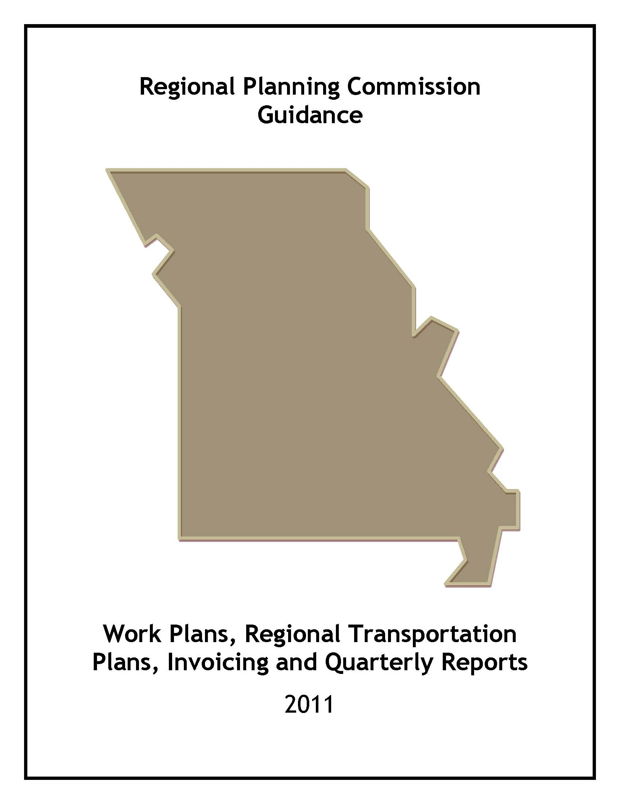
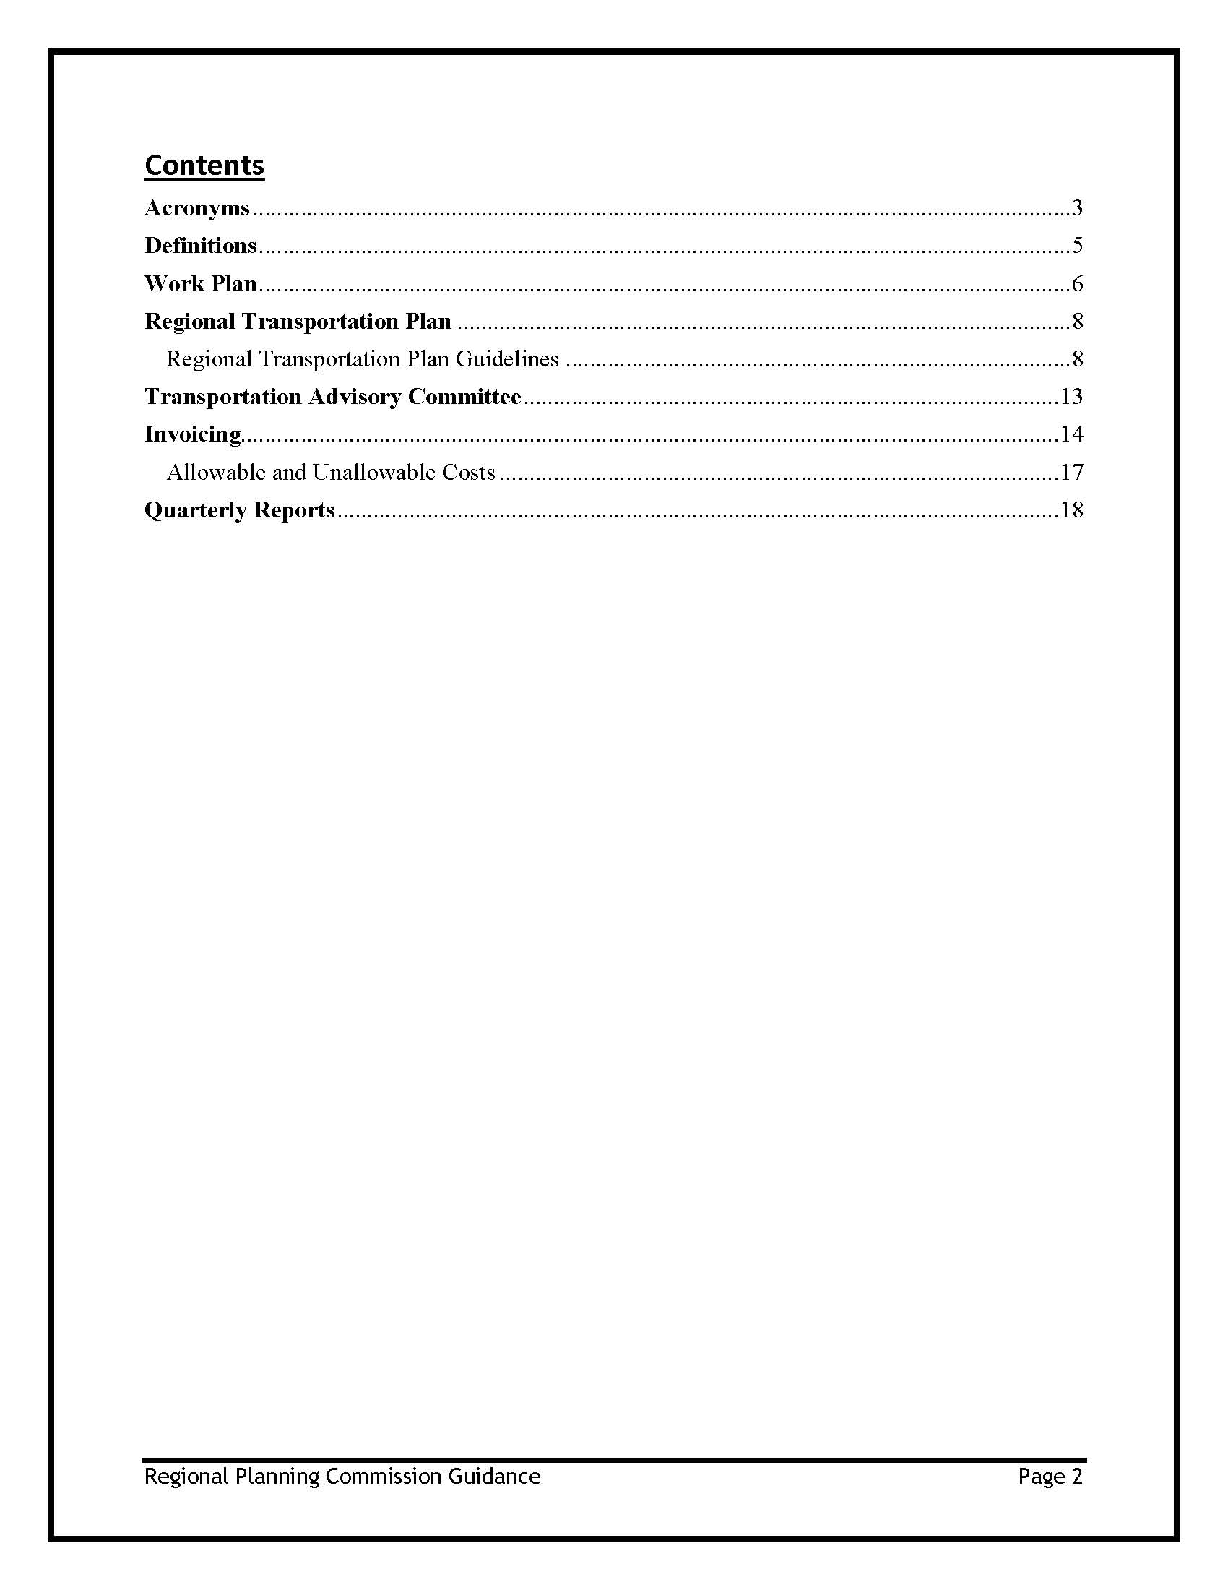

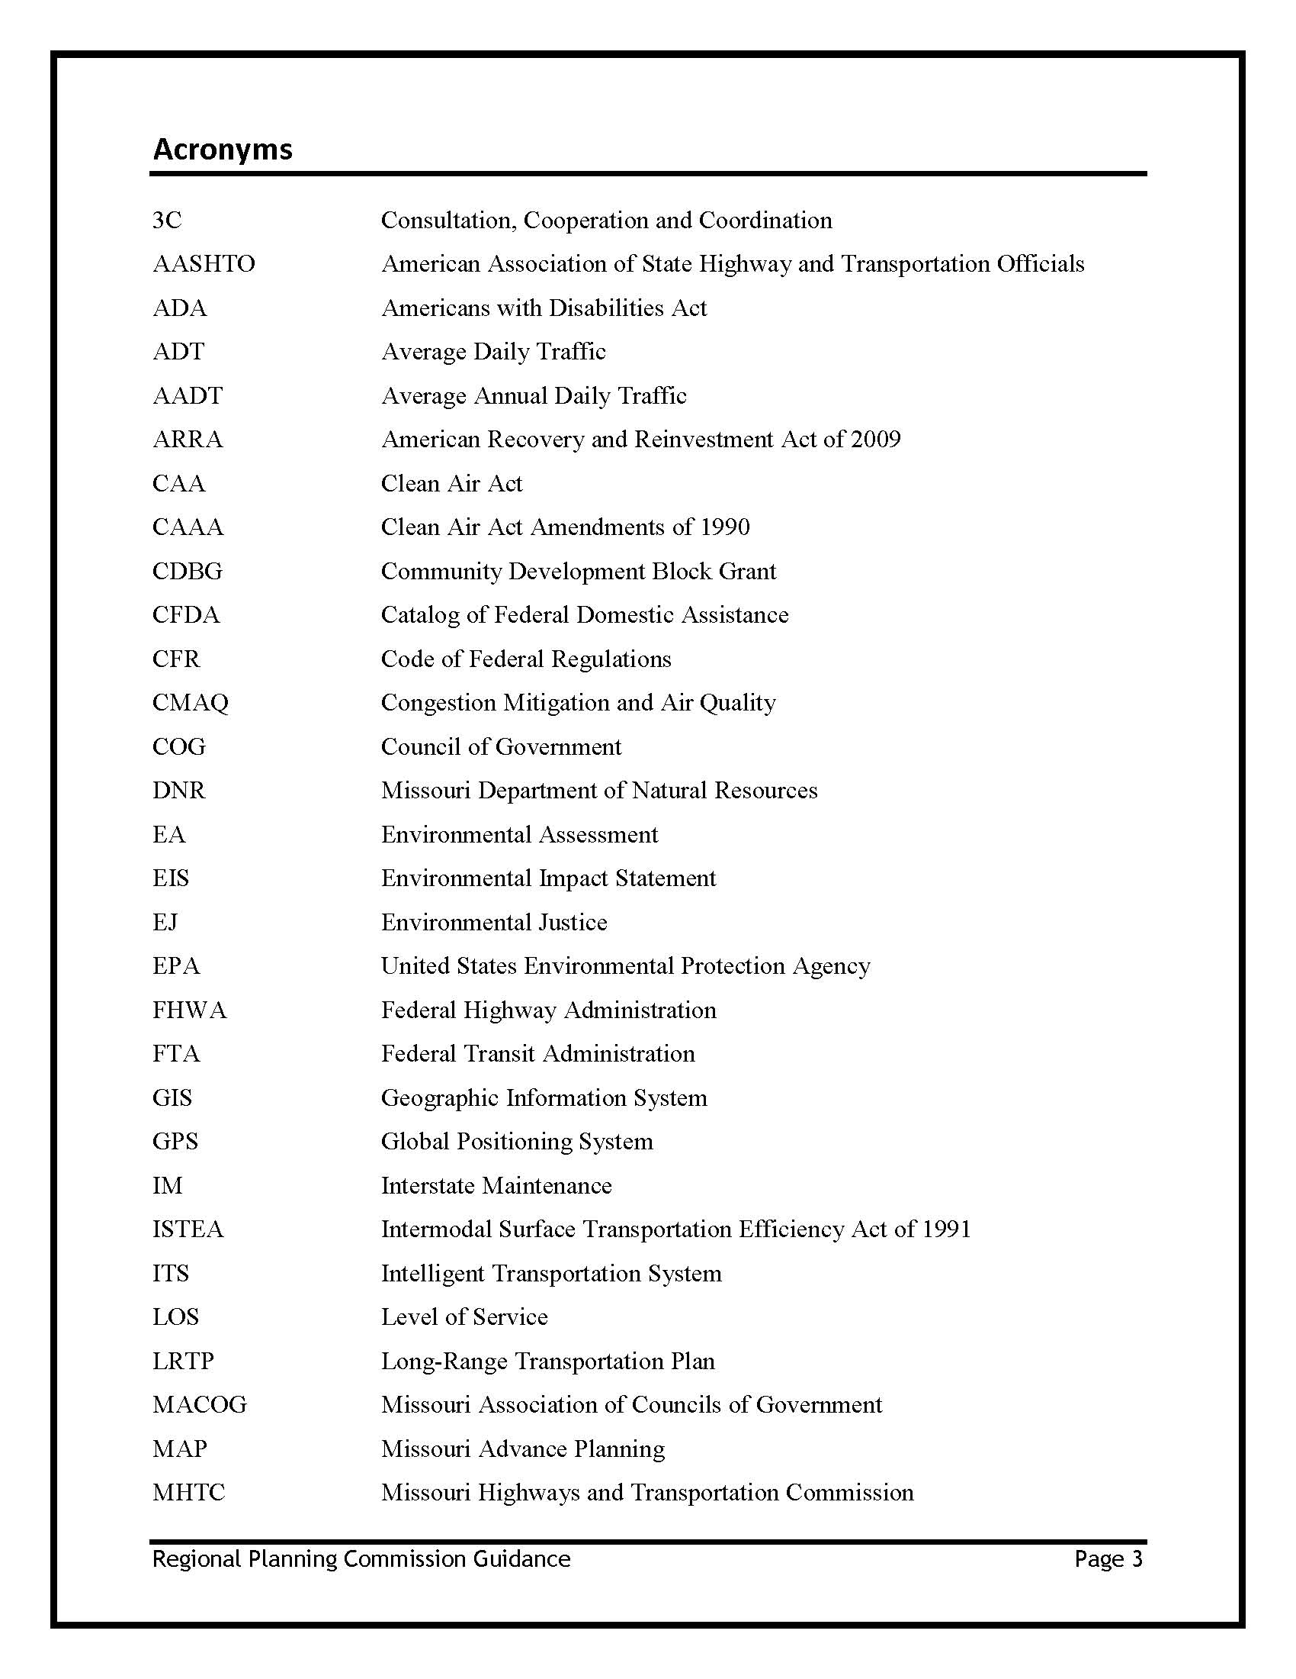

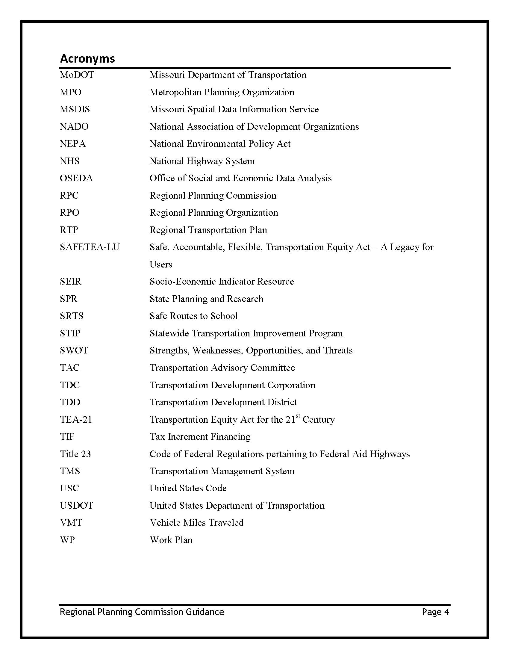

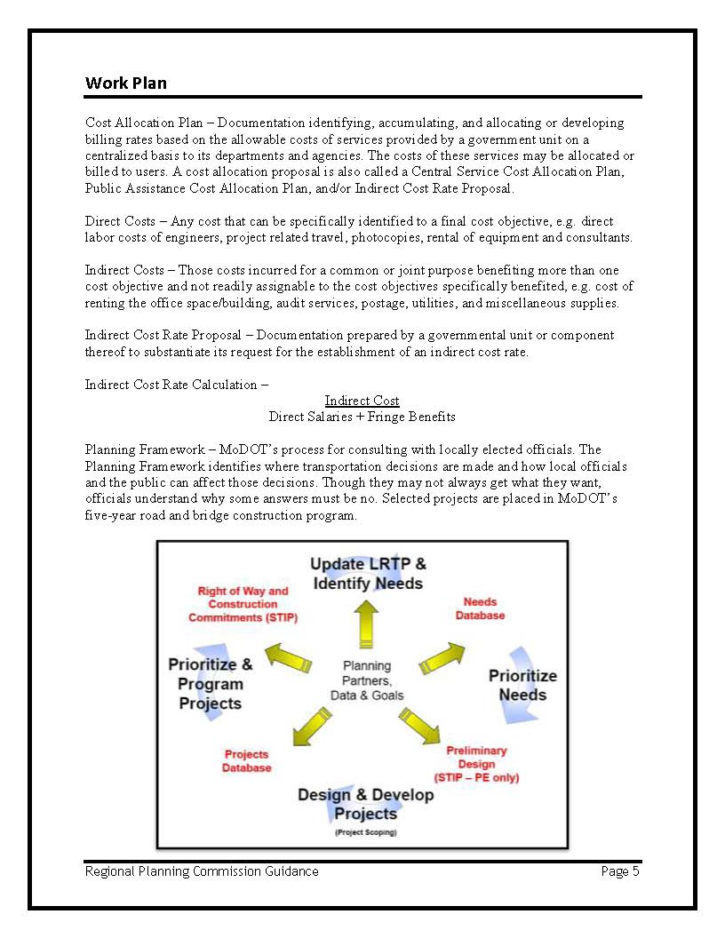

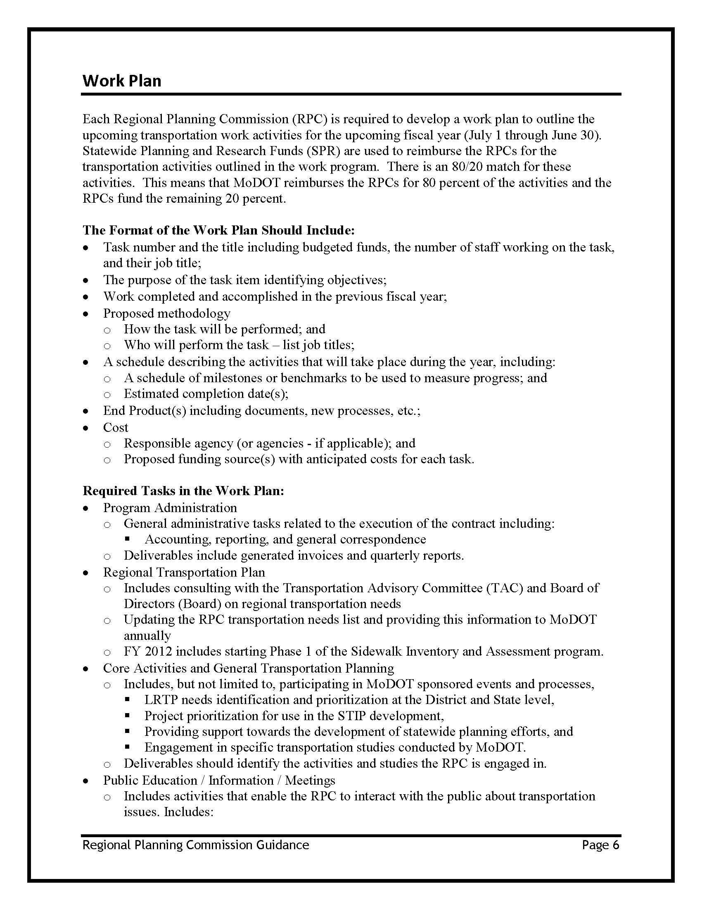
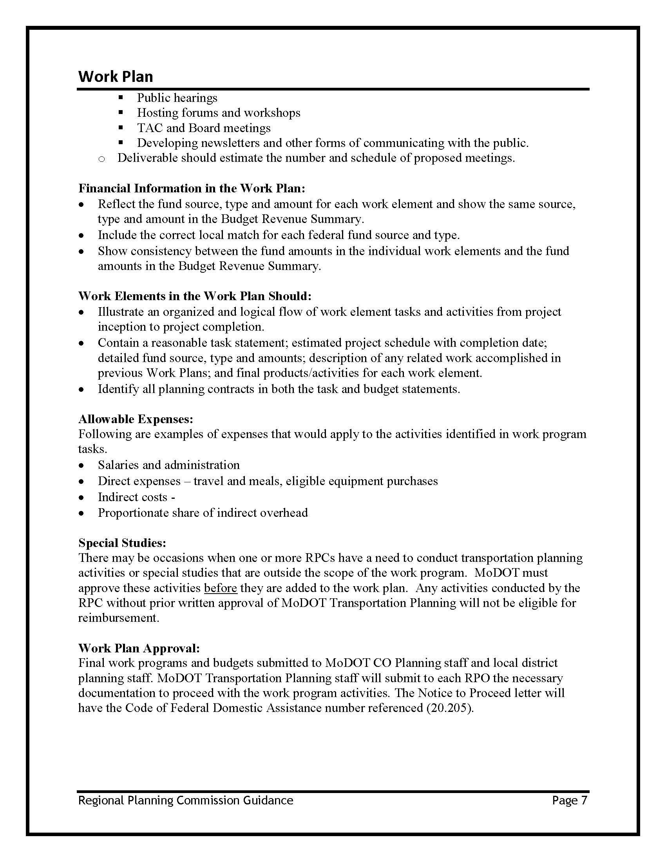
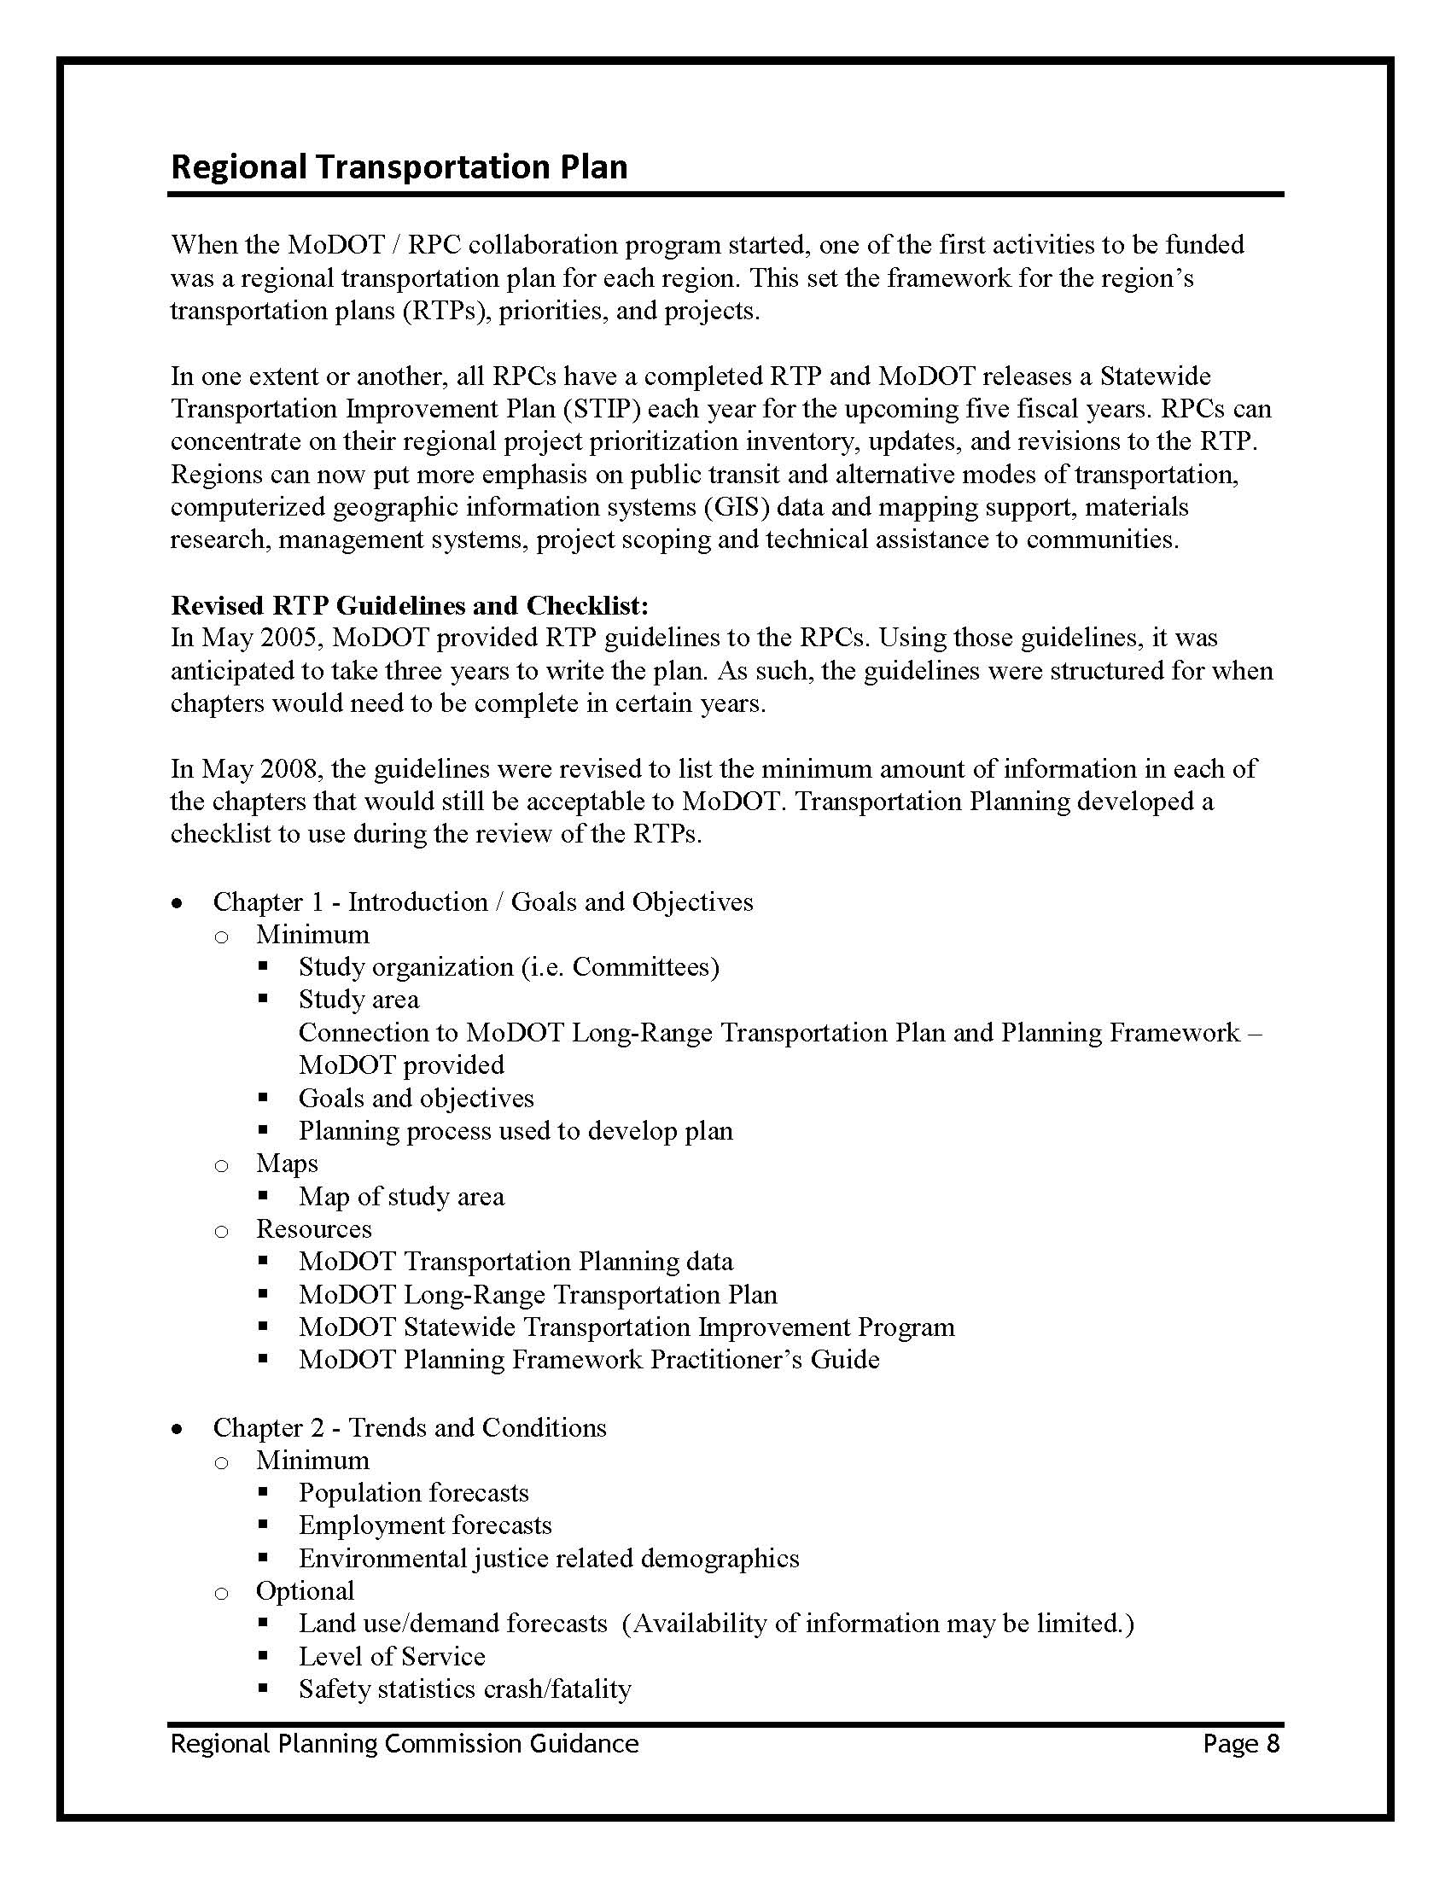
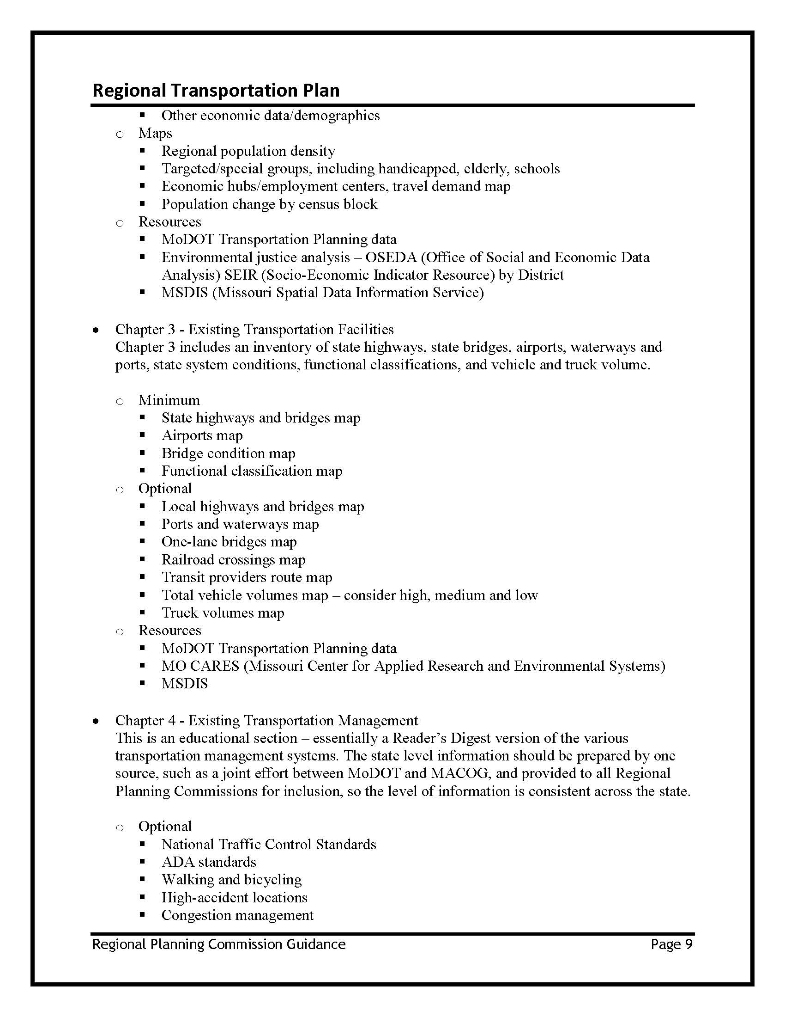
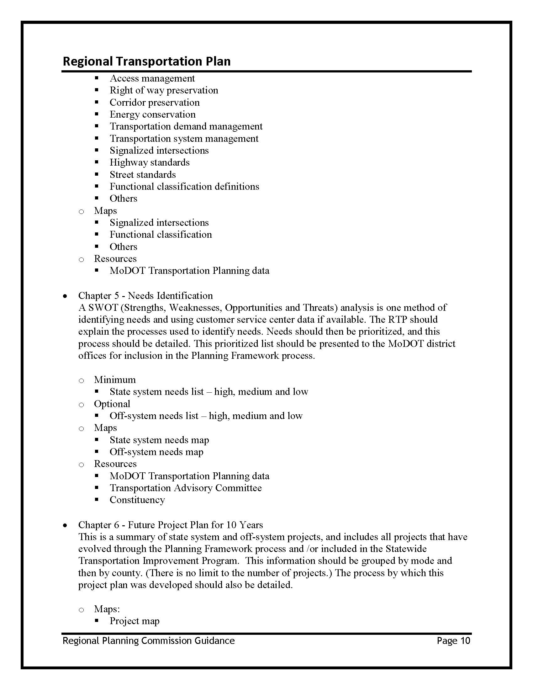
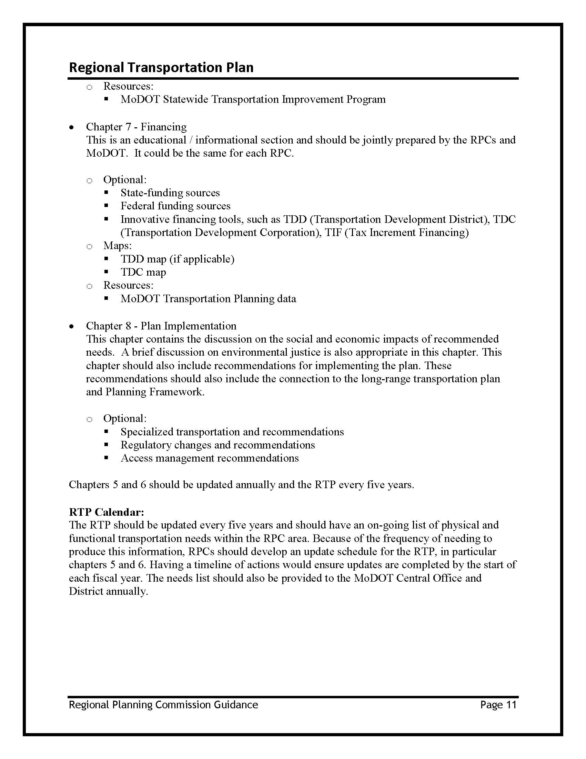
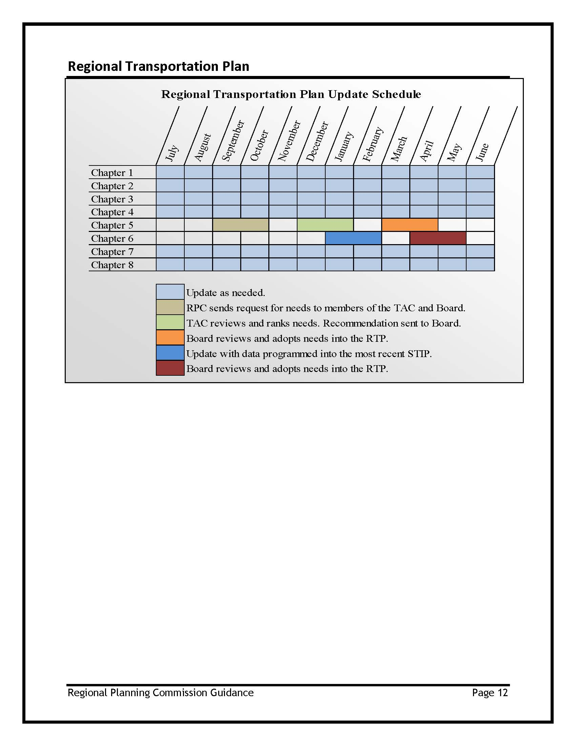
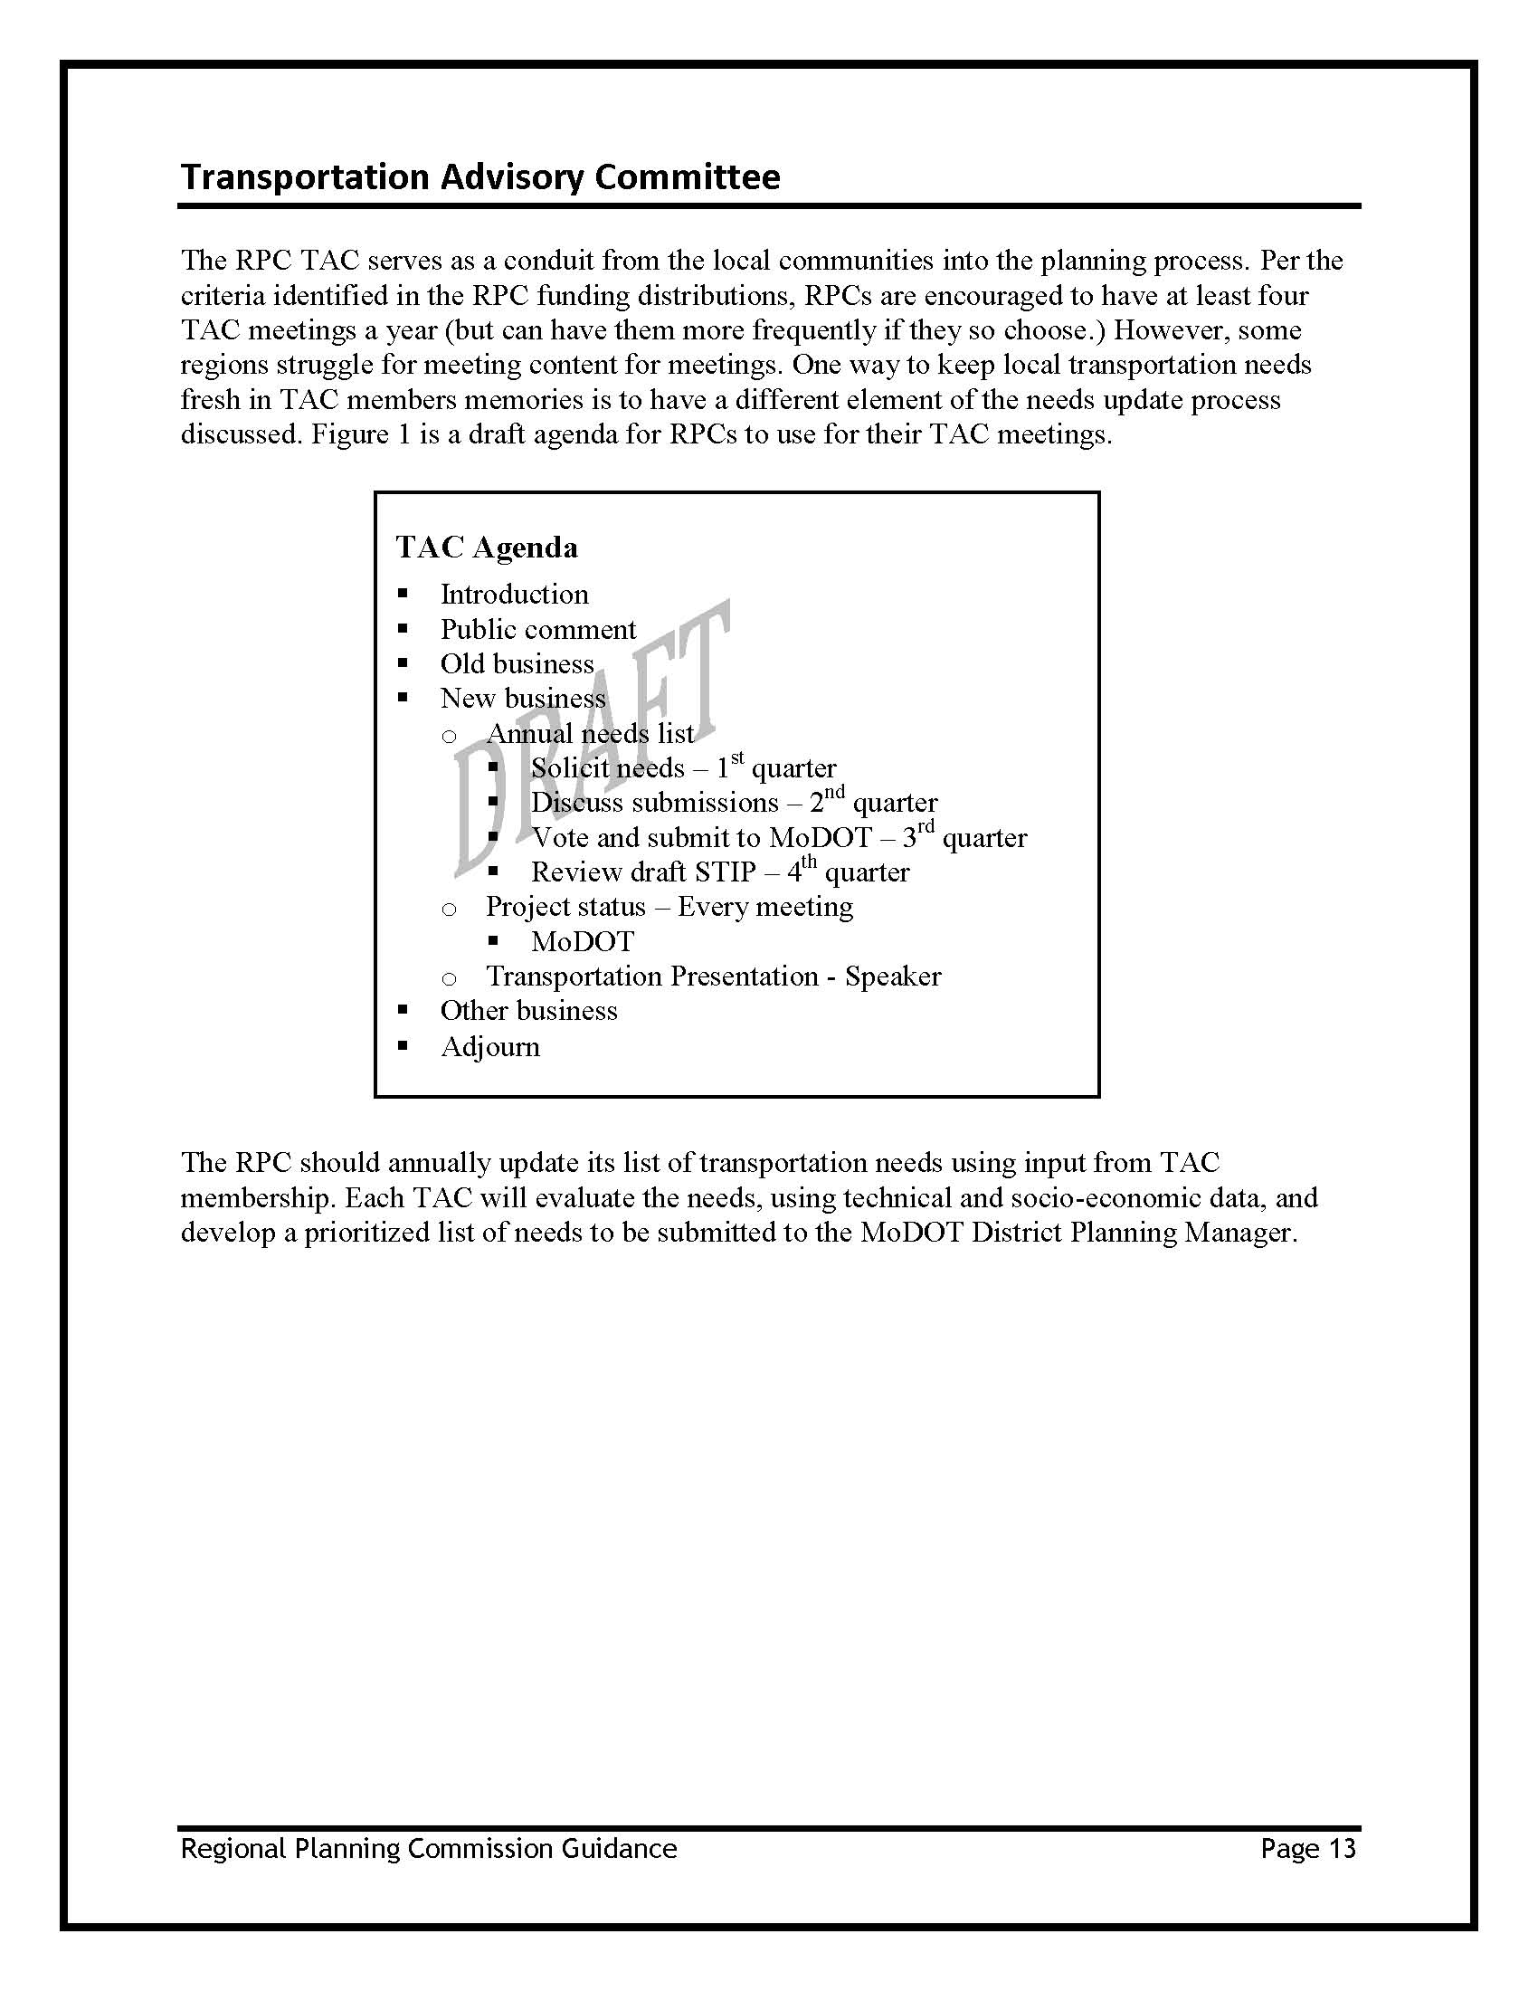
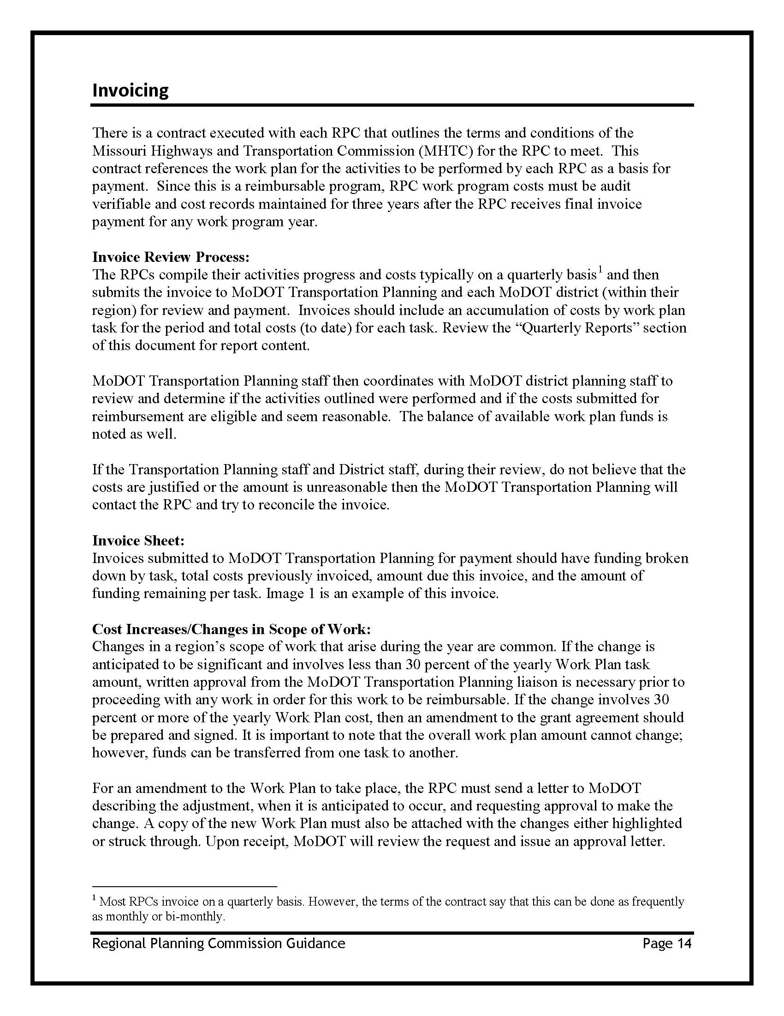
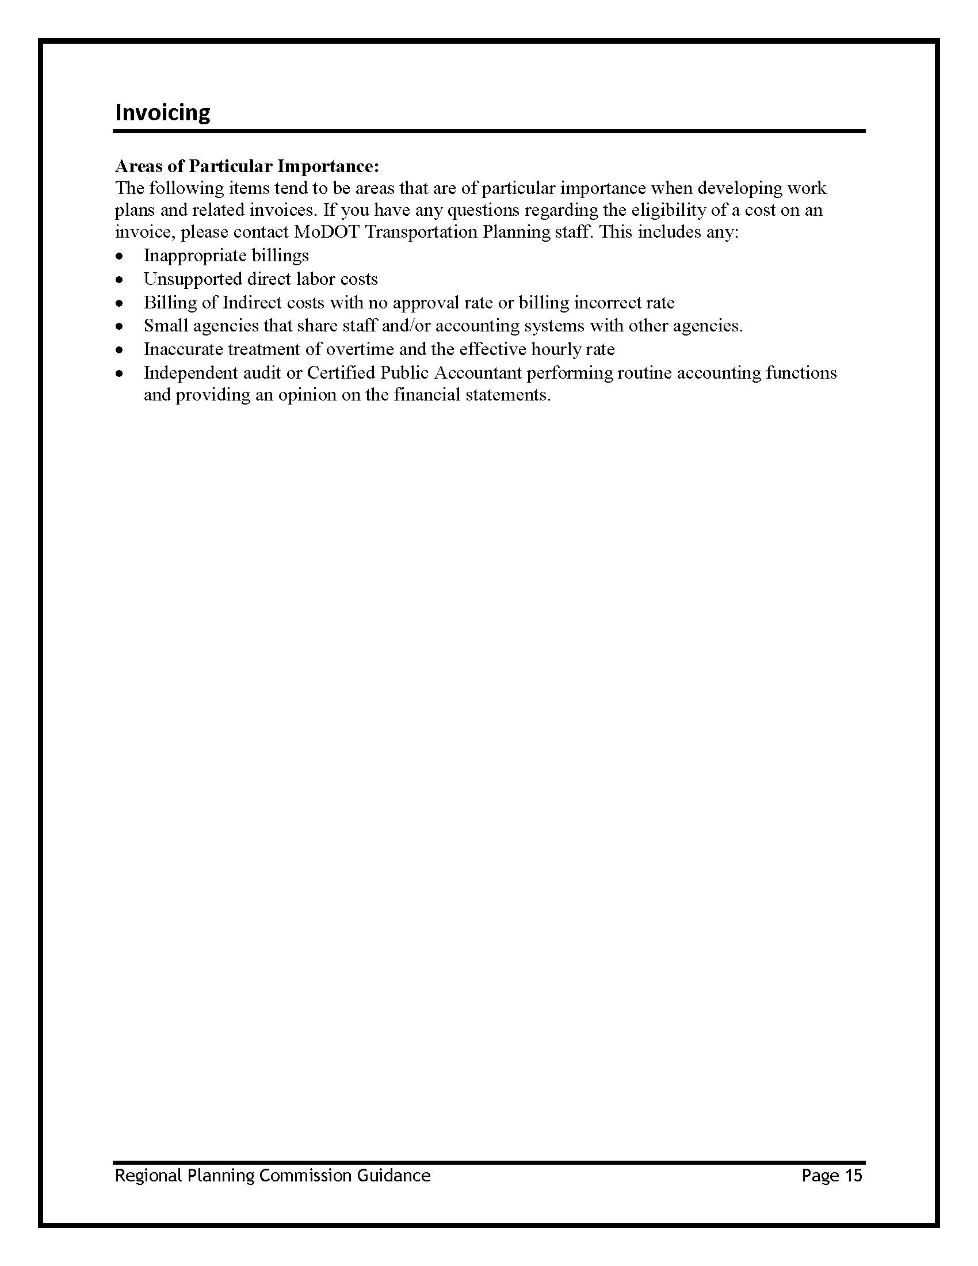

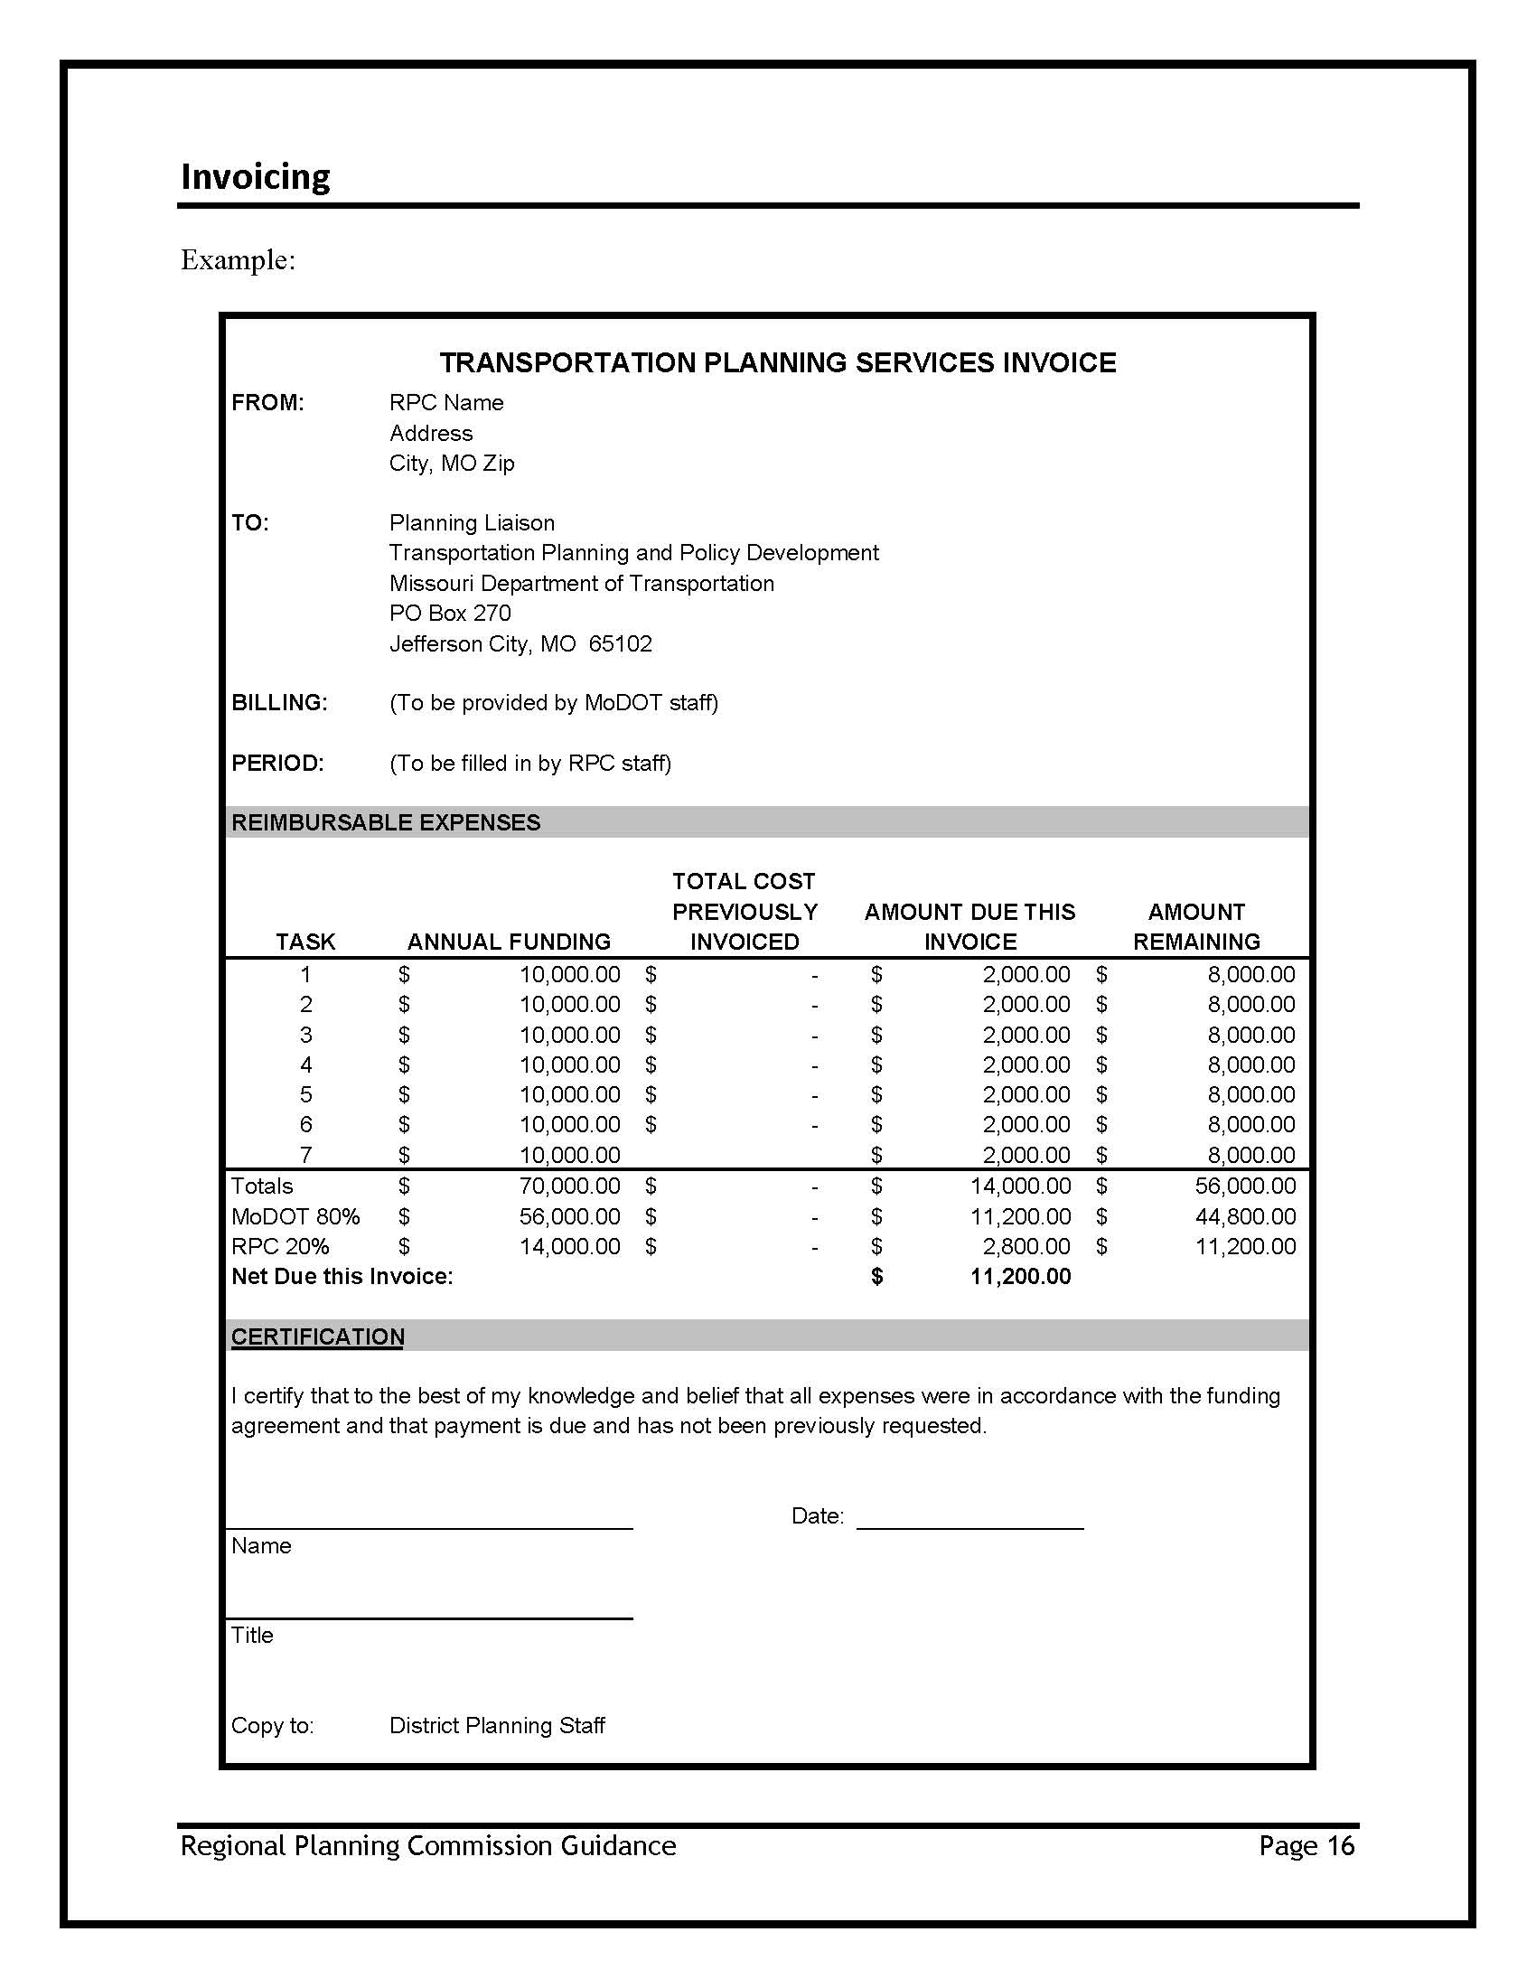

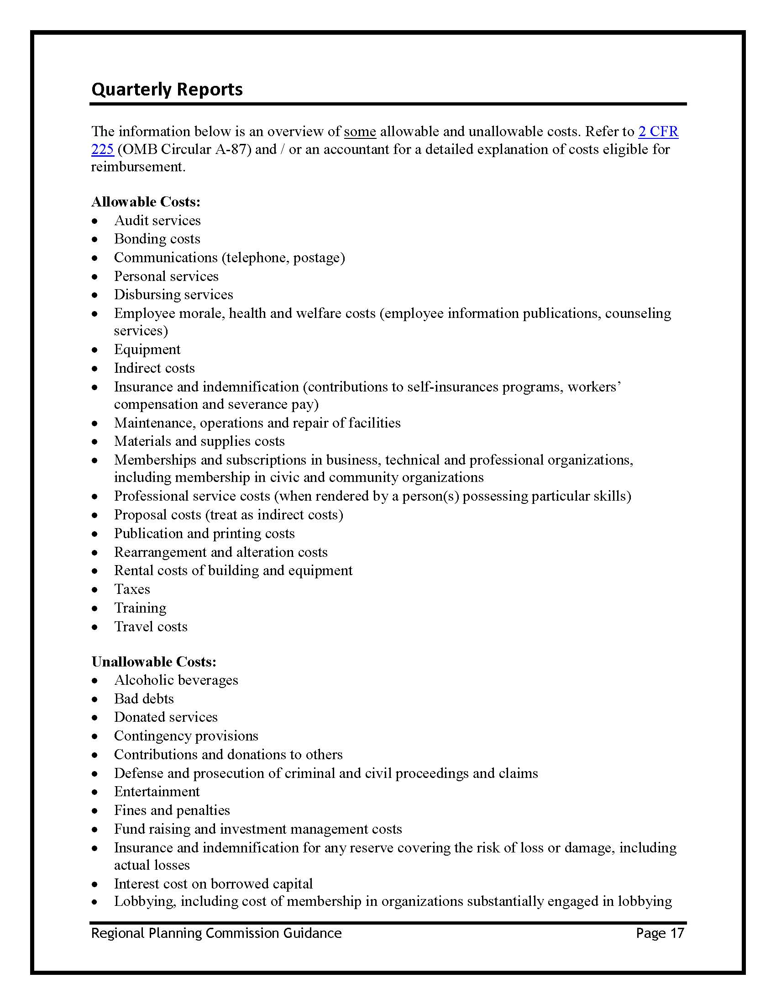

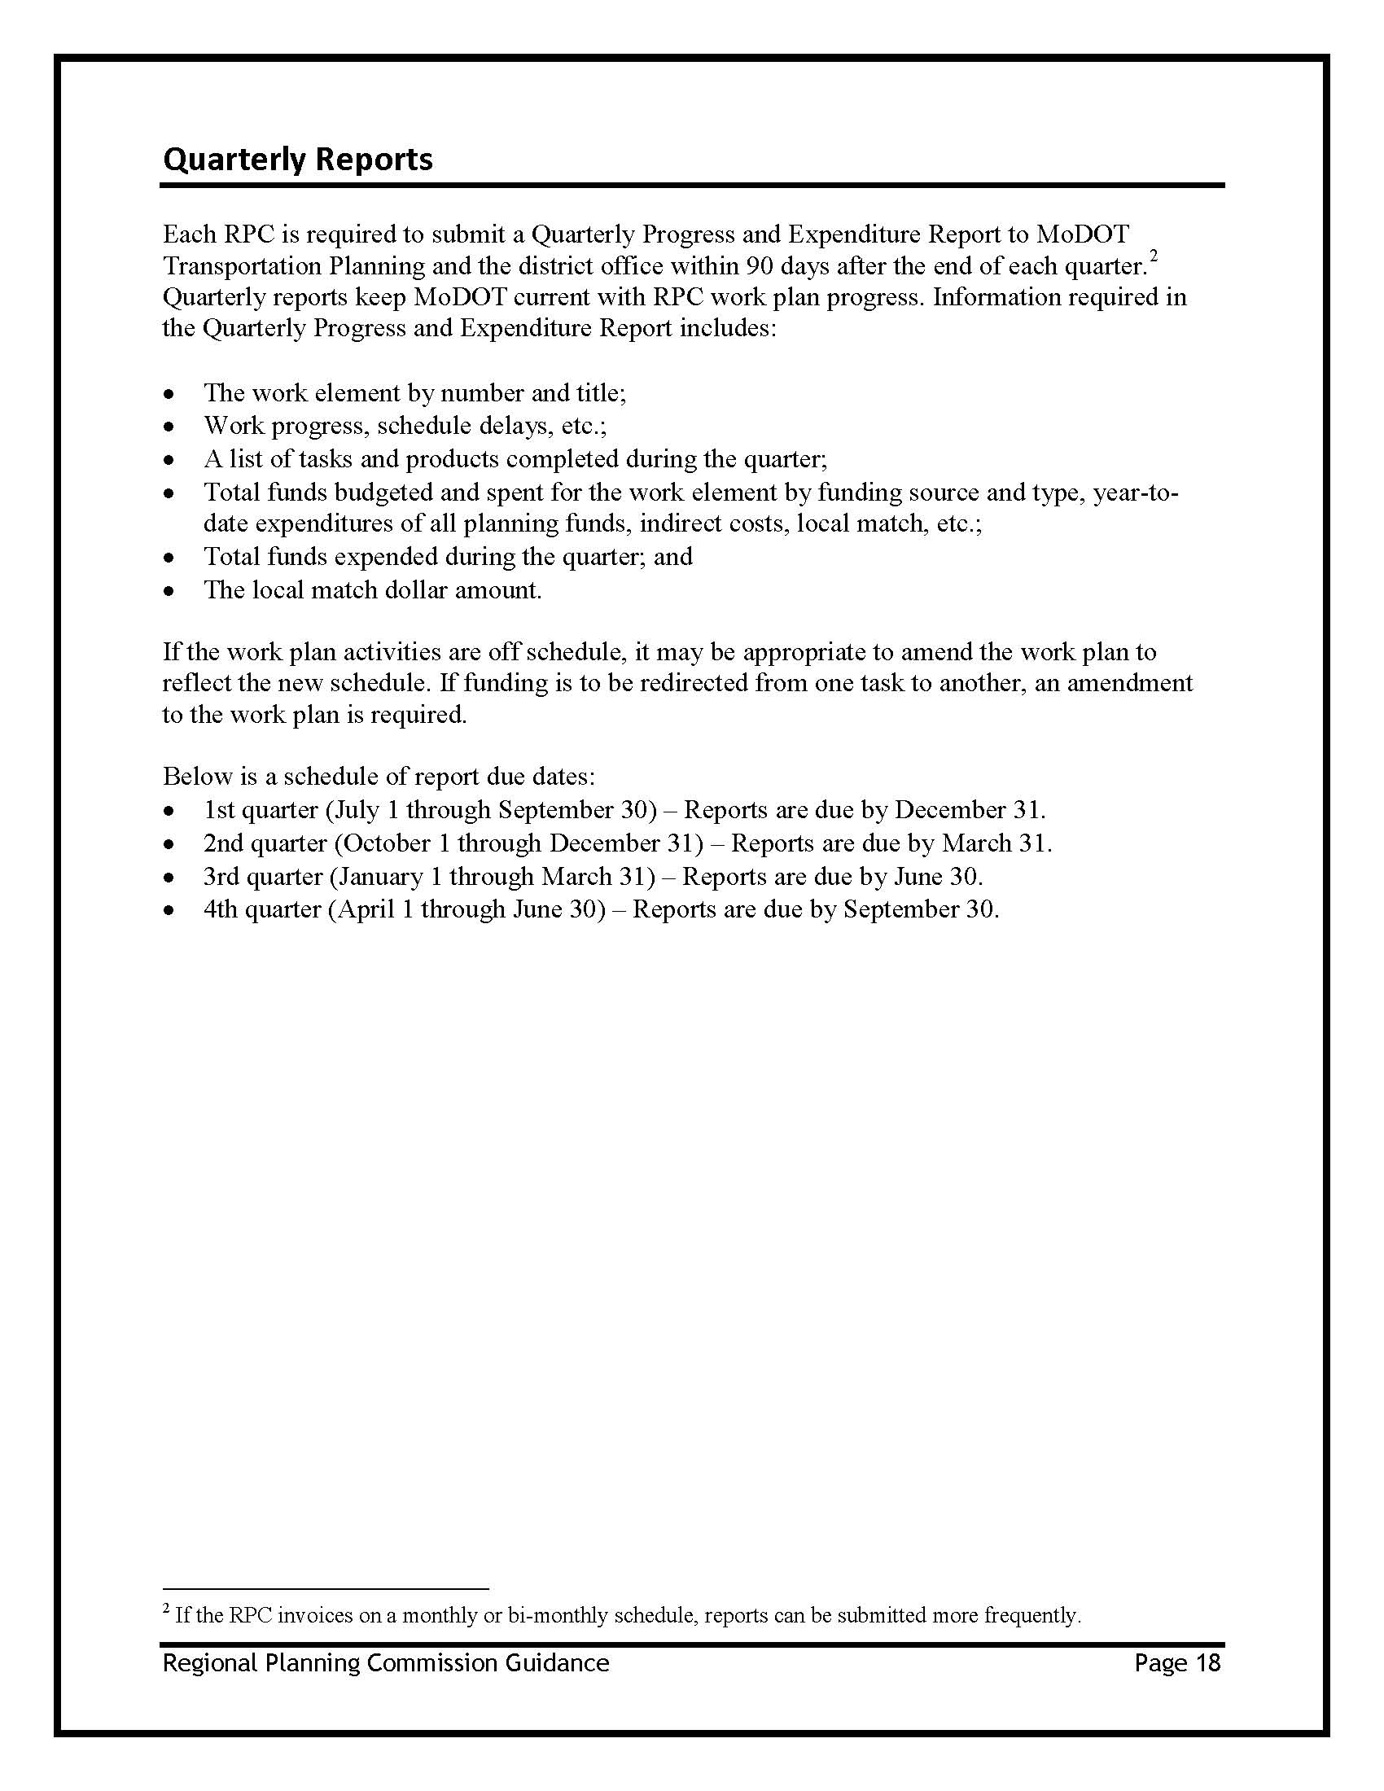

RTP Guidelines (Original)
Missouri Association of Councils of Governments

Regional Transportation
Plan
Guidelines

Prepared
in cooperation with the
Missouri Department of Transportation

Approved with modifications Aug. 5, 2004

Why a Regional Transportation Plan?

We—as residents of Missouri and as Regional Planning Commissions working on behalf of our local governments—now have a real and meaningful role to play in transportation planning. The development and implementation of MoDOT’s Transportation Planning Framework has made us a partner at the decision-making table. This has been an eye-opening experience as we recognize the vast transportation needs that Missouri has both locally and statewide and the limited amount of funds available for addressing them. We have come to realize the monumental and enormous challenges that the Missouri Department of Transportation faces, and we are now a partner in that process. As we work in partnership with the Missouri Department of Transportation, we have the opportunity to offer new and different information as well as the local perspective that can be brought to bear on transportation decisions. As local users of the systems, we are able to offer perspectives previously missing from the process.

With this opportunity comes responsibility. As a partner in the decision-making process, we must also be willing to share the responsibility of the decision-making and support the final outcome. We cannot make decisions in a vacuum. We must represent the views of our local elected official and their constituents, therefore it is imperative that the Regional Planning Commission and the Transportation Advisory Committees have a strong connection to one another. As planners, we must be able to identify—and bring to the forefront—the information that is necessary for local elected officials, transportation advisory members and staff to make sound, prudent and defendable recommendations.

Therein lies the need for the Regional Transportation Plan. The goal of any transportation plan is the efficient and safe movement of goods, services and people from one place to another. This needs to occur with minimal impact to communities and the environment. With such limited resources for addressing needs, we must strive to spend each and every dollar wisely—and to do that, we must use information and data—not just emotion—to make those recommendations and decision. That kind of information may vary from region to region, and this Regional Tranportation Plan guideline allows for and actually encourages that variation and flexibility. Even different people looking at the same data may draw different conclusions, all of which can benefit the decision process.

To date, Regional Planning Commissions across Missouri—through their partnership with MoDOT—have been focusing on the state highways system and prioritization of those needs and projects. That work will continue, but to better serve all transportation customers, this emphasis needs to expand to consider all modes of transportation and all systems, including those owned and maintained by counties and municipalities. It is important to consider how the different systems work together, now and in the future.

MoDOT, through this effort, is providing system management data and mapping information to each Regional Planning Commission. This does not mean that our efforts—those of MoDOT and RPCs—will be redundant. In fact, they must not be. The intent is for RPCs to analyze this information from a regional perspective, develop different scenarios using the data that may generate new information, consider issues that may have been overlooked in the past and consider local perspectives when deciding what information to analyze. It really is up to each RPC to decide what information is needed and what type of analysis is needed to allow them to make the best transportation recommendations for its region. Therefore, the RTP Guidelines set forth the minimum, but depending on your region, you may wish to expand the scope of work to reflect information deemed necessary to make sound, prudent and defendable recommendations.

It is the responsibility of each Regional Planning Commission to make its Regional Transportation Plan its own and to make it a dynamic and useful planning document. While MoDOT’s Transportation Planning Framework allows the public to see the process by which state transportation decisions are made, the RPC’s Regional Transportation Plan justifies and documents recommendations that go forward from the region to the state’s planning framework process. It also encourages county and city leaders to look at their individual transportation systems, how they interact with other systems and consider ways to improve these networks in order to provide an efficient and safe movement of goods and people and to do so in the most cost-effective means possible.

It is important that each RPC embraces the development of the Regional Transportation Plan as its own, and not simply a requirement of MoDOT. For these documents to be useful, each RPC must involve its local elected officials, decide what information is necessary to make sound, prudent and defendable recommendations, analyze that information and then document the process and resulting recommendations within the plan. It then becomes a useful planning tool and an important education resource that allows local transportation users to see the recommendations and to understand the process for transportation decision-making. While 100-percent consensus on these decisions is not a reasonable expectation, there should be an understanding of how—and why—the decisions were made.

As we begin this planning process, we recognize that these guidelines are evolving and are subject to modification by both the Missouri Association of Councils of Government and MoDOT. As the Planning Framework is implemented and the state’s Long Range Transportation Plan is developed, we may find it necessary to amend these guidelines to reflect changes within these documents. At the same time, if it is determined that some aspect of the guideline’s scope of work is extremely cumbersome or simply not doable or relevant, then MACOG—as a group—will revisit that portion of the guideline. Again, RPCs are encouraged to view these guidelines as a minimum and consider, from a local perspective, what information is needed for sound decision-making and expand this document to include that information so that your RPC can better serve the transportation users in your region.

Regional Transportation Plan
Guidelines
Assumptions:
The Regional Transportation Plan ideally will be developed in three phases over a three-year time period. Work on this effort will begin this year, FY 2004-2005, with a minimal effort because regional planning commissions have already begun their work programs with the Missouri Department of Transportation. Regional planning commissions will strive to accomplish as much of Year 1/Phase 1 efforts as possible during this planning year, given the resources—both time and money—available. At a minimum, all RPCS are expected to produce goals and objectives and the inventory discussed in Phase 1, Chapter 3, by June 30, 2005, the conclusion of the 2004-2005 fiscal year. This start-up work will feed into Year 1/Phase 1, which will start July 1, 2005, and conclude by June 30, 2006.
These guidelines have been modified since the Aug. 5, 2004 meeting with the Missouri Association of Councils of Governments. Some flexibility —and options—have been added to various phases so that regional planning commissions can determine what will best meet the needs of their particular regions. These guidelines are designed to allow interpretation, therefore, each step of the process is not detailed precisely. Each regional planning commission can best decide how expansive some sections should be in order for the RPC and its Transportation Advisory Committee to make informed transportation recommendations and decisions. Each RPC must consider what information is important to its board, TAC committee and staff in order to make those decisions. These guidelines allow such flexibility. Additionally, these guidelines can be changed as the RTP evolves. This is most definitely a learning process, and as we work through this first Regional Transportation Plan as partners with the Missouri Department of Transportation, we may find that changes are needed to improve the process. In fact, such changes are actually anticipated.
The following phases are suggested:
Year 1/Phase 1: RTP would include state highways, state bridges, airports, waterways and ports.
Year 2/Phase 2: RTP would be expanded to include and off-system bridges, county road and non-off system bridges, public transit, railroads as available and transportation information on cities with comprehensive plans with a transportation component
Year3/Phase 3: RTP would be expanded to include and bike and pedestrian facilities as available and could include information on cities without comprehensive plans, if the RPC chooses.
Essentially, there would be one planning document that would be expanded each year. Information on the above elements would be added to the plan, based on the above schedule. For example, in Year 1/Phase 1, the plan would include information on state highways, state and off-system bridges, airports, waterways and ports. Information would be developed for each chapter, based on these elements. Then in Year Two, information would be added to each chapter to include the elements to be identified in Year Two and then the same for Year 3.
MODOT will provide GIS on state systems to each RPC.
How Does the Regional Transportation Plans (RTP) and the Statewide
Long-Range Transportation Plan (LRTP) Work Together

The LRTP sets the transportation direction for Missouri. MoDOT collaborates with metropolitan planning organizations, regional planning commissions, local officials, the general public and other stakeholders to facilitate the LRTP development. The LRTP sets the vision for Missouri’s transportation system and defines transportation goals that can take Missouri toward that vision.
Because they are established with broad public support, the LRTP goals form the foundation of the RTPs. Normally, Regional Transportation Plans begin with the LRTP goals, but refine them to fit the unique nature of the region. This includes prioritizing goals and defining broad transportation strategies to help identify transportation needs that will help meet the highest priority goals. However, in this first round, the RTP will be developed before the LRTP plan.
Finally, the statewide-significant needs and priorities established in RTPs feed directly back into the statewide LRTP updates. The efforts are both iterative, with updates taking place approximately every five years. As these updates take place, the link between the plans grows stronger.

Regional Transportation Plan Outline

Start-Up Effort Due By June 30, 2005
Fiscal Year 2004-2005 (minimum): All RPCS are expected to produce:
• Goals and objectives and
• The inventory outlined in Phase 1, Chapter 3.
Given RPCs’ experience with planning, it expected that the goals and objectives may somewhat already be defined and may only need to be perfected for this effort. The following resources may be helpful: Transportation goals identified in the RPC’s Comprehensive Economic Development Strategy; transportation goals identified by cities within your region through comprehensive plans; and TAC priority setting activities involving transportation investment strategies. It will also be helpful to review other transportation plans to consider the broad scope of goals and objectives and to help ensure that all issues for your particular area are addressed. The local Transportation Advisory Committee should be involved in the development of an RPC’s goals and objectives and should officially adopt them, in partnership with the RPC, for this planning effort.
The inventory information for state highways, state and off-system bridges, airports, waterways and ports is included in the GIS information, as map attribute data, already provided by MODOT. Maps of this inventory information for this start-up effort are not required for the June 30 work program and can be accomplished in Year 1/Phase 1, detailed later.
Year 1/Phase 1: 2005-2006
RTP would include state highways, state and off-system bridges, airports, waterways and ports discussed in the following chapters:
Chapter 1—Introduction/Goals and Objectives (from FY 2004-2005):
Chapter 1 will discuss/explain the following:
• Study organization (i.e. RPC and TAC)
• Study area
• Connection to the Planning Framework (Yet to be defined)
• Connection to MoDOT LRTP (Yet to be defined)
• Planning Process used to develop plan
• Goals and Objectives
MAPS: Map of Study Area
Resources: MODOT GIS
Information on connection to planning framework and MODOT LRTP can be prepared and provided to all. MODOT and MACOG will develop this information jointly, and there will be the opportunity to add information specific to the RPC planning effort.

Chapter 2—Population and Employment
Chapter 2 will include
• Population forecasts
• Employment forecasts
• Land use/demand forecasts (Availability of information may be limited.)
• Other economic data/demographics that may be relevant
• Identify/include environmental justice related demographics

MAPS: (1) Regional Population Density (MSDIS)
(2) Targeted/Special groups, including handicapped, elderly, schools
—(MSDIS STF 1A for Elderly)
(3) Economic hubs/employment centers, travel demand map (1990-2000
Population Changer by Census Block)

Optional: Population Change Map (

Resources: Environmental Justice Analysis—OSEDA/MODOT SIER by Districts
Chapter 3—Existing Transportation Facilities:
Chapter 3 will include an inventory of state highways, state bridges, airports, waterways and ports, state system conditions, functional classifications and vehicle and truck volume. (Inventory should have been completed as a part of FY 2004-2005)

MAPS: Phase I:
Information that needs to be included in a visual format:
State highways and bridges (MODOT)
Airport/waterways/ports map for region
Total vehicle volumes (MODOT)—Consider high, medium and low.
Truck volumes (MODOT
Bridge Conditions Map
One-lane Bridges
Resources: MoDOT
MO CARES, MSDIS

Chapter 4—Existing Transportation Management:
It was decided that this section would be an educational section—essentially a Reader’s Digest version—of the various transportation management systems. Information on national traffic control standards as used by Missouri could be included. The state level information could be prepared by one source—perhaps a joint effort between MODOT and MACOG— and provided to all RPCs for inclusion. Therefore the level of information would be consistent across the state.

This chapter could include discussions on congestion/congestion management, access management, right-of-way and corridor preservation, energy conservation, transportation demand management, transportation system management (TMS), highway standards, street standards and signalized intersections.
MAPS:
Optional: Signalized intersections
Resources:

Chapter 5—Needs Identification:
This would be a needs identification. A SWOT is one method of doing that. This could be a way to use customer service center data if available. The RTP needs to explain the processes used to identify needs. Needs would then need to be prioritized and this process would also need to be detailed. It expected that most RPCs already have a prioritized list of needs and those would be dropped into this section, updated and prioritized as needed. This prioritized list would be presented to the MODOT district offices for inclusion in the Planning Framework process.
Phase/Year 1: State system and off-system only.
MAPS: Needs identified on a map
Resources:
Chapter 6—Future Project Plan for 10 Years:
This is a summary of state system and off-system projects, and would include all projects that have evolved through the Planning Framework process and /or included on the STIP. This would be grouped by mode and then by county. (There would be no limit to the number of projects.) The process by which this project plan was developed should also be detailed.
MAPS: Project Map
Resources:
Chapter 7—RTP for 10 years:
This would include a ranking/recommendation of projects, by the TAC/RPC, with cost estimates, as available. This would focus on the high priority projects that are achievable in 10 years. This information would then flow to the appropriate district for ranking and consideration for the STIP.
MAPS: Top ranking projects by County
Resources:
Chapter 8—Financing:
This is an educational information section and would be jointly prepared by MACOG and MODOT, and essentially for Year 1/Phase 1 would be the same for every RPC. This could include state and federal funding resources, cost estimates, maintenance and operating costs, total revenue and how allocated, and financing tools available.
Phase 1 would discuss funding sources and financing tools at the state and federal.
MAPS: Transportation Development Districts Map (if applicable)
Resources:
Chapter 9—Plan Implementation:
This chapter could contain the discussion on the social and economic impacts of the
recommended needs and projects. A very brief discussion on environmental justice would also fit in this chapter. Other issues that could be discussed include:
• Specialized transportation and recommendations
• Regulatory changes & recommendations
• Access Management recommendations

This chapter could also include recommendations for implementing the plan. This section will be expanded with each phase of the plan. One of those strategies could be updating/reviewing the plan every five years. These recommendations should also include the connection to the LRTP and Planning Framework.
MAPS: none
Resources:
Year 2/Phase 2: 2006-2007
RTP would be expanded to include county roads and bridges, available city transportation information (for example, street names, functional classifications, volume as available), railroad information as available, public transportation/transit.

Chapter 1 and Chapter 2 could be updated as needed, given the release of new information or changes in existing information.

Chapter 3—Existing Transportation Facilities:
Chapter 3 will include an inventory of off-system bridges , county roads and bridges,
available city transportation information (for example, street names, functional
classifications, volume as available), railroad information as available, and public
transportation/transit.

MAPS: Phase II: Information that needs to be included in a visual format
Offsystem Bridge Map
County roads & bridges
Public/Mass transit service area map
City transportation maps, as available
Railroad map for region, as available

Resources: MoDOT
MO CARES, MSDIS
Mass transit: U.S. Dept. of Transportation—usdot.dot.gov

Chapter 4—Existing Transportation Management:
This section is an educational section—essentially a Reader’s Digest version—of the various transportation management systems. State level information was provided in Phase 1.

In Phase 2, RPCS will need to incorporate city and county information as available.

This chapter could include discussions on management systems used at the local level that may be different than state systems. This may include congestion/congestion management, access management, right-of-way and corridor preservation, energy conservation, transportation demand management, transportation system management (TMS), highway standards, street standards and signalized intersections. In some cases, the local information may be very limited. If so, the RPC may want to consider the impact of no standards and decide whether it should recommend that cities and counties adopt and/or document certain standards in the plan implementation chapter.

MAPS:

Resources:

Chapter 5—Needs Identification:
In Phase 2/ Year 2, this would be a needs identification of city and county needs as they relate/connect to state system. Only those of a significant nature would be forwarded to the districts for inclusion in the Planning Framework process. The plan needs to explain processes used to identify needs.

OPTION: This chapter can be as basic as stated above or as expansive to include all local transportation needs. Some RPCS may want to identify all local needs for future funding consideration. It may be beneficial to know what local needs its cities and counties may have so that it can assist in finding other forms of funding to help address those needs. These needs would not be prioritized and would not be included in the Planning Framework process. This would simply be for the benefit of the RPC and its local transportation needs assessment effort.

MAPS: Needs identified on a map

Resources:

Chapter 6—Future Project Plan:
Again, in this phase, this chapter can be as basic as only those city/county projects that relate or connect to the state system, or it can be as expansive as all city and county needs as identified through the budget process or capital expenditure planning. The RPC could opt to expand this section to include city/ county projects, as identified by local governments in their own planning process. (This information would be collected directly from cities and counties, and could be updated annually.) This would be grouped by mode and then by county. This local projects information would not be included in the RTP recommendations, but simply would be listed and documented for planning purposes.

MAPS: Projects Map

Resources:

Chapter 7—Financing:
Again, this is an educational information section and, in Phase 2, would be expanded to include local transportation financing and funding information. For example, what cities or counties have passed transportation sales taxes, for how long and at what amount? Are there local funded transportation development districts? Are there local foundations that have funded transportation projects in the past?

MAPS:

CHARTS: Transportation Sales Tax, if applicable

Resources:

Chapter 9—Plan Implementation:
This chapter would be expanded to include local recommendations, such as updating/reviewing the plan every five years and perhaps updating certain sections—needs and projects—every year. The RPC could also consider whether recommendation on local transportation management tools (street standards, right-of-way standards, etc.) are needed.

MAPS: none

Resources:

Year 3/Phase 3: 2007-2008

The RTP would be expanded to include an inventory of bike and pedestrian facilities, as separate facilities. As an option, the RPC may choose to gather/create additional city transportation information not available in Phase 2 that may be relevant to its RTP process.

Chapter 1 and Chapter 2 could be updated as needed, given the release of new information or changes in existing information.

Chapter 3—Existing Transportation Facilities:
Chapter 3 will be expanded to include an inventory of bike and pedestrian facilities, viewed as separate facilities. (For example, if a community has a bike path through its park, that would be included in this inventory because it is a separate facility. However, if bicyclists use the shoulder of Route BB as a bike path, but it is not designated as such, it would not be included in this inventory. )

As an OPTION and as time and financial resources allow, RPCs may gather and/or create date for city transportation systems not available in Year 2/Phase 2.

MAPS:
Phase III: Information that needs to be included in a visual format:
Bike/pedestrian facilities map for region, as available

OPTIONAL: City street/bridge maps, if the RPC chooses to expand this section to
include new information on city transportation systems.

Resources:

Chapter 4—Existing Transportation Management:
This section will be reviewed and revised as needed. Any information on design standards for bike and pedestrian trails would be included. If the RPC chooses to expand its city transportation information, then any new information on city street standards would be incorporated, if not addressed in Phase 2.

Chapter 5—Needs Identification:
In Phase 3/Year 3, the needs identification would be expanded to incorporate any access issues and needs—such as bike and pedestrian needs and sidewalk needs—as they relate/connect to the state system.

OPTION: Any local access issues, including bike/ped/sidewalk needs, could be included as well. Again this would be a recognized list of local needs; such information may be helpful to the RPC as it looks for alternative funding for such needs.

MAPS: Needs identified on a map

Resources:

Chapter 6—Future Project Plan:
In Phase 3/Year 3, this chapter would be undated to include any other local projects that relate or connect to the state system and have been through the Planning Framework process.

MAPS: Projects Map

Resources:
Chapter 7—Financing:
In Phase 3, RPCs should review this chapter and make sure all state, federal and local funding/financing resources and tools are have been included and are complete, and that the information is adequately discussed.
Resources:
Chapter 8—RTP for 10 years:
This would include a ranking/recommendation of projects with cost estimates, as
available. This would focus on the high priority projects that are achievable in 10 years.
This information would then flow to the appropriate district for ranking and consideration for the STIP.

In Phase 3, the RPC needs to review the information created in Phase 1 and make any changes in the plan, given new and/or additional information.

MAPS: Top ranking projects by County (revised with any needed changes.)

Resources:
Chapter 9—Plan Implementation:
In Phase 3, this chapter should be reviewed to include any new or additional information that may have been missed in previous phases. The RPC should consider all recommendations—beyond specific projects— that should included in this section, including but not limited too:
• Specialized transportation and recommendations
• Regulatory changes & recommendations
• Access Management recommendations

This chapter should also include recommendations for implementing the plan. One of those strategies could be updating/reviewing the plan every five years. The plan should also discuss whether local needs will be identified and prioritized annually, in order to feed the Planning Framework process. Those RPCs that opted to create local needs lists may need to update those annually as local governments adopt their budgets and capital expenditure plans. The RPC should look for opportunities to tie the RTP and its recommendations to the LRTP and Planning Framework.
This chapter should also outline the TAC/RPC process for adopting the plan.
MAPS: none
Resources:

Exhibit 1:

Mapping Requirements
and
Standards

    - Work Plan Copy
Northwest Missouri
Regional Council of Governments

2012 Transportation Work Plan

Contact Information

Tye Parsons, Executive Director Dana J. Ternus, Regional Planner
tye@nwmorcog.org dana@nwmorcog.org

114 West Third Street
Maryville, Missouri 64468
Phone: 660-582-5121
Fax: 660-582-7264

Task 1: Administration
Purpose: | Track and report all activities that relate to the transportation work plan. Contracts will be entered at the beginning of July 2011 and any budget adjustments will be made the remainder of the year. This task is not only for the purpose of requesting reimbursement of funds from MoDOT, but it is also the basis of providing the audit detail to justify continued funding.
Work Completed in Fiscal Year 2011: | - Quarterly reports compiled and submitted to MoDOT  - Completed the FY2012 Transportation Work Plan
Goals for Fiscal Year 2012: | - Complete paperwork to enter into agreement with MoDOT at the beginning of the fiscal year.  - All quarterly reports, financial statements, and invoices will be submitted to MoDOT in a timely manner and adequately prepared with enough detail to explain all activities completed.  - Prepare and submit 2013 Work Plan
Methodology: | The Fiscal Officer will track and report all transportation-associated costs, examine and evaluate month-end reports, review monthly and year-to-date revenue and expense reports, revise budgets as appropriate, and participate in preparation of the FY 2013 Work Plan.  The Transportation Planner will review monthly and year-to-date revenue and expense reports. They will submit quarterly reports in a narrative format no later than one month after the designated end of the quarter. Included with the quarterly narratives will be a quarterly financial statement, invoice, and minutes from quarterly TAC meetings. An annual report detailing all work plan activities and year-end financial information will be submitted to MoDOT within 30 days of the end of FY2012. The planner will also participate in the establishment of the FY 2013 Work Plan.  Executive Director will review all reports prior to submission and participate in preparation of the FY 2013 Work Plan.
Schedule of Activities and Deliverables: | Monthly activities: Track and report all transportation-associated costs.  Quarterly reports: QSR submission deadlines:  October 31, 2011  January 31, 2012  April 30, 2012  July 31, 2012  Annual report: Annual report submission deadline July 31, 2012.  FY2012 Work Plan: April 2012
Staff on task: | Denise Workman – Fiscal Officer  Dana Ternus – Regional Planner  Tye Parsons – Executive Director  Total Hours: 167
FY2012 Budget Amount | $5,065.70 (80% MoDOT; 20% NWMORCOG)  **Please see the following page for task-specific cost analysis.

Task 2: Regional Transportation Plan
Purpose: | This task will continue developing the Northwest Missouri Regional Transportation Plan (RTP). The Regional Council’s overall vision and goals for transportation will be included and every effort will be made to include elements that are consistent with MoDOT’s Planning Framework Process.
Work Completed in Fiscal Year 2011: | - Prioritization of local transportation needs  - Stage two completion of Google Earth project with FY2011 prioritized regional needs  - Second stage sidewalk assessments  - RTP update
Goals for Fiscal Year 2012: | Maintain and update the Northwest Missouri RTP in conjunction with MoDOT. Additions to the RTP will include the Safe and Sound program, Safe Routes to School, and others.  The Regional Council will continue to maintain a centralized needs list and virtual tour of MoDOT District One in conjunction with Green Hills Regional Planning Commission and Mo-Kan Regional Council using Google Earth. The local priorities website will be updated with the current year’s prioritized needs lists and virtual tours from each TAC to maintain a centralized District One list for MoDOT and public access.  Building off of the FY2011 initial sidewalk assessment, a tertiary sidewalk assessment will be completed for those municipalities within the service area that currently have existing sidewalks to determine condition and accessibility. Updates to towns completed in FY 2011 will be completed using standardized criteria and new assessments will be completed for towns over 500 in population. Results of the sidewalk assessment will be incorporated into the RTP for facilitation of multi-modal projects in the region as funding is available.
Methodology: | The Transportation Planner will continue to maintain and update the RTP. This task will require the Planner and GIS Technician to update the nine chapters of the plan and add information relating to regional needs and project ranking. Google Earth will be used to provide a visual medium for MoDOT and the general public.  Other updates may include specialized transportation, regulatory changes, funding information, and others. The tertiary sidewalk assessment will be completed by the Planner and GIS Technician.
Schedule of Activities and Deliverables: | Sidewalk Assessment for compliance: Fall 2011.  Prioritized Needs List: Completed by January 30, 2012.  RTP update: Spring 2012.  Website Creation and updating: Spring 2012.
Staff on task: | Dana Ternus – Regional Planner  Joseph Riemer – GIS Technician  Total Hours: 240
FY2011 Budget Amount | $4,322.37 (80% MoDOT; 20% NWMORCOG)  **Please see the following page for task-specific cost analysis.
Task 3: Core Activities
Purpose: | To identify and review transportation needs to evaluate planning activities and products associated with participation in the development of the Statewide Transportation Improvement Program (STIP), needs identification, transportation studies, and special event attendance. This task will also include all activities that enhance the general transportation for the region. Activities may include GIS development, data generation, local development trends, and assistance with local financing options for communities.
Work Completed in Fiscal Year 2011: | - Assisted in transportation-related activities throughout the region and assisted MoDOT, local jurisdictions, and counties.  - Represented the region on project committees, public meetings, and other functions on the state, district, and local levels. (District 1 Blueprint for Safety Committee, local trails committees, Safe Routes to School, etc.)  - Provided grant writing services to member communities related to transportation planning.  - Provided local MoDOT offices with maps as requested.
Goals for Fiscal Year 2012: | The Transportation Planner , Executive Director, and GIS Technician will work with counties and communities within the Regional Council’s service area to provide transportation related services.  Maps, data layers, and all other pertinent data will be provided to MoDOT to assist in planning efforts.  Staff will provide input and participation in all framework activities and meetings as requested by MoDOT.
Methodology: | The Transportation Planner and Director will continue to work with the local Economic Development partners to identify and resolve needs in the region. The Transportation Planner and Executive Director will actively participate in local, regional and statewide planning meetings, including Safe Routes to School, Blueprint for Roadway Safety, and other statewide planning. The Regional Council will continue to provide traffic counter services to member governments to analyze traffic patterns on off-system roads. To further facilitate Safe Routes to School, tertiary sidewalk assessments will be completed.  The Regional Council will continue to gather and provide relevant geographic data layers to MoDOT. The GIS Technician will continue to update CART maps for the five counties as requested by MoDOT. GPS equipment will be maintained under Task 3 and will be used to generate studies for local governments to assist with grant application preparation.  The Planner will assist participating communities with the grant application process and act as a liaison between the community and MoDOT. Other projects identified for FY 2012 include assisting communities with the completion of any transportation related grants, particularly Community Development Block Grant applications and Innovative financing assistance. In conjunction with Green Hills Regional Planning Commission and Mo-Kan, the Planner will coordinate and participate in Road Safety Audits in the District One region.  In conjunction with Mo-Kan and Green Hills, Road Safety Audit Teams will be used to help assess local transportation safety issues.  It is assumed that other planning activities will be identified as the year progresses. These will be discussed with MoDOT before any activity occurs.
Schedule of Activities and Deliverables: | Local, Regional, Statewide Planning Meetings: Continuous participation.  Traffic counter services: Completed as needed/upon request.  Sidewalk Assessments: Fall 2011.  GIS services: Completed as needed/upon request.  Grant application services: CDBG – Spring 2012; Other grant assistance is ongoing (Safe Routes to School, Innovative Financing, etc.).  Road Safety Audits: Ongoing activity with a minimum of three RSAs completed during the fiscal year.
Staff on task: | Dana Ternus – Regional Planner  Tye Parsons – Executive Director  Joseph Riemer – GIS Technician  Total Hours: 1,027
FY2012 Budget Amount | $31,230.66 (80% MoDOT; 20% NWMORCOG)  **Please see the following page for task-specific cost analysis.

Task 4: Professional Development
Purpose: | To provide a well-informed and knowledgeable transportation staff. Professional Development includes attendance at events, seminars, and conferences as well as maintaining memberships in organizations that facilitate and expand their knowledge to increase productivity.
Work Completed in Fiscal Year 2011: | - Attendance at professional development functions including monthly MACOG meetings, MACOG annual retreat, and the Rural Transportation Conference.  - Attendance at the NADO annual conference.  - Membership maintained in related organizations including MACOG, RPO America, and NADO.
Goals for Fiscal Year 2012: | Executive Director will attend MACOG meetings, professional development conference, and annual retreat.  Transportation Planner will attend transportation related conferences.  Transportation Planner to coordinate and attend quarterly transportation meetings at MACOG.  Dues paid to NADO and MACOG (partial funding).  Membership in RPO America.
Methodology: | The Transportation Planner and Executive Director will attend training that will assist in the development of a broad-based knowledge of transportation issues. Example of activities may include planning, community development and involvement, GIS or mapping. Other activities include the Missouri Association of Council of Governments (MACOG) meetings and retreats, and the National Association of Development Organizations (NADO) conferences or meetings.
Schedule of Activities* and Deliverables: | Regular MACOG meetings: Monthly  Transportation MACOG meetings: Quarterly  Annual MACOG retreat: Fall 2011  Rural Transportation PEER conference: Fall 2011  *Professional development opportunities listed here are tentative and may be supplemented as additional events are made available.
Staff on task: | Dana Ternus – Regional Planner  Tye Parsons – Executive Director  Total Hours: 240
FY2012 Budget Amount | $19,947.25 (80% MoDOT; 20% NWMORCOG)  **Please see the following page for task-specific cost analysis.

Task 5: Public Education/Information/Meetings
Purpose: | To advise the public of the existence of the Transportation Advisory Committee (TAC) and help publicize MoDOT activities and projects. Staff will coordinate TAC meetings and attend regional meetings at the request of MoDOT.
Work Completed in Fiscal Year 2011: | - Publication of bi-annual newsletters.  - Hosted a public education Halloween event.  - Hosted four TAC meetings.  - Publicized the TAC’s prioritization of local needs.
Goals for Fiscal Year 2012: | Provide up-to-date information on transportation issues to the TAC members and the general public by using press releases, flyers, meetings, the agency’s transportation website, and social media site(s).  Regional Planner will stay in contact with the Area Engineer and/or District 1 staff to track the progress of projects and issues related to the five counties.
Methodology: | The Transportation Planner will provide information to the general public regarding transportation issues, events, projects, and initiatives. TAC meetings will be hosted and facilitated by the Regional Council. One TAC training session will be held in conjunction with District 1 Regional Planning Commissions. Special TAC meetings will be held as necessary.  Establish and maintain a social media account for NWMORCOG to expand opportunities for public information concerning transportation issues, events, projects, and initiatives including but not limited to:  - Public meeting and TAC information  - Transportation-related events  - Construction and detour updates  - Newsletter links  - Service reminders  - Local commuter links.  Two newsletters focusing on regional transportation issues will be circulated to the Regional Council’s general mailing lists. The agency’s transportation website will continue to include MoDOT press releases, electronic newsletters, public meeting notices, and other pertinent links.  Develop a coordinated plan for public education related to transportation safety. Implement plan to identify, coordinate, and support local safety events in the RCOG are. Events may include, but are not limited to:  - Annual Halloween safety event  - Walk to School month events and programs  - Traffic safety education at community and/or regional events
Schedule of Activities* and Deliverables: | Regular TAC meetings: Quarterly (August 2011, November 2011, February, 2012, May 2012)  Joint TAC training session: Spring 2012  Annual MACOG retreat: Fall 2011  Rural Transportation PEER conference: Fall 2011  Annual NADO conferences: Fall 2011, Spring 2012  Safety-related events: Ongoing  Social Media Site: Established Summer 2011, Ongoing activity.  Newsletters: Fall 2011, Spring 2012  *Public information/education opportunities vary by year and may be expanded from the tentative schedule above as opportunities arise.
Staff on task: | Dana Ternus – Regional Planner  Tye Parsons – Executive Director  Joseph Riemer – GIS Intern  Total Hours: 380
FY2012 Budget Amount | $10,559.02 (80% MoDOT; 20% NWMORCOG)  **Please see the following page for task-specific cost analysis.

Timelines and Deadlines

MoDOT

Task | Due Dates / Dates of completion
Work plan | April 15 draft  June 15 final
Quarterly reports | 1st quarter – December 31  2nd quarter – March 31  3rd quarter – June 30  4th quarter – September 30
Prioritized needs submittal | February/March
RTP update | 4th quarter
TAC meetings | Quarterly
Other tasks completed as included in the RPC work plan.

TAC Handbook/Information

MoDOT TAC Agenda Guidance
First Quarter
- Introduction, Public Comment, Old Business, Approval of Agenda and Previous Minutes
- New Business
  - MoDOT and RPC TAC 101
    - MoDOT, the Executive Director and the Planner discuss the importance of regional transportation planning and why the TAC members are there.
    - MoDOT provides a “MoDOT 101” overview to the TAC.
  - Update the Membership Roster
    - The Planner asks the TAC members to fill out a sheet of names, titles, jurisdictions, addresses, phone numbers, and email addresses.
    - This information copied and sent to MoDOT Central Office and District planners for outreach efforts.
  - MACOG and Quarterly Transportation Planner Update
    - The Executive Director and Planner discuss noteworthy items from the MACOG and RPC Transportation Planner meeting.
  - Project Status (MoDOT / RPC / Local)
    - MoDOT provides an update of transportation studies and/or construction projects occurring within the RPC boundary
    - The RPC planner provides an update of the status of work plan being completed
      - Sidewalk assessment
        - Number of surveys sent and received from communities
        - Status of sidewalk assessments (underway, completed)
      - Transportation grants – pending, applied for, awarded and constructed
        - CDBG
        - Transportation Enhancements
        - Safe Routes to School
        - Etc.
    - The jurisdictions each take turns about transportation issues / concerns occurring in their area.
  - Review and Discuss Submitted Needs
    - Prior to the first quarter meeting, each of the member jurisdictions submit their top functional and physical transportation needs to the RPC. Each need should include mode, project location, purpose and need, and any other relevant data or pictures. The Planner should compile this information as soon as possible and distribute it to the TAC members before the first quarter meeting so they have time to review.
    - The Executive Director and Planner have a map, Powerpoint, and spreadsheet of all the submitted needs. Handouts are given with all of the information submitted by jurisdictions.
    - The Planner gives a powerpoint presentation of the submitted needs, each with a picture and the information submitted by the jurisdictions The Planner allows the entities to talk about their need and why it is important. One tool the Planner can use is GoogleEarth.
    - After presenting all of the needs, the Executive Director and Planner ask the TAC how they would like to prioritize the needs. This can be on a high, medium, low scale, weighted criteria (like in the Planning Framework) or other devise that the TAC approves. Before the next TAC meeting, this needs to be determined so members are ready to vote.
  - Legislative Update
    - Elected officials and their spokespeople will provide TAC members an update of any transportation legislation pending at the state and/or federal level.
- Other Business / Miscellaneous, Schedule the next TAC meeting, Adjourn

Second Quarter
- Introduction, Public Comment, Old Business, Approval of Agenda and Previous Minutes
- New Business
  - MACOG and Quarterly Transportation Planner Update
    - The Executive Director and planner discuss any noteworthy items from the MACOG and RPC Transportation Planner meeting.
  - Project Status (MoDOT / RPC / Local)
    - MoDOT provides an update of transportation studies and/or construction projects occurring within the RPC boundary
    - The RPC planner provides an update of the status of work plan being completed
      - Sidewalk assessment
        - Number of surveys sent and received from communities
        - Status of sidewalk assessments (underway, completed)
      - Transportation grants – pending, applied for, awarded and constructed
        - CDBG
        - Transportation Enhancements
        - Safe Routes to School
        - Etc.
    - The jurisdictions each take turns about transportation issues / concerns occurring in their area.
  - Vote on Updated Needs List
    - The Executive Director and Planner discuss the method that the TAC will vote on the submitted needs.
    - The group votes and is able to ask RPC and MoDOT questions.
    - After the meeting, the Planner compiles the needs ranking sheets. The results will be shared with the group and MoDOT before the third quarter TAC meeting.
    - The updated needs list is incorporated into the RTP.
  - Legislative Update
    - Elected officials and their spokespeople will provide TAC members an update of any transportation legislation pending at the state and/or federal level.
- Other Business / Miscellaneous, Schedule the next TAC meeting, Adjourn

Third Quarter
- Introduction, Public Comment, Old Business, Approval of Agenda and Previous Minutes
- New Business
  - MACOG and Quarterly Transportation Planner Update
    - The Executive Director and Planner discuss any noteworthy items from the MACOG and RPC Transportation Planner meeting.
  - Needs Progress in STIP
    - MoDOT staff discuss what needs from past years TAC submittals have progressed to scoping and construction in the STIP.
  - Proposed Work Plan for Next Fiscal Year
    - The Executive Director and Planner discuss next fiscal year’s work plan, going over each task and their funding amounts. After discussion, the work plan is open for Q and A. The work program will be presented again at the fourth quarter meeting.
  - Project Status (MoDOT / RPC / Local)
    - MoDOT provides an update of transportation studies and/or construction projects occurring within the RPC boundary
    - The RPC planner provides an update of the status of the work plan being completed
      - Sidewalk assessment
        - Number of surveys sent and received from communities
        - Status of sidewalk assessments (underway, completed)
      - Transportation grants – pending, applied for, awarded and constructed
        - CDBG
        - Transportation Enhancements
        - Safe Routes to School
        - Etc.
    - The jurisdictions each take turns about transportation issues / concerns occurring in their area.
  - Updated Needs List
    - The Planner discusses the transportation need ranking results from the second quarter TAC meeting.
  - Legislative Update
    - Elected officials and their spokespeople will provide TAC members an update of any transportation legislation pending at the state and/or federal level.
- Other Business / Miscellaneous, Schedule the next TAC meeting, Adjourn

Fourth Quarter
- Introduction, Public Comment, Old Business, Approval of Agenda and Previous Minutes
- New Business
  - MACOG and Quarterly Transportation Planner Update
    - The Executive Director and planner discuss any noteworthy items from the MACOG and RPC Transportation Planner meeting.
  - Approval of Work Plan for Next Fiscal Year
    - The planner discusses the work plan for the next fiscal year, going over each task and the funding amounts for each. After the discussion, the planner is open for Q and A. Following that, the planner asks for TAC approval of the work program.
  - Project Status (MoDOT / RPC / Local)
    - MoDOT provides an update of transportation studies and/or construction projects occurring within the RPC boundary
    - The RPC planner provides an update of the status of work plan being completed
      - Sidewalk assessment
        - Number of surveys sent and received from communities
        - Status of sidewalk assessments (underway, completed)
      - Transportation grants – pending, applied for, awarded and constructed
        - CDBG
        - Transportation Enhancements
        - Safe Routes to School
        - Etc.
    - The jurisdictions each take turns about transportation issues / concerns occurring in their area.
  - Next year’s transportation need list
    - The Planner discusses next year’s transportation needs list with the TAC membership. There is a handout showing the recent needs list and the Planner asks the group to look over it and see if there are new needs that should be added. The Planner reminds membership to submit their needs before the next quarter.
  - Legislative Update
    - Elected officials and their spokespeople will provide TAC members an update of any transportation legislation pending at the state and/or federal level.
- Other Business / Miscellaneous, Schedule the next TAC meeting, Adjourn

Bylaws
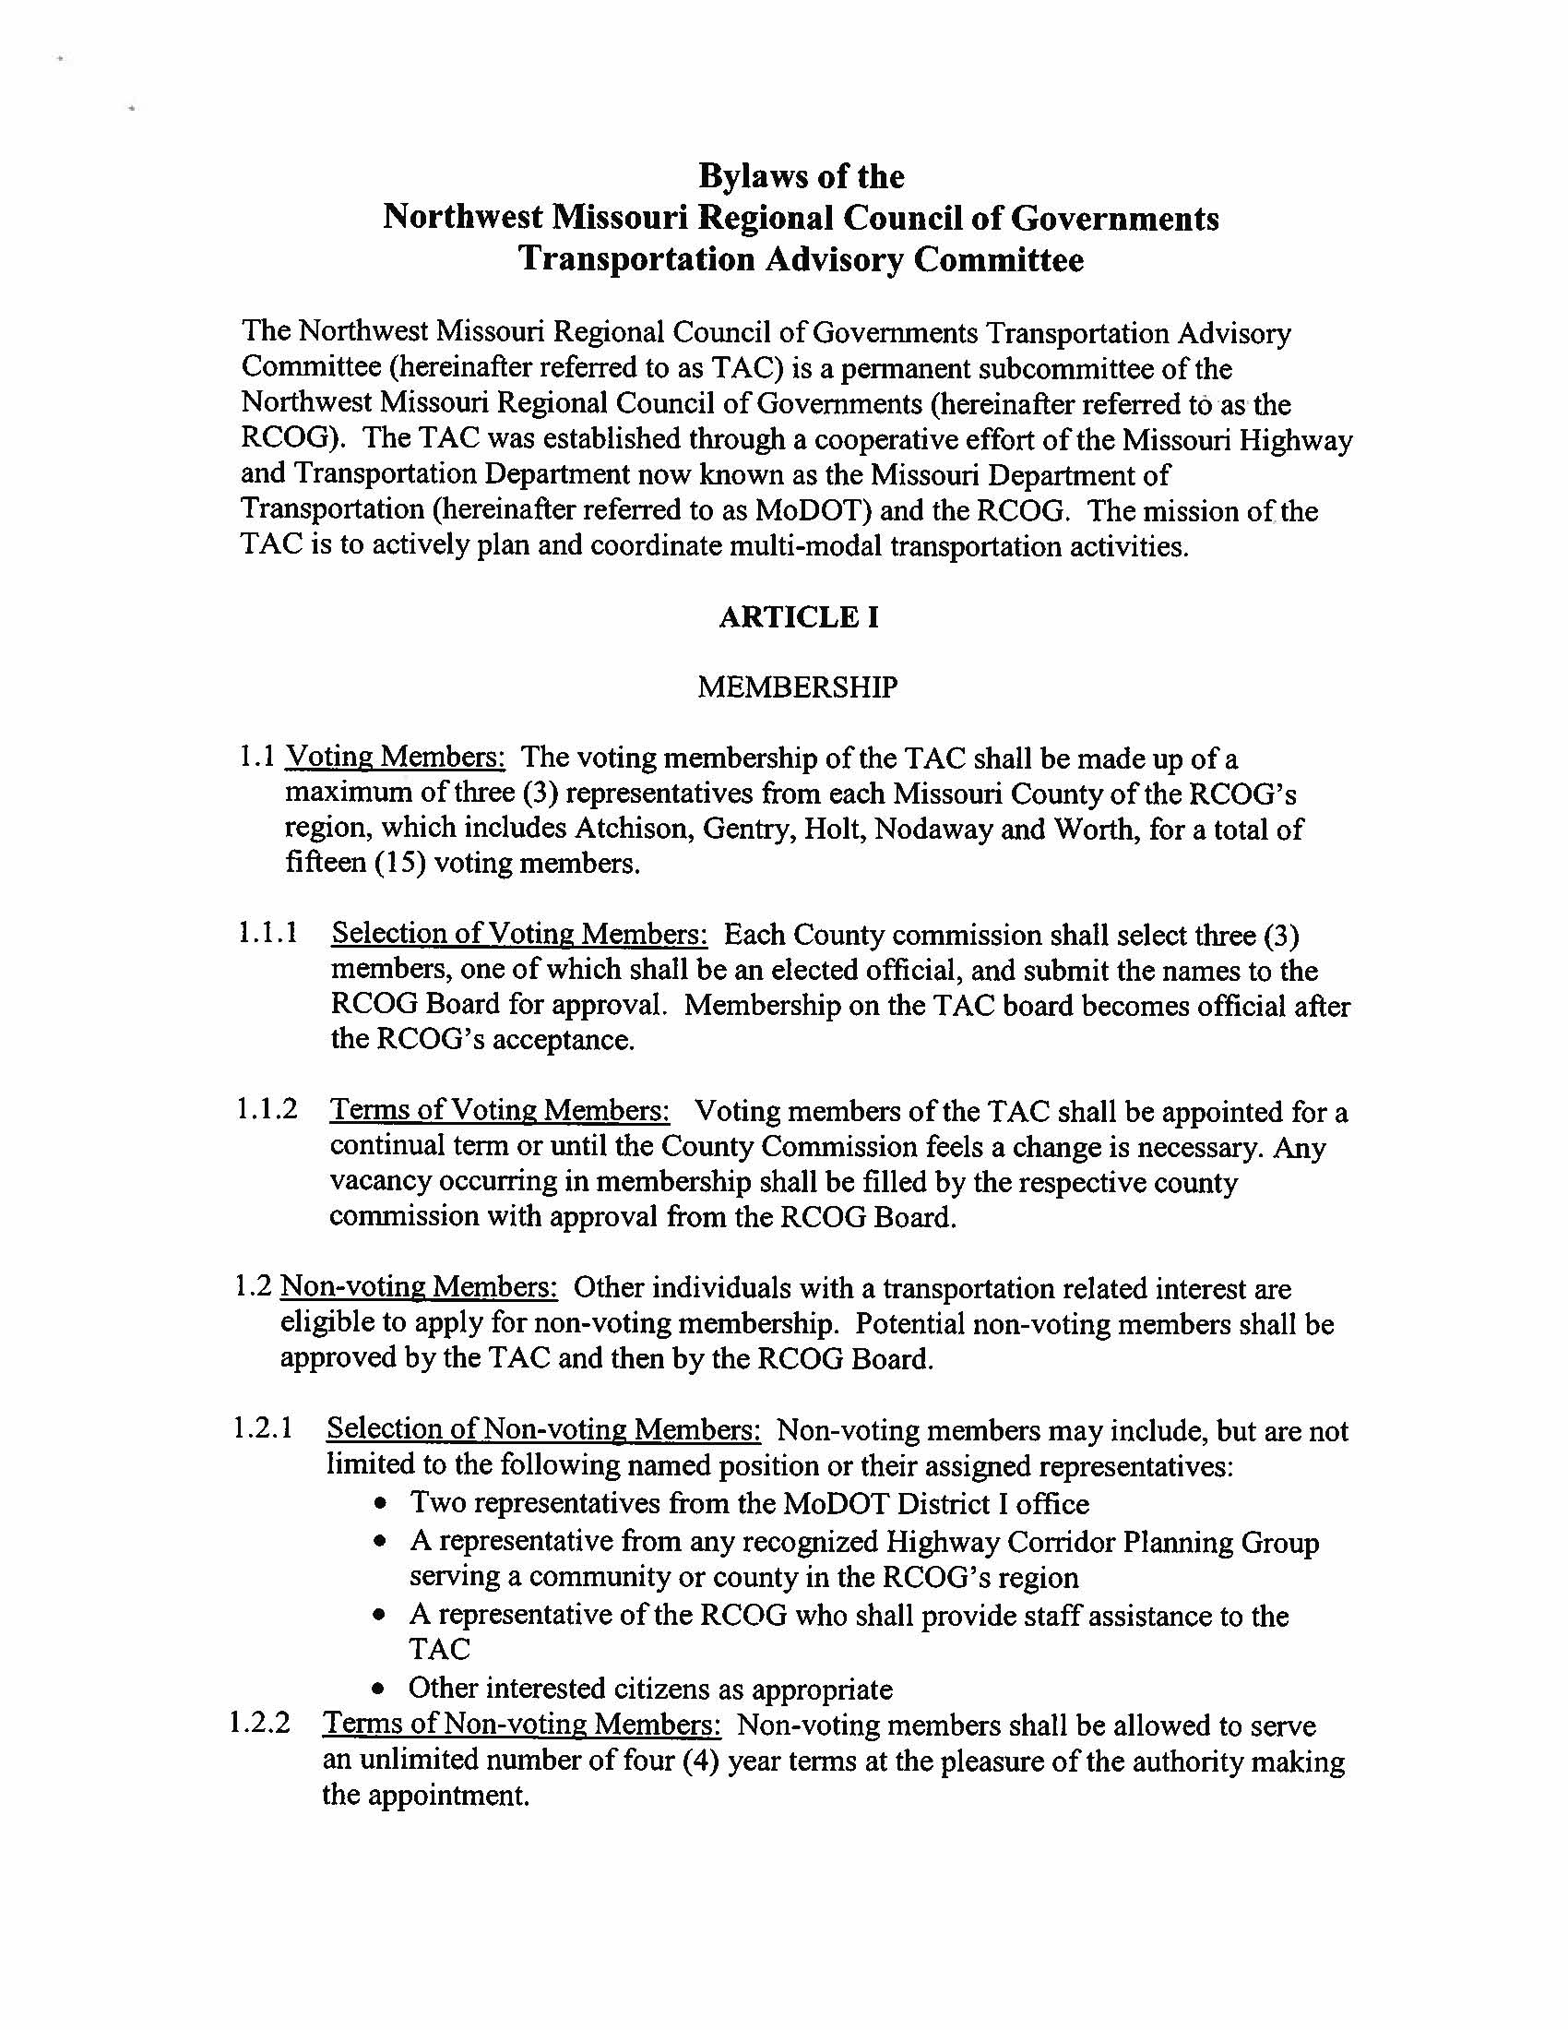

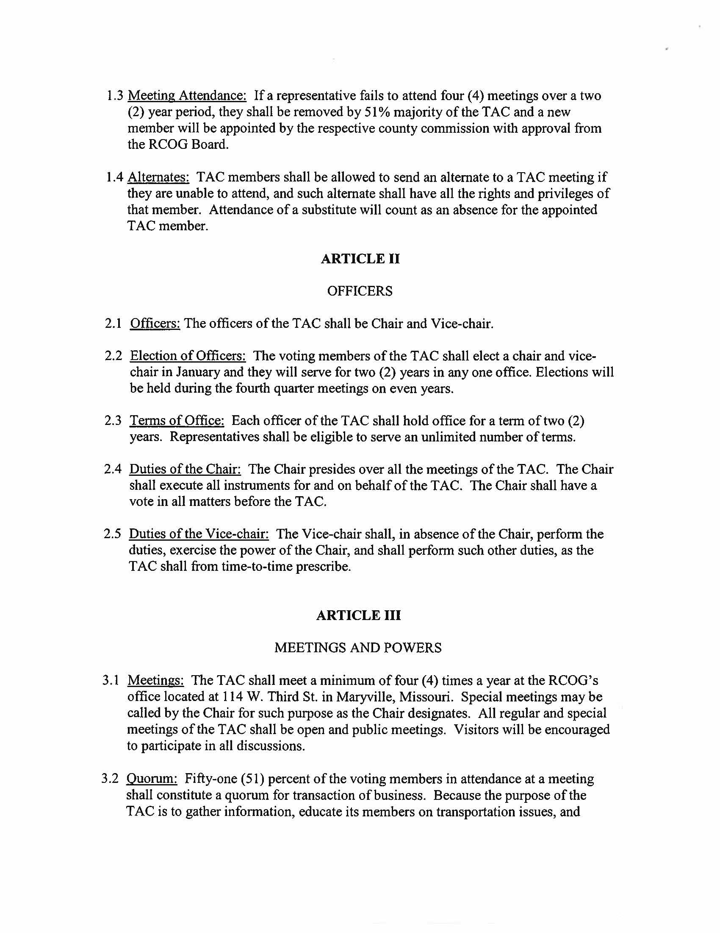
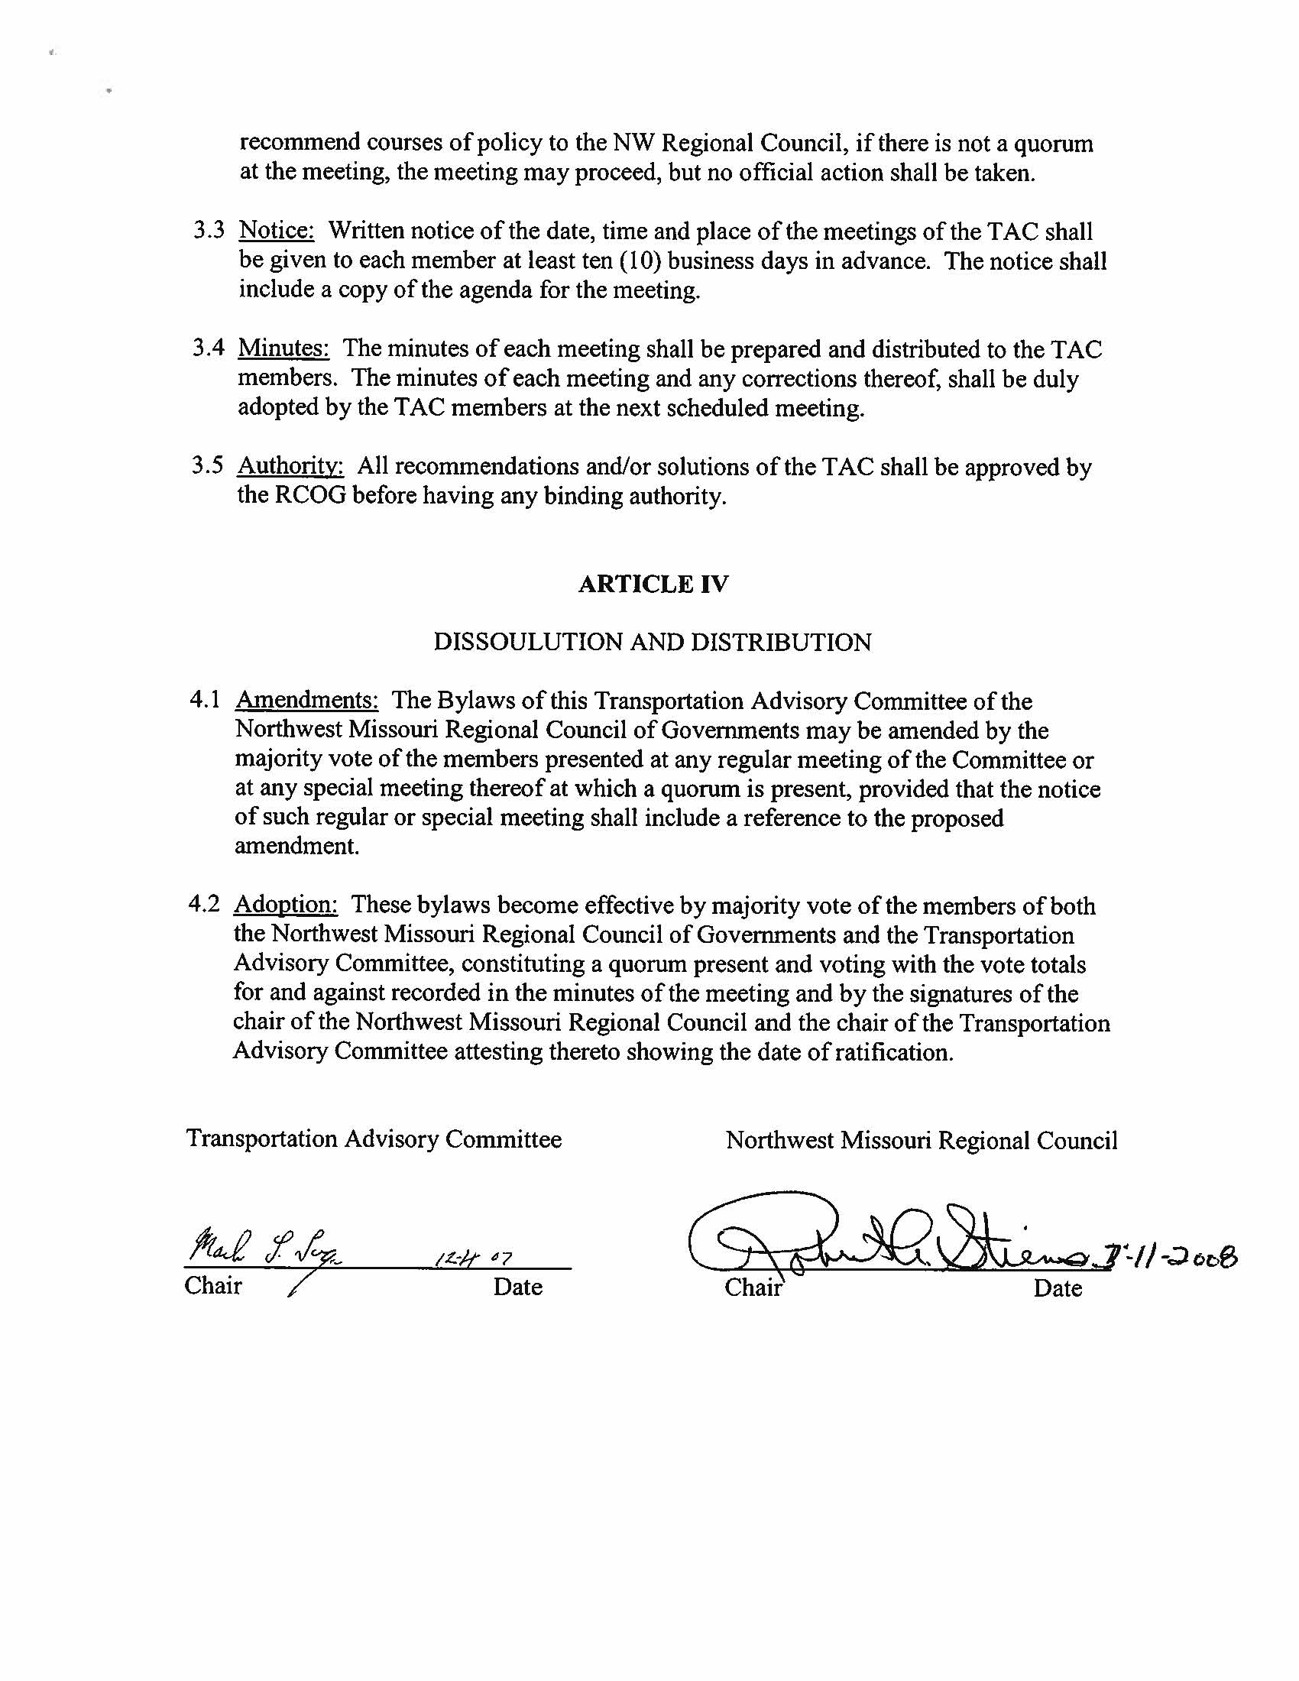

Formation and Responsibilities

Transportation Advisory Committee (TAC)
Roles and Responsibilities

History of Formation: On December 19, 1991, President George Bush signed the Intermodal Surface Transportation Efficiency Act (ISTEA). With this federal legislation came new responsibilities for transportation planning to include public, private and governmental input at a grassroots level. The Missouri Highway and Transportation Committee, under the direction of Commission Chairwoman Carol Williamson, stated their intention to works with the regional planning commissions to fulfill the requirement of the new legislation. From March 1992 to August 1994, staff worked towards a final agreement with the Missouri Association of Council’s of Governments (MACOG) to assist with this public planning process.

Local TAC: The Northwest Missouri Regional Council of Governments met on March 31, 1994 and approved a resolution, creating the Northwest Missouri Transportation Advisory Committee (TAC). The original TAC was comprised of one representative from each county in the Regional Council’s service area, a representative from each city that possessed an air strip, and a representative from both the Highway 136 Coalition and the Highway 71 Coalition. The TAC has transformed over the years as priorities have changed, but an unbiased representation from each county still exists today.

Responsibilities: Voting members of the Northwest TAC are expected to perform the following functions:

- Actively attend and participate at TAC meetings. Each county has two voting members and if any members are missing, that county is at a disadvantage. The TAC makes recommendations on many issues that affect transportation in the region. When one county is not fully represented, then the transportation needs for that county may not be fairly and adequately represented.

- Understand the scope of work to be accomplished by the TAC and the NW Missouri Regional Council of Governments.
Each year, the NW Missouri Regional Council of Governments signs a contract with MoDOT to provide certain services and deliverables. The TAC plays a critical role in fulfilling those obligations. Each TAC Member needs to know what the scope of work for each year entails and what the TAC’s role will be for each year.

- Understand the planning framework process and how the TAC’s involvement is incorporated into the process.
It is important for TAC members to understand the overall planning process, to know how their input is used and how it is combined with other input and information for a final recommendation to the Missouri Highways and Transportation Commission.

- Provide input on transportation needs in your county and its communities.
The best resources for determining transportation needs in a community are the people who live in that community. As a TAC representative, you will be called upon to present those needs to the TAC and MoDOT for discussion. Although MoDOT and the NWMORCOG receive some input from the public on particular needs, it does not reflect the entire picture of needs in the region. TAC members must be able to provide additional information to insure that all needs are identified and incorporated into the planning process.

- Disseminate information to communities and residents.
TAC members attend meetings quarterly. At these meetings, community representatives and MoDOT personnel discuss all aspects of transportation across the region. It is important that this information be shared with the public. Equally important is the support of the TAC for MoDOT activities essential to the success of the department.
- Prioritize transportation needs for the region.
At least once a year, each MoDOT district asks for the needs of the area in a prioritized listing. The TAC plays a key role in how the needs are prioritized. TAC members are also accountable to their communities in how the needs of the area are represented. At times, MoDOT may call upon the TAC to prioritize project for a certain pool of funds or grant activity. TAC members should be present to adequately represent the priorities of their communities and region.

- Prioritize project for the region.
High priority needs move forward in the Planning Framework process. These needs are evaluated by MoDOT to find the best solutions based on engineering, public input and financial considerations. Design plans are started and the need then becomes a project. Projects must then be prioritized to determine how they fall into the Statewide Transportation Improvement Program (STIP). Again, TAC members are tasked with providing MoDOT a prioritized listing of projects in the region. Additionally, TAC members are accountable to their communities for how projects are included in the STIP.

- Provide ideas to the NWMORCOG staff on ways to improve the planning process and TAC meetings.
It is important for you to provide staff with feedback on ways to improve TAC meetings. Each meeting usually includes an education component, and you can assist by letting staff know what information would be useful. It is also helpful to staff if TAC members and suggest ways to improve any processes used.

Contact Lists

MoDOT Contacts
Troy Pinkerton  Long Range Transportation Planning Coordinator, Central Office | (573) 751-6775  Troy.pinkerton@modot.mo.gov
Denis Beganovic  Transportation Planning, Central Office | 573-522-6995  denis.beganovic@modot.mo.gov
Jenni Jones,  Senior Transportation Planner, Central Office | (573) 526-4142  jennifer.j.jones@modot.mo.gov
Don Wichern,  District Engineer, District 1 | (816) 387-2422  Don.wichern@modot.mo.gov
Anthony McGaughy  Assistant District Engineer, District 1 | (816) 387-2480  Anthony.mcgaughy@modot.mo.gov
Melissa Black  Community Relations, District 1 | (816) 387-2353  Melissa.black@modot.mo.gov
Darby Logan  Senior Transportation Planner | (816) 387-2596  Darby.logan@modot.mo.gov
Shannon Kusilek  District Utilities and Planning Engineer, District 1 | (816) 387-2359  Shannon.kusilek@modot.mo.gov
Martin Liles  Area Engineer, District 1 | Martin.liles@modot.mo.gov  (660) 582—0434  (816) 271-6938 cell

RPC Transportation Planners
Boonslick Regional Planning Commission | Chris Michael  Krishna Kunapareddy  (636) 456-3473  cmichael@boonslick.org  Krishna@boonslick.org  www.boonslick.org
Bootheel Regional Planning Commission | Scott Perry  (573) 614-5178  sperry@newwavecomm.net  www.bootrpc.com
East-West Gateway Coordinating Council | Edward Hillhouse  (314) 421-4220  ed.hillhouse@ewgateway.org  www.ewgateway.org
Green Hills Regional Planning Commission | Lance Rains  (660) 359-5636  lance@ghrpc.org  www.ghrpc.org
Harry S Truman Coordinating Council | Jason Ray  (417) 649-6400  jray@hstcc.org  www.hstcc.org
Kaysinger Basin Regional Planning Commission | Emily Wilson  (660) 885-3393  emily@kaysinger.com  www.kaysinger.com
Lake of the Ozarks Regional Council of Local Governments | Mac McNally  (573) 346-5692  Mac.mcnally@loclg.org  www.loclg.org
Mark Twain Regional Council of Governments | David Cheek  (573) 565-2203  cheekcog@rallstech.com  www.marktwaincog.com
Meramec Regional Planning Commission | Kelly Sink-Blair  Connie Willman  (573) 265-2993  kellysb@meramecregion.org  www.meramecregion.org
Mid-America Regional Council | Mell Henderson  (816) 474-4240  mellh@marc.org  www.marc.org
Mid-Missouri Regional Planning Commission | Chad Eggen  (573) 657-9779  chadeggen@mmrpc.org  www.mmrpc.org
Mo-Kan Regional Council | Matt Buchanan  (816) 233-3144  matt@mo-kan.org  www.mo-kan.org
Northeast Missouri Regional Planning Commission | Kathie Small  (660) 465-7281  kathiesmall@nemorpc.org  www.nemorcog.org
Northwest Missouri Regional Council of Governments | Dana Ternus  (660) 582-5121  dana@nwmorcog.org  www.nwmorcog.org
Ozark Foothills Regional Planning Commission | Andrew Murphy  (573) 785-6402  Andrew@ofrpc.org  www.ofrpc.org
Pioneer Trails Regional Planning Commission | Nancy Heidrich  (660) 463-7934  nancy@trailsrpc.org  www.trailsrpc.org
South Central Ozark Council of Governments | Steven Reed  (417) 256-4226  sreed@scocog.org  www.scocog.org
Southeast Missouri Regional Planning Commission | Drew Christian  (573) 547-8357  dchristian@semorpc.org  www.semorpc.org
Southwest Missouri Council of Governments | Dan Watts  (417) 836-6900  Dan.watts@missouristate.edu  smcog.missouristate.edu

Engineering Terms
-A-
Abandon
A proceeding wherein a shipper/consignee seeks authority to abandon all or parts of their cargo; railroad abandonment occurs when operation of all or part of a route or services is ceased, especially with the intent of never resuming it again; abandonment of an easement is the relinquishment of some accommodation or right in another's land, such as right-of-way.
Abutment
A substructure element supporting each end of a single span or the extreme ends of a multi-span superstructure and, in general, retaining or supporting the approach embankment.
Acceleration lane
Drivers entering a roadway use this lane to increase speed so that they may safely merge with traffic.
Access management
Measures regulating access to streets, roads and highways from public roads and private driveways.
Accessibility
The extent to which facilities accommodate persons with disabilities, including wheelchair users.
Active warning device
Flashing lights and/or gates used at railroad/highway grade crossings.
Administrative law judge
A representative of a government commission or agency vested with power to administer oaths, examine witnesses, take testimony, and conduct hearings of cases submitted to, or initiated by, that agency.
Advance acquisition
The acquisition of real property rights for use on a transportation corridor in advance of the fiscal year in which right of way acquisition would normally occur; this is done to take advantage of favorable prices or the availability of land and to preclude further development that would make the property more costly to the public.
Alignment
The horizontal and vertical definition of a roadway.
All-terrain Vehicles (ATV)
Vehicle designed for off-road use.
Alternate mode users
Individuals who choose a method of transportation other than driving a single-occupancy motor vehicle.
Alternative transportation mode
This term refers to all passenger modes of travel except for single-occupancy vehicles, including bicycling, walking,public transportation, carpooling, and vanpooling.
Ambient conditions
The visual background or surrounding atmospheric and visibility conditions.
Americans with Disabilities Act of 1990 ADA)
Civil rights legislation enacted in 1990 to end discrimination against persons with disabilities.
Anchor span
The span that counterbalances and holds in equilibrium the cantilevered portion of an adjacent bridge span during construction.
Anchorage
Massive concrete structural parts of a bridge, also called "cable anchorages" and "shore anchors"; these are placed far enough back from the edge of the water to ensure against sliding; they provide stability where the cable end is tied, withstanding the tremendous stress of the loaded cables.
Angular motion sensitivity
The ability of an observer to detect changes in the apparent distance and direction of movement of an object as a function of the change in the angular size of the visual stimulus on the observer's retina.
Angular velocity threshold
The rate of change in angular size of the visual stimulus that is necessary for an observer to discern that an object's motion has increased or decreased.
Annual Average Daily Traffic (AADT)
The total volume passing a point or segment of a highway facility in both directions for one year, divided by the number of days in the year.
Apportioned
The formula share from which one receives funds; example: The state's apportionment grew by 5 percent this year.
Apportionment
A federal budgetary term that refers to a statutorily prescribed division or assignment of funds; it is based on prescribed formulas in the law and consists of dividing authorized obligation authority for a specific program among transit systems.
Approach span
The span or spans connecting the bridge abutment with the main span or spans.
Appropriation
A federal budgetary term that refers to an act of Congress that permits federal agencies to incur obligations and make payments out of the Treasury for specified purposes; an appropriation act is the most common means of providing budget authority, but in some cases the authorization legislation itself provides the budget authority.
Arterial street or highway
A major thoroughfare used primarily for through traffic, rather than access to private land.
Articulated bus
An extra-long, high-capacity bus with a rear body section or sections flexibly, but permanently, connected to the forward section; the arrangement allows the vehicle to bend in curves and yet have no interior barrier to movement between the two parts; typically 54- to 60-feet long, an articulated bus has a seating capacity of 60 to 80 passengers.
At-grade
The surface where the rail and a roadway (or pathway) cross at the same level.
Attraction signing
Information/supplemental signs featuring logos or verbal messages pointing out places to visit or food, gas and rest area locations.
Authorization
Basic, substantive legislation which establishes or continues the legal operation of a federal program or agency, either indefinitely or for a specific period of time, or which sanctions a particular type of obligation or expenditure within a program; an authorization may set appropriation limits.
Authorized
Legislation assigns a dollar amount that is the maximum amount that can be spent. They can be trust funds or annual funds. Example: The legislative body authorizes the total amount of funds which can be budgeted for the two-year cycle.
Aviation Trust Fund
Fund established by Congress to pay for improvements to the nation's airports and air traffic control system; money in the fund comes solely from users of the system - primarily a tax on domestic airline tickets.
Awarded
This refers to a contract, not funds. A contract is awarded once the selection process has been completed and a contractor has been chosen.

-B-
Barge
Flat-bottomed boat designed to carry cargo on inland waterways, usually without engines or crew accommodations; barges can be lashed together and either pushed or pulled by tugs, carrying cargo of 60,000 tons or more; small barges for carrying cargo between ship and shore are known as lighters.
Barnes Dance timing
Type of exclusive signal timing phase where pedestrians may also cross diagonally, in addition to crossing either street; also referred to as scramble timing.
Base fare
The price charged to one adult for one transit ride; excludes transfer charges, zone charges, express service charges, peak period surcharges and reduced fares.
Beam
A linear structural member designed to span from one support to another.
Benefit/Cost (B/C) ratio
B/C is used to compare the benefit versus the cost of proposed alternatives. For highway projects, benefits may include reduced fuel consumption, travel time, and air pollution; costs may include construction, right-of-way, and maintenance.
Bent
A substructure unit supporting each end of a bridge span; also called a pier; made up of two or more columns or column-like members connected at their top most ends by a cap, strut or other member holding them in their correct positions.
Bicycle facilities
A general term denoting improvements and provisions made to accommodate or encourage bicycling, including parking facilities, all bikeways and shared roadways not specifically designated for bicycle use.
Bid and Bid Process
The process of a public agency requesting proposals for a specific project or scope of work and the response from an individual or firm to secure a contract.
Bike lane
A portion of a roadway that has been designated by striping, signing and pavement markings for the preferential or exclusive use of bicyclists.
Bikeway
A bikeway is created when a road has the appropriate design treatment for bicyclists, based on motor vehicle traffic volumes and speeds. On-road bikeways include a shared roadway, shoulder bikeway, bike lane or bicycle boulevard design treatments.
Borrow
Site for obtaining earth materials for roadway embankment construction.
Bottleneck
Highway sections that experience operational problems such as congestion; bottlenecks may result from factors other than reduced roadway width; for example, the close spacing of exit and entrance ramps can cause weaving patterns that result in congestion; a less obvious example is a steep freeway grade that can slow trucks and cause a localized "bottleneck".
Bow
The front of a vessel.
Box girder
A support beam that is a hollow box; its cross-section is a rectangle or square.
Boxcar
An enclosed car used for general service and especially for lading that must be protected from weather.
Brake reaction time
The interval between the instant that the driver recognizes the presence of an object or hazard on the roadway ahead and the driver actually applies the brakes.
Branch railroad
Non-class 1 railroad.
Branchline
A secondary line of a railroad, not the main line.
Budget Authority
A federal budgetary term that refers to legal authority given by Congress to federal agencies to make funds available for obligation or expenditure.
Budget resolution
A federal budgetary term that refers to a concurrent resolution passed by both Houses of Congress, but not requiring the signature of the President, setting forth the congressional budget for each of five fiscal years; the budget resolution sets forth various budget total and functional allocations, and may include reconciliation instructions to designated House or Senate committees.
Bulk
Cargo shipped in loose condition and of a homogeneous nature; cargoes that are shipped unpackaged either dry, such as grain and ore, or liquid, such as petroleum products; bulk service generally is not provided on a regularly scheduled basis, but rather as needed, on specialized ships, transporting a specific commodity.
Bulk transfer
The transfer of bulk products, such as plastic pellets or liquid sweeteners, from one mode of transportation to another; bulk transfer permits off-rail shippers and receivers of varied commodities to combine rail's long-haul efficiencies with truck's convenient door-to-door delivery.
Bus
A rubber-tired vehicle designed for roadway operation to transport a large number of people for public transportation service.
Bus, Charter
A bus transporting a group of persons who, pursuant to a common purpose, and under a single contract at a fixed price, have acquired the exclusive use of a bus to travel together under an itinerary.
Bus, Intercity
A bus with front doors only, high-backed seats, separate luggage compartments, and usually with restroom facilities for use in high-speed long-distance service.
Buttonhook ramp
J-shaped ramp that connects to a parallel or diagonal street or frontage road, which is often well removed from the interchange structure and other ramps.
-C-
Cable
The part of a suspension bridge or cable-stayed bridge that supports suspension support to the deck; the cable is made of many steel wires bound together into strands and anchored at each end.
Cable saddle
The cable saddles sit at the summit of each bridge tower. They hold the main suspension cable where it crosses over each tower leg. As traffic, wind and temperature changes affect the movement of the cables, the saddles absorb the load and shift it to the towers.
Cable spinning
The technique of pulling wires from the bridge anchorage over towers and back to form the main cable; a "spinning wheel," or "traveler," carriers the wires; at the anchorage the strands of wire are attached to the eye-bar; the wires are grouped into strands then bound tightly together to form strong suspension cables.
Cable-stayed bridge
A bridge in which the superstructure is directly supported by cables or stays, passing over or attached to a tower or towers located at the main pier(s).
Caisson
"Caisson" is the French word for "box." A caisson is a huge box made of steel-reinforced and waterproof concrete with an open central core. At the base of the caisson is its "cutting edge" of plate steel. In a suspension bridge the caisson becomes the foundation, the pier, supporting for the bridge's towers.
Capacity
The maximum number of vehicles (vehicle capacity) or passengers (person capacity) that can pass over a given section of roadway or transit line in one or both directions during a given period of time under prevailing roadway and traffic conditions.
Capital costs
Expenses related to the purchase of tangible property, such as land, buildings and vehicles
Cargo
Anything other than passengers, carried for hire, including both mail and freight.
Carload
A shipment of not fewer than five tons of one commodity.
Carman
Formal name for a craft employee that inspects and repairs railway cars.
Car-mile
The movement of a car a distance of one mile; an empty car-mile is a mile run by a freight car without a load; a loaded car-mile is a mile run by a freight car with a load.
Carpool
Two or more people sharing the use and cost of a privately owned vehicle in traveling to and from pre-arranged destinations.
Cast-in-place
Concrete poured within form work on site to create a structural element in its final position.
Catwalks
Temporary foot bridges, used by bridge workers to spin the main cables (several feet above each catwalk), and attach the suspender cables that connect the main cables to the deck.
Channelization
The separation or regulation of conflicting traffic movement into definite paths of travel by the use of pavement markings, raised islands or other subtle means, to facilitate the safe and orderly movement of both vehicles and pedestrians.
Chevron signs
A chevron symbol (sideways "V") in black, against standard yellow background, on a vertical rectangle; Used as an alternate or supplement to standard delineators and to large arrow signs.
Chord
A horizontal member of a truss.
Class 1
A railroad having operating revenues of more than $256 million annually.
Clean Air Act
The original Clean Air Act was passed in 1963, but our national air pollution control program is actually based on the 1970 version of the law. The 1990 Clean Air Act amendments are the most far-reaching revisions of the 1970 law.
Clear Zone
Area adjacent to the roadway absent of obstructions or with protected elements.

Closed-end street
A street that has only one egress to any other existing street or planned street identified in the local Transportation System Plan; cul-de-sacs, dead-end and looped streets are examples of closed-end streets.
Cloverleaf interchange
A form of interchange that provides indirect right-turn movements in all four quadrants by means of loops; generally used where the turning and weaving volumes are relatively low; this type of interchange eliminates all crossing conflicts found in a diamond interchange, but requires more area; the cloverleaf type of interchange can have one or two points of entry and exit on each through roadway.
Coal car
A freight car with fixed sides and no roof; for transporting coal.
Collector/Distributor streets
A street that gathers and disperses traffic between larger arterial highways and smaller streets; a collector/distributor street has intersections and provides access to abutting properties.
Collector highway
Collector highways are those highways that link local highways to arterial highways.
Collectors
In rural areas, routes serving intra-county, rather than statewide travel; in urban areas, streets providing direct access to neighborhoods as well as direct access to arterial.
Commercial Motor Vehicle
Any self-propelled or towed vehicle used on the public highways in commerce to transport passengers or cargo, if the vehicle has a gross weight of 10,000 pounds or more; or is designed to transport more than 15 passengers, including the driver, or is used to transport hazardous materials as defined by law.
Commercial service airport
An airport receiving scheduled passenger service and having 2,500 or more enplaned passengers per year.
Common carrier
Holds himself out for hire to the general public; must post rates and cannot discriminate against customers whose cargo he is equipped to carry.
Commuter rail
Local and regional passenger train operations between a central city, its suburbs and/or another central city; commuter rail usually has only one or two stations in the central business district; it is also known as "suburban rail".
Commuter rail transit
Also called regional rail transit, the passenger railroad service carries passengers within urban areas or between urban areas and their suburbs. Commuter rail transit differs from rail rapid transit in a number of ways: heavier passenger cars, longer average trip lengths and passenger stations spaced farther apart.
Complete Interchange Lighting (CIL)
Includes lighting in the interchange area on both the acceleration and deceleration areas, plus the ramps through the terminus.
Composite photometry
Light measurement applied to a high-mast lighting system that employs a counter beam arrangement, to take advantage of the efficiency with which pavement luminance can be increased with light directed upstream, while enhancing positive contrast through additively of vehicle headlighting with the light directed downstream.
Compressed work week
Also called alternative work hours; alternatives to the Monday through Friday, 8 a.m. to 5 p.m. work schedule; a compressed work week allows employees to work longer days and report to the work site less often.
Concrete Safety Shaped Barrier (CSSB)
Commonly used median barrier where there is heavy vehicle travel and narrow medians.
Congestion
Highway congestion results when traffic demand approaches or exceeds the available capacity of the transportation facility(ies).
Congestion Mitigation and Air Quality improvement program (CMAQ)
This federal funding source supports programs and projects to improve air quality.
Concrete Safety Shaped Barrier (CSSB)
Commonly used median barrier where there is heavy vehicle travel and narrow medians.
Connecting carrier
Railroad with a physical connection to another.
Constant Warning Time (CWT)
Circuitry at active warning devices that provides a constant warning time, despite the speed at which a train is approaching.
Constructability
A detailed review of construction issues and sequencing of a project during the project development phase.
Contract authority
A federal budgetary term that refers to a form of budget authority permitting obligations to be incurred in advance of appropriations; advance obligations, however, have been limited by the appropriations committees with obligation limitations.
Contrast sensitivity
Ability to perceive a lightness or brightness difference between two areas; frequently measured for a range of target patterns differing in value along some dimension, such as pattern element size and portrayed graphically in a contrast sensitivity function in which the reciprocal of contrast threshold is plotted against pattern spatial frequency or against visual angle subtended at the eye by pattern elements.
Controlled Access
Partial access restriction that gives preference to through traffic; also provides for connections to selected public routes and to certain other adjacent locations where vehicles can enter or leave a roadway safely without interfering with through traffic.
Corridor
A broad geographical band that follows the general directional flow or connects major sources and destinations or trips; generally representing the major travel patterns within a region, corridors may contain a number of streets, highways, and transit route alignments.
Crash Rate
Measure of the number of crashes on a roadway segment related to the amount of traffic on that segment; the rate is calculated by taking the number of crashes over a given time period divided by the total vehicle miles of travel on a roadway segment; the rate is typically reported in number of crashes per hundred million vehicle miles of travel.
Critical gap
The gap (distance to nearest vehicle) in oncoming or cross traffic that a driver will accept to initiate a turning or crossing maneuver 50 percent of the time it is presented, typically measured in seconds.
Cross brace
Transverse brace between two main longitudinal members.
Crossarm
Commonly used by railroads, a crossarm, located at the top of a utility pole, is a wooden bar to which power lines are attached; the crossarm keeps the lines separated by a sufficient distance to prevent arcing.
Crossbuck
Crossbucks are white reflectorized X-shaped signs with "RAILROAD CROSSING" in black lettering, located alongside the roadway at railroad tracks. Crossbucks are to be viewed as a yield sign, and is a regulatory sign.
Crossover
Two track switches laid back-to-back to allow trains to move from one track to another parallel track.
Cross section
A section formed by a plane cutting through an object, usually at right angles to an axis.
Crosswalk
A point along a street that is identified by striping, signage and/or signal lights that designate it as a spot for pedestrians to cross the street.

-D-
Damping
The action of reducing the vibration of an object; this tends to return the vibrating object to its original position.
Dark adaptation
Adjustment of the eye to low levels of illumination, which results in increased sensitivity to light.
Dead load
A static load due to the weight of the structure itself.
Deadhead
The movement of a transit vehicle without fare-paying passengers aboard, often to and from a garage or terminal or between routes, also refers to commercial truck movement when the unit is moving empty cargo.
Deceleration lane
A lane designed to allow traffic to safely decrease speed.
Decision Sight Distance (DSD)
The distance required for a driver to detect an unexpected or otherwise difficult-to-perceive information source or hazard in a roadway environment that may be visually cluttered, recognize the hazard or its threat potential, select an appropriate speed and path, and initiate and complete the required safety maneuver safely and efficiently.
Deck
The roadway portion of a bridge that directly supports vehicular and pedestrian traffic.
Deck bridge
A bridge in which the supporting members are all beneath the roadway.
Deck truss
A bridge whose roadway is supported from beneath by a truss.
Depth perception
The ability to distinguish the relative distance of objects in visual space, used to interpret their motion over multiple observations.
Design criteria
Established state and national standards and procedures that guide the establishment of roadway layouts, alignments, geometry, and dimensions for specified types of roadways in certain defined conditions; the principal design criteria for roadways are traffic volume, design speed, the physical characteristics of vehicles, the classification of vehicles, and the percentage of various vehicle classification types that use the roadway.
Diagonal
A sloping structural member of a truss or bracing system.
Diamond interchange
The simplest and perhaps most common type of interchange; this type of interchange contains a one-way diamond-type ramp in one or more of the quadrants; the diamond interchange provides for all movements to and from the intersecting road.
Disadvantaged Business Enterprise (DBE)
A business owned and operated by one or more socially and economically disadvantaged individuals; socially and economically disadvantaged individuals include African Americans, Hispanic Americans, Native Americans, Asian Pacific Americans or Asian Indian Americans and any other minorities or individuals found to be disadvantaged by the Small Business Administration under Section 8(a) of the Small Business Act.

Discretionary spending
A federal budgetary term that refers to any funds whose distribution is not automatic; discretionary spending encompasses programs controlled by annual appropriations bills and is subject to the constraints imposed by the discretionary spending limits set in the balanced budget law.
Diverge steering zone
Used with interchange/ramp exit models; it is the distance upstream from the exit gore at which a driver begins to diverge from the freeway.
Divided attention
The ability of a driver to allocate attention among tasks or stimuli in the roadway environment, where more than one task or stimulus is perceived to be important to safe performance at a given time.
Divided highway
Roadway that is separated by a median.
Double-stack
Shipping containers that can be stacked atop one another on a railroad flatcar.
Drawn down
Using funds that have been awarded.
Dynamic Message Sign (DMS)
An electronic traffic sign is often used on roadways to give travelers information about special events; they warn of traffic congestion, accidents, incidents, roadwork zones, or speed limits on a specific highway segment; they may also ask vehicles to take alternative routes, limit travel speed, warn of duration and location of the incidents or just inform of the traffic conditions.
Dynamic visual acuity
Acuteness or clarity of vision for an object that has angular movement relative to the observer; acuity depends on sharpness of retinal focus, sensitivity of nervous elements, oculomotor coordination, interpretive faculty of the brain, and contextual variables.
-E-
Earmark
A federal budgetary term that refers to the specific designation by Congress that is part of a more general lump-sum appropriation to be used for a particular project; the earmark can be designated as a minimum and/or maximum dollar amount.
Edgeline visibility
The detection/recognition of painted pavement surface delineation along roadway edges.
Encumbered
The point at which there is a complete contract, used in various terms; encumbered is one type of obligation.
Enplanements
Passenger boardings at airports.
Environmental Assessment (EA)
Compared to an Environmental Impact Statement an environmental assessment is a less-detailed level of environmental scrutiny. At the conclusion of the environmental assessment, an environmental impact statement may be ordered if conditions warrant. If not, a Finding of No Significant Impact (FONSI) will be issued.
Environmental Impact Statement (EIS)
One of the environmental protection mechanisms established by the National Environmental Policy Act of 1969; environmental impact statements report the environmental impacts that will likely result from major federally assisted projects.
Environmental Protection Agency (EPA)
The federal department that oversees enforcement of major environmental laws.

Environmental stewardship
A philosophical concept of government, the public, resource users and businesses all taking responsibility and working together to care for natural resources.
Essential air service
Government subsidized airline service to rural areas of the United States that continued after the Airline Deregulation Act of 1978.
Exit gore area
The area located immediately between the left edge of a ramp pavement and right edge of the mainline roadway pavement at a merge or diverge area.
Expansion joint
A joint in concrete paving or bridge construction designed to provide means for expansion and contraction movements produced by temperature changes, load or other forces.
Expended
Same as drawn down, but uses its own funds.
Expressway
An expressway is a divided highway facility usually having two or more lanes for the exclusive use of traffic in each direction and partial control of access; as opposed to a freeway which has full control of access.
Eye-bar
Steel bars that hold wire strands of the main bridge cable, and that are attached to beams embedded in the concrete of an anchorage.
-F-
Fare box revenue
Value of cash, tickets, tokens and pass receipts given by passengers as payment for rides; excludes charter revenue.
Farm-to-market
An identifier for a roadway designated a State DOT to be part of the statewide highway system; normally associated as a two-lane roadway in rural areas, but are located in urban areas and can be a 4- or 6- lane divided roadway.
Fatality rate
The number of fatalities per 100 million vehicle miles traveled.
Fatigue
Cause of structural deficiencies, usually due to repetitive loading over time; also refers to tired drivers.
Feasibility study
A study about a project's feasibility which is summarized in a document; the study addresses issues including the project's benefits, costs, effectiveness, alternatives considered, analysis of alternative selections, environmental effects, public opinions, and other factors; the feasibility study for major projects involving Federal funds was replaced under the Intermodal Surface Transportation Efficiency Act by the Major Investment Study.
Federal-Aid Highway(s)
Those highways eligible for assistance under Title 23 of the United States Code, which does not include those functionally classified as local or rural minor collectors.
Federal-Aid project
An activity, study, survey, project, or other work related to transportation authorized in advance by the Federal Highway Administration, Federal Transit Administration, or other federal agency, and which is paid for either partially or fully by public funds.
Federal Aviation Administration (FAA)
The government agency responsible for air safety and operation of the air traffic control system, the FAA also administers a program that provides grants from the Airport and Airway Trust Fund for airport development.

Federal fiscal year (FFY)
The yearly accounting period for the federal government which begins October 1 and ends on the following September 30; the fiscal year is designated by the calendar year in which it ends (e.g., FY 06 is from October 1, 2005 to September 30, 2006).
Finding of No Significant Impact (FONSI)
Issued at the conclusion of an Environmental Assessment when the determination has been made that an Environmental Impact Statement is not necessary for a specified project.
Fixed cost
An indirect cost that remains relatively constant, irrespective of the level of operational activity.
Fixed-route transit
A system of transit vehicles that follows a schedule over one or more prescribed routes.
Flagman/Flagger
The person assigned to duties at the rear of the train, primarily responsible for applying the breaks; Roadway work zone.
Flatcar
An open railroad car without sides or a roof.
Flextime
Work system allowing alternative work hours different from the standard 8 a.m. – 5 p.m., but not length in shifts.
Footing
The enlarged, lower portion of a substructure that distributes the structure load either to the earth or to supporting piles; the most common footing is the concrete slab; "footer" is a colloquial term for footing.
Formula funds
Funds distributed or apportioned to qualifying recipients on the basis of formulas described in law.
Freeway
A divided highway facility having two or more lanes for the exclusive use of traffic in each direction and full control of access; the freeway is the only type of highway intended to provide complete "uninterrupted" flow.
Freight intermodal facility
An intercity facility where freight is transferred between two or more modes (e.g. truck to rail, rail to ship, truck to air, etc.).
Frontage road
An arterial type roadway that parallels a major transportation facility such as a freeway; it serves to collect and distribute traffic along the major facility without impeding flow along the freeway; frontage roads are also referred to by the public as "access," "feeder," and "service" roads.
Full diamond interchange
Interchange with a one-way diagonal-type ramp in each quadrant.
Functional roadway classification
The organization of roadways into a hierarchy based on the character of service provided; typical classifications include arterial, local and collection roadways.
-G-
Gap acceptance
The decision by a driver that there is sufficient time and/or distance ahead of an approaching vehicle to allow safe performance of a desired crossing or merging maneuver.
Gap judgments
The judgment of a driver of the time and/or distance ahead of an approaching vehicle traveling in a lane that the driver wishes to turn across or merge into.

Gap search and Acceptance (GSA) zone
Used with interchange/ramp entry traffic models, it is the zone in which the driver searches, evaluates and accepts or rejects the available lags or gaps in the traffic stream for execution of a merging maneuver.
General Accountability Office (GAO)
Conducts analysis of federal programs.
General aviation airport
An airport that serves corporate aviation, flight schools, air charter operations, light cargo, or private pilots flying for business or recreation.
Girder
A main support member for the bridge structure that usually receives loads from floor beams and stringers; also, any large beam, especially if built up.
Geographic Information System (GIS)
Computerized mapping and planning tool.
Global positioning system (GPS)
A navigation system that uses satellites to provide a receiver on Earth with extremely accurate measurements of its three-dimensional position, velocity and time.
Grade
The slope (ratio of change in elevation to change in distance) of a roadway typically given in percent; for example, a 2 percent grade represents 2-feet of elevation change over a 100-foot distance.
Grade crossing
The point at which a roadway intersects a rail line.
"Green Book"
The official title of this book is: "A Policy on Geometric Design of Highways and Streets." This book is published by AASHTO and contains accepted practices for designing the physical features of a roadway. Examples of these features are: sight distance, design speeds, lane width, horizontal and vertical curves, etc.
Gross ton-mile
The movement of the combined weight of railroad cars and their contents a distance of one mile.
Gross tonnage
The overall volume of a ship's hull, including crew cabins, storerooms and machinery spaces; a ton equals 100 cubic feet.
Guardrail
Protective barrier along a roadway to prevent vehicles from leaving the roadway or crossing the centerline.
-H-
Half-diamond interchange
An interchange with a one-way, diagonal-type ramp in two adjacent quadrants; this type of interchange is appropriate to situations in which traffic demand is predominantly in one direction.
Hanger
A tension member serving to suspend an attached member on a bridge; A facility where airplanes are stored.
Haulage rights
Rights obtained by one railroad to have its trains operated by another railroad over that railroad's tracks.
High-Occupancy Vehicle (HOV)
Any passenger vehicle that meets or exceeds a certain, predetermined minimum of passengers, generally two or more.
High-occupancy vehicle lane
A highway or street lane reserved for one or more specified category of vehicle, usually buses, carpools and vanpools.

High-mast lighting
Illumination of a large area by means of a cluster of luminaries, which are designed to be mounted in fixed orientation at the top of a high mast (generally 80 feet or higher).
High-spatial-frequency stimulus
A visual target characterized by fine detail.
Highway Advisory Radio (HAR)
A radio station which broadcasts highway conditions and traffic information.
Highway-railroad
The point at which a roadway and railway intersect.
Highway Sufficiency Rating
A 0-100 rating representing the relative condition of the highway segment (0 worst – 100 best); this measure takes into account the structural adequacy, safety and service of each segment; the rating is used as a performance measure and as a tool to identify reconstruction needs.
Highway Trust Fund
The federal trust fund established by the Highway Revenue Act of 1956; this fund has two accounts -- the Highway Account and the Mass Transit Account; trust fund revenues are derived from federal highway-user taxes and fees such as motor fuel taxes; trust fund uses and expenditures are determined by law.
Hinge
A point in a structure at which a member is free to rotate.
Hopper
An open-top railroad car with pockets, or hoppers, opening on the underside of the railcar for unloading bulk commodities.
Horizontal alignment
The linear (tangent) character or specific degree of curvature describing the geometry of a defined section of highway in plain view.
-I-
Illuminance
The density of luminous flux (rate of emission of luminous energy flow of a light source in all directions) incident on a surface; the quotient of the flux divided by the area of the surface, when the surface is uniformly illuminated.
Illumination
The amount of light falling onto a surface.
Incident
An incident may be any of the following: traffic accident, stalled vehicle, load spillage, or other action that effects one or more lanes of traffic; an "accident" typically involves a collision of a moving vehicle with another vehicle, person or object.
Initial Acceleration (IA) zone
Used with interchange/ramp entry traffic models, it is the zone in which the driver accelerates to reduce the speed differential between the ramp vehicle and the freeway vehicle to an acceptable level for completing the merge process.
In-Service Brightness Level (ISBL)
The brightness level of a delineation treatment at an intermediate point in its anticipated service life; this value varies by type of delineator, type of wear (traffic level) and environmental conditions.
Intelligent Transportation System (ITS)
ITS replaces the term Intelligent Vehicle Highway System. ITS is a surveillance system designed to monitor traffic flows on major freeways and to inform motorists of problem areas. Some ITS technology includes changeable message signs (CMS), cameras, and video detectors. ITS applications include: the integration of traffic control and transportation management systems; traffic signals which adapt to traffic and change control each cycle; highway advisory radio systems; changeable message signs; vehicle detectors; closed-circuit television; Global Positioning Systems and route guidance (currently used in some trucks, buses, and rental cars). An ITS may enable drivers to operate their vehicles more safely and with greater knowledge about existing traffic conditions.
Interchange (grade separation)
A system of interconnecting roadways that provides for the movement of traffic between two or more highways on different levels.
Intermodal
Switching from one form of transportation to another.
Intermodal facility
A transportation element that accommodates and interconnects different modes of transportation and services the statewide, interstate and international movement of people or goods, For example, an intermodal yard is a railyard that facilitates the transfer of containers or trailers to a commercial motor carrier.
Intermodal service
Freight moving via at least two different modes of transport; intermodal service generally involves the shipment of containers and trailers by rail, truck, barge or ship.
International Registration Plan (IRP)
IRP is a method of registering fleets of vehicles that travel in two or more member jurisdictions. Motor carriers that qualify for IRP must register fleets of vehicles in their home or “base” jurisdiction. A fleet, for IRP purposes, is comprised of one or more vehicles that pay registration fees in multiple states.
Intersecting angle (skew)
The angle formed by the intersection of two roadways (other than a 90-degree angle).
Intersection Sight Distance (ISD)
The unobstructed view of an entire (at-grade) intersection and sufficient lengths of the intersecting highway to permit control of the vehicle to avoid collisions during through and turning movements.
Interstate Highway System
A network of freeways in the United States; the Interstate Highway System is a separate system within the larger National Highway System; the entire system, as of October 2002, had a total length of 46,726 miles.
-J-
Job Access Reverse Cmmute (JARC) program
A federal program that provides grants to help states and localities develop a coordinated regional approach to new or expanded transportation services that connect welfare recipients and other low-income persons to jobs and other employment services.
Joint
In stone masonry, the space between individual stone; in concrete, a division in continuity of the concrete; in a truss, the point at which members of a truss frame are joined.
-K-
-
-L-
Lane miles
The product of centerline miles and number of lanes; a four-lane road, two miles long, has eight lane miles.
Legibility Index (LI)
Used to describe the relative legibility of different letter styles; it is calculated from the distance at which a character, word or message is legible divided by the size of the letters on the sign.

Less-than-truckload (LTL)
The quantity of freight that is less than that is required for application of a trailer load rate.
Letting
The process by which a DOT requests and decides on bids from competing companies for work on transportation projects.
Level of service
A description of the quality of service that can be expected by users of transportation facilities.
Level of Service (LOS)
A qualitative measure describing operational conditions within a traffic stream, based upon service measures such as speed and travel time, freedom to maneuver, traffic interruptions, comfort, and convenience; LOS A represents completely free flow of traffic allowing traffic to maneuver unimpeded; LOS F represents a complete breakdown in traffic flow resulting in stop and go travel; LOS is typically calculated based upon peak-hour conditions.
Light rail transit
A type of electric rail system with a "light" total passenger carrying capacity compared to the capacity of heavy rail transit.
Limited access highway
Highway designated for through traffic with very few entrances and exits.
Limited sight distance
A restricted preview of the traveled way downstream due to a crest vertical curvature or horizontal curvature of the roadway, or to blockage or obstruction by a natural or constructed roadway feature or by (an)other vehicle(s).
Line capacity
The maximum number of trains that can operate safely and reliably over a given segment of track during a given period of time.
Line-haul service
The movement over the tracks of a carrier from one city to another, not including the switching service.
Liquefied Natural Gas (LNG)
An alternative fuel; a natural gas cooled to below its boiling point of -260 degrees Fahrenheit so that it becomes a liquid; stored in a vacuum bottle-type container at very low temperatures and under moderate pressure; LNG vapor is lighter than air.
Longer Combination Vehicles (LCV)
Commercial motor vehicles with two or more trailers.
Lower chord
The bottom horizontal member of a truss.
Luminaire
A complete lighting unit consisting of a lamp or lamps together with the parts designed to distribute the light, to position and protect the lamps and to connect the lamps to the power supply.
Luminance
The luminous intensity or brightness of any surface in a given direction, per unit of projected area of the surface as viewed from that direction, independent of viewing distance; the International System of Units is the candela per square meter.
Luminance contrast
The difference between the luminance of a target area and a surrounding background area, divided by the background luminance alone (e.g., lane marking minus lane pavement surface, divided by pavement surface).
-M-
Machine Control Grading
Also called Machine Guidance.
Main beam
A beam supporting the bridge spans and bearing directly onto a column or wall.
Main line
Primary rail line over which trains operate between terminals; it excludes sidings, and yard and industry tracks.
Main track
A railroad's primary track that usually extends great distances, it usually carries both freight and passenger trains.
Maintenance-of-way
The maintenance of railroad rights-of-way, it can include procedures from the initial grading of the right-of-way to its general upkeep and eventual dismantling.
Major air carrier
An airline with annual revenue of more than $1 billion.
Manual on Uniform Traffic Control Devices (MUTCD)
This manual is published by the Federal Highway Administration and used by most departments of transportation across the country as the standard for traffic control devices. These devices include signals, signs and pavement striping.
Marked pedestrian crossing
Any portion of a roadway at an intersection or elsewhere that is distinctly indicated for pedestrian crossing by lines or other markings on the surface of the roadway.
Mass Transit Account
The federal account, established by the Surface Transportation Assistance Act of 1982, into which a designated portion of the federal Highway Trust Fund revenue from motor fuel taxes is placed (1.5 cents in 1994); this account is used for federal mass transportation assistance.
Mass transportation
Transportation by bus, rail, boat or other conveyance, either publicly or privately owned, that provides general or special service to the public on a regular and continuing basis (not including school bus, charter or sight-seeing service).
Measures of Effectiveness (MOEs)
Descriptions of driver or traffic behaviors that quantify the level of safety or service provided by facility or treatment to drivers, passengers or pedestrians; examples include vehicle speed, trajectory, delay and similar measures; MOEs are the dependent measures (e.g., the effects/behaviors resulting from introduction of a treatment or countermeasure).
Median
An island in the center of a street or intersection to protect pedestrians and provide landscaping; medians prevent passing and left turns, separate opposing travel lanes, and provide visual enhancement.
Median barriers
A longitudinal system of physical barriers used to prevent an errant vehicle from crossing the portion of the divided highway separating traffic moving in opposite directions.
Member
An individual angle, beam, plate or built piece intended to become an integral part of an assembled frame or structure.
Merge Steering Control (MSC) zone
Used with interchange/ramp entry traffic models, it is the zone in which the driver enters the freeway and positions the vehicle in the nearest lane on the mainline.
Metropolitan Planning Organization (MPO)
The organization designated by local elected officials to be responsible for carrying out the region transportation planning process and other regional planning processes; the MPO must be in place in every urbanized area with a population greater than 50,000; the MPO's responsibilities include the 20-year long-range plan and transportation improvement program.
Metropolitan Transportation Improvement Program (MTIP)
A staged, multi-year, intermodal program of transportation projects that is consistent with the metropolitan transportation plan.

Milepost
A green paddle-shaped sign alongside roads and highways that indicates the total mileage from a certain control point; for Interstate routes, the zero milepost is generally at the southern or western end of the route; for all other routes, the location of the zero milepost may vary.
Minimum Required Visibility Distance (MRVD)
The distance necessary to permit detection and comprehension, plus driver decision making, response selection and completion of vehicle maneuver, if necessary.
Minority Business Enterprise (MBE)
A business owned and operated by one or more individuals who are defined as minorities under U.S. Department of Transportation regulations; see also "disadvantaged business enterprise".
Mitigation measures
Specific design commitments made during the environmental evaluation and study process that serve to moderate or lessen impacts deriving from the proposed action; these measures may include planning and development commitments, environmental measures, right-of-way improvements, and agreements with resource or other agencies to effect construction or post construction action.
Mobility
The ability to move people and goods from place to place, or the potential for movement, mobility improves when the transportation network is refined or expanded to improve capacity of one or more modes, thus allowing people and goods to move more quickly toward a particular destination.
Mode
A general term to describe a manner of transportation; walking, driving, taking a bus or train or bicycling are all modes of transportation.
Multilevel car
A long railroad flatcar designed with one or more deck levels in addition to the car's main deck; used to haul new automobiles and trucks.
Multi-modal
Concerning or involving more than one transportation mode.
-N-
National air carrier
An airline with annual revenues of between $100 million and $1 billion.
National Environmental Policy Act (NEPA)
Federal law providing for environmental assessments of impacts and public input into all federally funded projects; an environmental study could be either an environmental impact statement or environmental assessment.
National Highway System (NHS)
An approximately 155,000-mile, still-to-be-designated network, to provide an interconnected system of principal routes to serve major travel destinations and population centers; picks up where the Interstate Highway System left off.
No-build alternative (also known as “No-Action Alternative”)
Option of maintaining the status quo by not building transportation improvements; serves as a baseline for comparison of “build” alternatives.
North American Free Trade Agreement (NAFTA)
A formal agreement, or treaty, between Canada, Mexico, and the United States of America to promote means for improved and increased free trade between the three countries; the effect of NAFTA on transportation was to increase the need to upgrade existing, and build new, transportation facilities between and within the countries.
Notice of Intent (NOI)
A notice that is prepared to inform the public that an Environmental Impact Statement will be prepared for a project.
No Turn on Red (NTOR)
This message on signs is used to indicate that a right turn on red (or left-turn on red for one-way streets) is not permitted at an intersection.

Non-attainment area
A metropolitan area that has failed to meet national ambient air quality standards.
-O-
Obligated
The money for a project becomes "obligated" once the monies have gone from the "promise" to actually being in an account.
Obligation
A federal budgetary term that refers to a binding agreement that will result in an outlay; an agreement by the federal government to pay for goods or services immediately or at some future time when the goods or services are delivered; also known as a "commitment".
Obligation limitation
A federal budgetary term that refers to a limit placed in appropriations bills on the amount of federal assistance that may be obligated during a specified time period; it does not affect the scheduled apportionment or allocation of funds; it just controls the rate at which these funds may be used.
Off-peak
Those periods of time outside the morning and afternoon peak travel periods, the non-rush hour periods when travel activity tends to be lower.
Operating assistance
Financial assistance for transit operating expenses (not capital costs); such aid may originate with federal, local or state governments.
Operating deficit
The sum of all operating expenses minus operating revenues.
Operating expense
Monies paid in salaries, wages, materials, supplies and equipment in order to maintain equipment and buildings, operate vehicles, rent equipment and facilities and settle claims.
Operating ratio
The percentage of revenues that goes into operating the railroad; it is calculated by dividing railway operating expenses by railway operating revenues.
Operating revenue
Monies used to fund general, day-to-day costs of running transportation systems; for transit, costs include fuel, salaries and replacement parts; for roads, operating costs involve maintaining pavement, filling potholes, paying workers' salaries, and so forth.
Oscillation
A periodic movement back and forth between two extreme limits; an example is the string of a guitar that has been plucked; its vibration back and forth is one oscillation; a vibration is described by its size (amplitude), its oscillation rate (frequency), and its timing (phase); in a suspension bridge, oscillation results from energy collected and stored by the bridge; if a part of the bridge has to store more energy than it is capable of storing, that part will probably fail.
Outlay
A federal budgetary term that refers to a payment made to meet an obligation; the point at which an actual payment of money is made.
-P-
Panel
The portion of a truss span between adjacent points of intersection of bridge web and chord members.
Paratransit
Comparable transportation service required by the Americans with Disabilities Act (ADA) of 1990 for individuals with disabilities who are unable to use fixed-route transportation systems.

Parclo loop ramp
A (partial cloverleaf) interchange with loops in advance of the minor road with direction of travel on the freeway; and in the same interchange area, an interchange with loops beyond the minor road.
Park-and-ride
A mode of travel, usually associated with movements between work and home that involve use of a private auto on one portion of the trip and a transit vehicle (i.e., a bus or a light-rail vehicle) on another portion of the trip.
Partial Interchange Lighting (PIL)
Lighting on an interchange that consists of a few luminaries located in the general areas where entrance and exit ramps connect with the through traffic lanes of a freeway (between the entry gore and the end of the acceleration ramp or exit gore and the beginning of the deceleration ramp).
Passenger Facility Charge
A tax authorized by Congress, approved by the Federal Aviation Administration, assessed by airports, and collected by airlines as an add-on to the passenger airfare; it is designated to help pay for airport improvements that enhance safety and capacity and is not revenue for airlines.
Passenger miles
The total number of miles traveled by passengers on transit or railroad vehicles.
Passenger-mile
Unit of measure that is a product of average trip length multiplied by number of passengers; statistics for transportation safety, for example, are cited on the basis of passenger miles.
Passive warning device
Signs or markers used at all highway-rail grade crossings.
Pavement Condition Index (PCI)
A 0-100 rating representing the condition of state highway pavements (0 worst – 100 best); PCI is a measure of pavement condition only and does not consider geometrics, safety or congestion; the index is used as a network-level performance measure and as one of many tools to identify pavement improvement needs.
Peak intensity
The maximum strength of a traffic signal maintained through a defined viewing angle; measured in candelas.
Pedestrian
A person on foot, in a wheelchair or walking a bicycle.
Peak intensity
The maximum strength of a traffic signal maintained through a defined viewing angle; measured in candelas.
Pedestrian
A person on foot, in a wheelchair or walking a bicycle.
Pedestrian control device
A special type of device (including pedestrian signal indications and sign panels) intended for the exclusive purpose of controlling pedestrian traffic in crosswalks.
Pedestrian facility
A facility provided for the benefit of pedestrian travel, including walkways, crosswalks, signs, signals, illumination, and benches.
Perception-reaction Time (PRT)
The interval between a driver's detection of a target stimulus or event and the initiation of a vehicle control movement in response to the stimulus or event.
Pier
A vertical support or substructure unit that supports the spans of a multi-span superstructure at an intermediate location between its abutments.
Pile
A shaft-like linear member that carriers loads through weak layers of soil to those capable of supporting such loads.
Pile bent
A row of driven or placed piles with a pile cap to hold them in their correct positions
Plate girder
A large solid web plate with flange plates attached to the web plate by flange angles or fillet welds.
Portal
The clear, unobstructed space of a bridge forming the entrance to the structure.
Positive offset
A term used to describe the alignment of opposing left-turn lanes at an intersection; this geometry exists when the left boundary of one left-turn lane, when extended across the intersection, falls to the right of the right boundary of the opposite left-turn lane.
Posted speed
This term refers to the posted speed limit on a given street or the legal speed limit as defined.
Post-Mounted Delineators (PMDs)
Retroreflective devices located serially at the side of a roadway to indicate alignment; each delineator consists of a flat reflecting surface, typically a vertical rectangle, mounted on a supporting post.
Preliminary design
An engineering design that specifies in detail the location and alignment of a planned transportation facility or improvement.
Primary Highway System
Highways that have been functionally classified by the Department of Transportation as either principal or minor arterials, and that have been selected by the Transportation Commission to be placed on the Primary Highway System.
Programming
A general term to refer to a series of activities carried out by planners, including data assessment, appraisal of identified planning needs, and consideration of available or anticipated fiscal resources to result in the drawing up, scheduling, and planning of a list of identified transportation improvements for a given period of time.
Public hearing
A NEPA required meeting designed to afford the public the latest project information and the opportunity to express support of or opposition to a transportation project in an forum at which a verbatim record (transcript) of the proceedings is kept.
Public meeting
An announced meeting conducted by transportation officials designed to facilitate participation in the decision-making process and to assist the public in gaining an informed view of a proposed project at any level of the transportation project development process; also, such a gathering may be referred to as a public information meeting.
Public Service Announcement (PSA)
Free television/radio messages.
Public transportation
Services provided for the public on a regular basis by vehicles such as a bus or rail on public ways, using specified routes and schedules; usually on a fare-paying basis; also includes non-scheduled, on-demand transit services.
-Q-
-
-R-
Railcar
A railroad car.
Rail, high speed
A rail transportation system with exclusive right-of-way which serves densely traveled corridors at speeds of 124 miles per hour (200 km/h) and greater.
Rail main line
A principal or well established rail line (Class I rail lines; e.g., Union Pacific and Burlington Northern/Sante Fe).
Rail rapid transit
A system operating high-speed, high-capacity passenger trains using an exclusive, fixed right-of-way.
Railway, railroad
A road composed of parallel steel rails supported by ties and providing a track for locomotive-drawn trains or other wheeled vehicles.
Raised Pavement Markers (RPMs)
Used as positioning guides and/or as supplements or substitutes for other types of markings; these markers conform to the color of the marking for which they serve as a positioning guide, can be mono- or bi-directional and are fastened into the pavement with the reflector surface visible above the road surface.
Reaction Time (RT)
The time from the onset of a stimulus to the beginning of a driver's (or pedestrian's) response to the stimulus, by a simple movement of a limb or other body part.
Reasonably direct
Either a route that does not deviate unnecessarily from a straight line or a route that does not involve a significant amount of out-of-direction travel for likely users.
Record of Decision (ROD)
The final approval of an Environmental Impact Statement issued by the Federal Highway Administration.
Regional transportation needs
Needs for movement of people and goods between and through communities and accessibility to regional destinations within a metropolitan area, county or associated group of counties.
Regional Transportation Plan (RTP)
The official intermodal transportation plan that is developed and adopted through the transportation planning process for the regional or metropolitan planning area.
Reimbursed
Paid back; in some cases, municipalities must first spend the money before getting funds back from the state.
Reinforced concrete
Concrete with steel reinforcing bars bonded within it to supply increased tensile strength and durability.
Rescission
A federal budgetary term that refers to the cancellation, in whole or part, of budget authority previously granted by Congress.
Resonance
The regular vibration of an object as it responds in step (at the same frequency) with an external force.
Resurfacing program
Provides for pavement resurfacing, rehabilitation, minor reconstruction, and pavement milling and recycling; such projects are intended to preserve the structural integrity of highway pavements.
Reverse commuting
Movement in a direction opposite the main flow of traffic, such as from the central city to a suburb during the morning peak period.
Ridership
The number of people making one-way trips on a public transportation system in a given time period.
Ridesharing
The shared use of a vehicle, such as a van or an automobile, to make a trip.
Right-of-way
Right of way
The land (usually a strip) acquired for or devoted to transportation purposes. For example, highway Row and railroad Row.
Right-of-way (hyphenated if an adjective, e.g., right-of-way agreement)
A general term denoting land or property acquired for or devoted to transportation purposes, but with other associated uses such as utilities, water and sewage lines and buffer zones.
Right turn on Red (RTOR)
Unless otherwise specified by traffic control signage, this practice permits a driver to proceed with a right turn on red signal after stopping at signalized intersections. It provides increased capacity and operational efficiency at a low cost.
Rigid frame bridge
A bridge with moment-resistant connections between the superstructure and substructure to produce an integral, elastic structure.
Riveted connection
A rigid connection of metal bridge members that is assembled with rivets; riveted connections increase the strength of the structure.
Roadmaster
Railroad employee in charge of track maintenance.
Rolling stock
The vehicles used in a transit system, including buses and rail cars.
Roundabout
A type of road junction (or traffic calming device) at which traffic streams around a central island, after first yielding (giving way) to the circulating traffic.
Route mile
The sum of the lengths of all the routes in a transit network less any miles duplicated among them.
Rumble Strips
Driver aids placed in the edges of a roadway pavement.
-S-
SAFETEA-LU (Safe, Accountable, Flexible, Efficient Transportation Equity Act:
A Legacy for Users)
The federal surface transportation legislation (Public Law 109-59) that authorizes programs for highways, highway safety, and transit for the five-year period 2005-2009.
Safety hangers
Back-up for original bridge or structural connections to provide redundancy; often added for seismic retrofit.
Safety Management System
A systematic process that has the goal of reducing the number and severity of traffic crashes by ensuring that all opportunities to improve highway safety are identified, considered, implemented as appropriate and evaluated in all phases of highway planning, design, construction, maintenance and operation; and by providing information for selecting and implementing effective highway safety strategies and projects.
Scissors off-ramp
A condition where one-way traffic streams cross by merging and diverging maneuvers onto exit ramps; drivers tend to go straight ahead onto an off-ramp instead of turning left.
Secondary Roadway System
Non-interstate roads.
Selective attention
The ability, on an ongoing moment-to-moment basis while driving, to identify and allocate attention to the most relevant information, especially embedded when within a visually complex scene and in the presence of a number of distracters.
Shared roadway
A type of roadway where bicyclists and motor vehicles share a travel lane.
Short line
An independent railroad company that operates over a relatively short distance.
Sight distance
The length of highway visible to the driver.
Sight triangle
In plain view, the area defined by the point of intersection of two roadways, and by the driver's line of sight from the point of approach along one leg of the intersection, to the farthest unobstructed location on another leg of the intersection.
Single-Occupancy Vehicle (SOV)
This term refers to vehicles that are carrying one person.
Situational awareness
The selective attention to and perception of environmental elements within a specified space and time envelope, the comprehension of their meaning and projection of their status in the near future.
Slip ramp
A diagonal ramp, more properly called a cross connection, which connects with a parallel frontage road.
Small target visibility (STV)
A proposed criterion for roadway lighting; the concept assumes that increased target visibility results in both increased nighttime safety and improved nighttime driver performance; a surrogate for reduced accident risk.
Smog
A general term used to describe irritating haze produced by photochemical reactions in the atmosphere.
Span
The distance between bridge piers, towers or abutments.
Special Mobile Equipment (SME)
Off-highway equipment incidentally operated on highways.
Speed
Design speed is the maximum safe speed that can be maintained over a specified section of highway when conditions are so favorable that the design features of the highway govern. The design speed of a roadway dictates which geometric design standards are used such as stopping sight distance, radius of curves, and banking (superelevation) of road surfaces.
Operating speed is the speed at which drivers are observed operating their vehicles.
Posted speed is the maximum speed limit posted on a section of roadway using a regulatory sign.
Speed-Change Lane (SCL)
Used in the interchange/ramp exit models; it refers to the speed-change maneuver on deceleration lanes segmented components.
Sprawl
A haphazard and disorderly form of urban development; there are several elements that characterize a sprawl.
Stable
Able to resist forces that can cause material deformation or structural collapse.
Statewide Transportation Improvement Program (STIP)
A State DOT program of transportation projects required by SAFETEA-LU, consisting of a federally required document that allocates transportation funds to a staged, multi-year, statewide, intermodal program of transportation projects; consistent with the statewide transportation plan and planning processes and RTP plans, TIPs and processes.
Stay
Diagonal brace installed to minimize structural movement.

Steel
A very hard and strong alloy of iron and carbon.
Steering Control (SC) zone
Used with interchange/ramp entry traffic models; it is the zone where positioning of the vehicle along a path from the controlling ramp curvature onto the Speed-Change Lane is accomplished.
Stopping Sight Distance (SSD)
The sight distance required to permit drivers to see an obstacle soon enough to stop for it under a defined set of reasonable worst-case conditions, without depending upon speed, gradient, road surface and tire conditions, and assumptions about the perception-reaction time of the driver.
Stranded shoe
The device at the end of an eye-bar that holds the wires of each strand for the main bridge suspension cable; the strands loop around the shoes to form a continuous cable from anchorage to anchorage.
Stringer
A longitudinal beam supporting the bridge deck.
Structure Inventory & Appraisal Rating (SI & A)
A 0-100 rating indicative of a structure’s sufficiency to remain in service (0 worst – 100 best); this is a Federal rating measure based on a structure’s structural adequacy, safety, serviceability, functional obsolescence, and essentiality for public use.
Strut
A piece or member acting to resist compressive stress.
Study Area
A geographic area selected and defined at the outset of engineering or environmental evaluations, which is sufficiently adequate in size to address all pertinent project matters occurring within it.
Study (or Project) Limits
The physical end points of a proposed project or study, usually designated at geographic or municipal boundaries, at interchanges, at roadway segments where cross sections change, or at the beginning or end of numbered state traffic routes.
Subdrains
Used to assist in controlling ground water under roadway pavements and various applications.
Substructure
The parts of a bridge that are below water or land; the piers, or tower foundations and anchorages.
Superpave
An asphalt mixture designed to resist the rutting and fatigue cracking caused by heavy loads and extreme temperatures, as experienced with the previous standard.
Superstructure
The parts of a bridge that are above water or land; the towers, main cables, suspender cables and related parts.
Supplemental Appropriation
An act appropriating funds in addition to those in an annual appropriation act because the need for funds is too urgent to be postponed until enactment of the next regular appropriation act.
Suspended span
A simple span supported from the free ends of cantilevers.
Suspender cables
The vertical wires are hung at regular intervals connecting the main bridge suspension cables to the deck; the connection is made using a cable band.
Suspension bridge
A bridge in which the floor system is supported by tow cables that are supported upon towers and are anchored at their ends.
Switching
Movement of freight cars between two nearby locations or trains; switching is a term typically associated with activities that occur in a railcar classification yard or terminal.
-T-
Telecommuting
The practice of allowing selected employees to work at home or at a remote site rather than the traditional work site to eliminate the commute trip.
Temporary pavement marking treatment
This treatment primarily involves the application of paint or tape striping and has been shown to be important for effective vehicle guidance at highway work sites.
Tension
A force that pulls or stretches.
Through freight train
An express freight train between major terminals.
Tie
A member carrying tension, such as a railroad or wire tie.
Timetable
The authority for the movement of regular trains subject to the rules; it may contain classified schedules and include special instructions.
T-intersection
An intersection that involves three legs, where one leg is perpendicular to the other two legs; there are several types of this intersection, such as plain, with turning lanes and channelized.
Torsion
A twisting force or action.
Tower
The vertical structure in a suspension bridge (or cable-stayed bridge) that holds up the suspension cables.
Track car
Equipment, not classified as an engine, which is operated on railroad track for inspection or maintenance; it may not shunt track circuits or operate signals and will be governed by rules and special instructions for trains other than passenger trains.
Trackage rights
Rights obtained by one railroad to operate its trains over another railroad's tracks.
Traffic
The number of motor vehicles in a given location at a given point in time.
Traffic calming
A transportation system management technique that aims to prevent inappropriate through-traffic and reduce motor vehicle travel speed on a particular roadway; traditionally, this technique has been applied to local residential streets and collectors, and may include speed bumps, curb extensions, planted median strips or rounded and narrowed travel lanes.
Traffic circle
An intersection where traffic moves around a circular center island; some traffic circles have traffic signals, also called a roundabout.
Traffic Control Device
The prime, and often the only, means of communicating with the driving public; these devices (e.g., signs, markings, signals, islands) must be used discriminately, uniformly and effectively to assure correct driver interpretation and response.
Traffic count
A tabulation of the number of vehicles passing a certain point over a specified time period; this is often a 12- or 24-hour period.
Trainload
The number of occupants or the amount of material that a passenger or freight train can hold.
Trainmaster
A railroad employer who is in charge of a railway yard.
Train-mile
The movement of a train a distance of one mile; mileage measurement is not increased because of the presence of multiple locomotives in the train.
Transit route
A designated, specified path assigned to a transit vehicle.
Transit stop
An area where passengers wait, board and transfer between transit vehicles.
Transload
A transload facility with full intermodal capabilities is a place where rail or barge freight is combined to take advantage of multiple modes of transportation.
Transportation analysis
Corridor analysis is a detailed analysis of a roadway performed for the purpose of obtaining the most accurate projected traffic volumes. The analysis takes into account existing traffic volumes, projected growth, and major traffic generating locations. A corridor analysis will yield projected traffic volumes for every movement allowed on a facility including main lane, ramp, frontage road, and turning volumes.
Design analysis is an analysis is used to determine the number of lanes required to deliver a specific LOS based on a forecast demand volume and given geometric design standards.
Operational analysis is an analytic evaluation of operations on an existing highway segment. The same type of analysis may be applied to evaluate probable operating conditions on a future facility. All traffic and roadway conditions must be specified, as well as traffic volumes. The typical situations which can be resolved through this type of analysis include the comparison of flow conditions for different volume levels and number of lanes. This type of analysis might also be used to establish the impacts of a change in the number of access points along a given section of multilane highway. Another typical application of an operational analysis might be to develop several alternative packages which would be used to improve the level of service or travel speed along a multilane highway.
Planning analysis is similar to design analysis in that the number of lanes needed for a LOS is determined. However, the Planning Analysis requires much less input of detail, and it uses a very rough estimate for directional design hourly volume and using the design procedures.
Transportation Management Associations (TMA)
This term refers to non-profit coalitions of local businesses and/or public agencies dedicated to reducing traffic congestion and pollution and improving commuting options for employees. As defined in federal regulations, this term refers to "an urbanized area with population over 200,000" and "applies to the entire metropolitan planning area." All locations must meet certain standards, and nonattainment. TMAs must meet additional planning requirements.
Trestle
A bridge structure consisting of spans supported upon frame bents.
Tri-level
Enclosed rail freight car for carrying three levels of automobiles.
Truck terminal
A facility that serves as a primary gateway for commodities entering or leaving the metropolitan area.
Trumpet interchange
A three-legged interchange where a connecting highway terminates and where only a small amount of traffic moves between the terminating highway and one of the two legs of the freeway; the trumpet is laid out so that this minor traffic moves via a 200-degree loop.
Truss
A rigid, jointed structure made up of individual straight pieces arranged and connected, usually in a triangular pattern, so as to support longer bridge spans.
Truss bridge
A bridge having a pair of trusses for the superstructure.
Trust funds
Funds collected and used by the federal government for carrying out specific purposes and programs according to terms of a trust agreement or statute, such as the Social Security and highway trust funds; trust funds are administered by the government in a fiduciary capacity and are not available for the general purposes of the government.
Tunnel
An underground passage open to daylight at both ends.
Two-quadrant cloverleaf interchange
A type of partial cloverleaf where most traffic leaving one highway turns to the same leg of the intersecting highway.
-U-
Uniform Act
On January 2, 1971, Public Law 91-646, the "Uniform Relocation Assistance and Real Property Acquisition Policies Act of 1970," (Uniform Act) was signed into law. The Uniform Act provides important protections and assistance for people affected by Federally funded projects. This law was enacted by Congress to ensure that people whose real property is acquired, or who move as a result of projects receiving Federal funds, will be treated fairly and equitably and will receive assistance in moving from the property they occupy.
Unit train
A freight train that moves carloads of a single product between two points; by unloading on arrival and returning promptly for another load, such trains can cut costs because they eliminate intermediate stops in yards and reduce cycle times.
Upper chord
The top longitudinal member of a bridge truss.
Useful Field of View (UFOV)
That area surrounding the point of fixation within which one can perform more complex tasks; this might include discriminating among letters or geometric figures, identifying a target against a complicated background display, or combining a secondary task in the periphery with an ongoing task in the forward (central) field of view.
-V-
Vanpool
An organized consistent arrangement of five to 15 people traveling together and sharing the expense of the commute van.
Vehicle Miles of Travel (VMT)
The total distance traveled in miles in a given time period.
Vertical curve
The parabolic curve connecting the two approach grades on either side of a hill.
Viaduct
A series of spans carried on piers at short intervals.
Visual Clear (VC) zone
Used with interchange/ramp entry traffic models, this refers to the zone that provides a buffer between the driver and the end of the acceleration lane, where the driver can either merge onto the freeway in a forced maneuver or abort the merge and begin to decelerate at a reasonable rate.

-W-
Walkway
A hard-surfaced transportation facility intended and suitable for use by pedestrians, including persons using wheelchairs; walkways include sidewalks, surfaced portions of accessways, paths and paved shoulders.
Warren truss
A triangular truss with sloping members (and no vertical members) between the top and bottom chords, forming the letter "W".
Web
The portion of a bridge beam located between and connected to the flanges.
Web members
The intermediate members of a bridge truss, not including the end posts, usually vertically or inclined.
Welded joint
A joint in which the assembled elements and members are united through fusion of metal.
Welded rail
The standard unit of track structure providing safer, seamless service.
Wetlands
Those areas that are inundated or saturated by surface water or ground water at a frequency or duration sufficient to support, and under normal circumstances do support, a prevalence of vegetation typically adapted for life in saturated soil conditions.
Wetland and wildlife conservation banks
Large land areas purchased for wetland and wildlife conservation to mitigate transportation impacts on a regional basis.
Wide outside lane
A wider than normal curbside travel lane that is provided for ease of bicycle operation where there is insufficient room for a bike lane or shoulder bikeway.
Women's Business Enterprise (WBE)
A business owned and operated by one or more women.
-X-
-
-Y-
Yardmaster
The railway employee designated as being in charge of all operations in a yard
-Z-
-

Acronyms
AADT | - | Average Annual Daily Traffic
AADTT | - | Average Annual Daily Truck Traffic
AASHTO | - | American Association of State Highway and Transportation Officials
ADA | - | Americans with Disabilities Act
AICP | - | American Institute of Certified Planners
AMPO | - | Association of Metropolitan Planning Organizations
APA | - | American Planning Association
APE Study | - | Advance Preliminary Engineering Study
ARRA | - | American Recovery and Reinvestment Act
ATR | - | Automatic Traffic Recorder
BTS | - | Bureau of Transportation Statistics
CADD | - | Computer-Aided Design and Drafting
CDBG | - | Community Development Block Grant
CIP | - | Capital Improvement Program
COG | - | Council of Government
DBE | - | Disadvantaged Business Enterprise
DED | - | Missouri Department of Economic Development
DNR | - | Missouri Department of Natural Resources
DOT | - | Department of Transportation
ED | - | Economic Development
EDA | - | Economic Development Administration
EIS | - | Environmental Impact Statement
EPA | - | United States Environmental Protection Agency
ER | - | Environmental Review
EA | - | Environmental Assessment
FAA | - | Federal Aviation Administration
FARS | - | Fatal Analysis Reporting System
FEMA | - | Federal Emergency Management Agency
FFY | - | Federal Fiscal Year
FHWA | - | Federal Highway Administration
FOIA | - | Freedom of Information Act
FONSI | - | Finding of No Significant Impact
FRA | - | Federal Railroad Administration
FTA | - | Federal Transit Administration
FY | - | Fiscal Year
GIS | - | Geographic Information System
GPS | - | Global Positioning System
HMP | - | Hazard Mitigation Plan
HUD | - | Department of Housing and Urban Development
IDOT | - | Illinois Department of Transportation (East-West Gateway Service Area)
ITE | - | Institute of Transportation Engineers
KDOT | - | Kansas Department of Transportation (MARC and Mo-Kan Service Areas)
LOS | - | Level of Service
LRTP | - | Long Range Transportation Plan
MACOG | - | Missouri Association of Councils of Government
MoDOT | - | Missouri Department of Transportation
MoTA | - | Missouri Transportation Alliance
MPO | - | Metropolitan Planning Organization
MTP | - | Metropolitan Transportation Plan
NADO | - | National Association of Development Organizations
NEPA | - | National Environmental Policy Act
NHI | - | National Highway Institute
NHTSA | - | National Highway Transportation Safety Administration
PER | - | Preliminary Engineering Report
RPC | - | Regional Planning Commission
RPO | - | Rural Planning Organization
RSA | - | Road Safety Audit/Assessment
RTP | - | Regional Transportation Plan
SAFETEA-LU | - | Safe, Accountable, Flexible, Efficient Transportation Equity Act—A Legacy for Users
SEIR | - | MoDOT Socio-Economic Indicator Resource
SEMA | - | Missouri State Emergency Management Agency
SFY | - | State Fiscal Year
SRTS | - | Safe Routes to Schools
STIP | - | Statewide Transportation Improvement Plan
TAC | - | Transportation Advisory Committee
TE | - | Transportation Enhancement Program
TIP | - | Transportation Improvement Program
TEA-21 | - | Transportation Equity Act for the 21st Century
USDA-RD | - | United States Department of Agriculture-Rural Development
USDOT | - | United States Department of Transportation
VMT | - | Vehicle Miles Traveled
WP | - | Work Plan

Organizations/Websites

State and National Organizations
American Fact Finder 2010 | factfinder2.census.gov
American Planning Association (APA) | www.planning.org
American Public Transportation Association (APTA) | www.apta.org
Missouri Association of Councils of Government (MACOG)  Rural Transportation.org  National Association of Development Organizations | www.macogonline.org  www.ruraltransportation.org  www.nado.org

Transportation
American Traffic Safety Services Association | www.atssa.com
APA Transportation Planning Division | www.apa-tpd.org
Missouri Bicycle and Pedestrian Federation | www.mobikefed.org
Missouri Department of Transportation (MoDOT) | www.modot.org
MoDOT Engineering Policy Guide(EPG) | epg.modot.org
Transportation Research Board | www.trb.org
US House of Representatives  Transportation and Infrastructure Committee | transportation.house.gov

GIS
Center for Applied Research and Environmental Systems | www.cares.missouri.edu
ESRI | www.esri.com
Missouri Spatial Data Information Service | www.msdis.missouri.edu
MO Geographic Information System Advisory Committee  MoDOT Transportation Planning Data Profile and Corridor Analysis | www.mgisac.org  www.modot-seir.info/#

